FOR IMMEDIATE RELEASE: 6 February 2020
Contact: Anna Docherty, Press and Media Officer
anna.docherty@traverse.co.uk / press@traverse.co.uk
Direct: 0131 659 7104

TRAVERSE THEATRE ANNOUNCES FULL CAST AND CREATIVE TEAM FOR THE WORLD PREMIERE PRODUCTION OF RONA MUNRO’S DONNY’S BRAIN

- Cast includes two actors making their Traverse Theatre debut – Roanna Davidson and Lauren Grace

- Rehearsals begin in Edinburgh on 9 March

- Tickets on sale now

The Traverse Theatre is delighted to reveal the full cast and creative team details for the Traverse Theatre Company world premiere production of Donny’s Brain (11 Apr-2 May), written by acclaimed Scottish playwright Rona Munro (Iron, The Last Witch, The James Plays) and directed by award-winning director Caitlin Skinner (Hope and Joy, Woke).

Donny’s Brain is where rom-com meets neuroscience, delving deep into the fascinating and eternal mystery that is the human brain. In the end, are we just a bunch of chemicals sloshing around? And who are we without our memories?

When Donny (Michael Dylan) wakes up in hospital, he is desperate to see his partner Emma (Suzanne Magowan) and unable to understand why she hasn't come to see him. Soon he realises he's forgotten something. Something important. Donny still sees the world as the person he used to be three years ago, when his life was in a very different place.
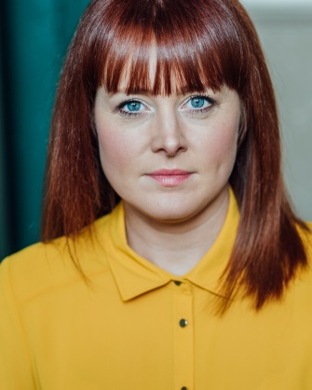
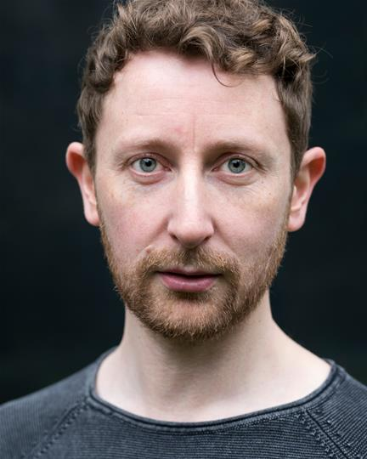

(L-R: Michael Dylan and Suzanne Magowan)

The cast also includes Roanna Davidson (as Trish, Donny’s ‘other’ partner); Lauren Grace (as Flea, Emma’s daughter); and Bhav Joshi (as Al, Donny’s doctor). Both Roanna Davidson and Lauren Grace are new to the Traverse stage, making their debut performance.

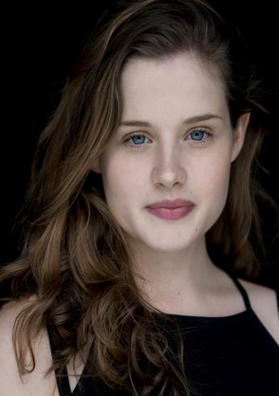

(L-R: Roanna Davidson, Lauren Grace, Bhav Joshi)

Completing the creative team will be Designer Becky Minto; Lighting Designer Renny Robertson; Composer and Sound Designer Danny Krass; and Choreographer Emma Jayne Park.

Donny’s Brain enjoyed a rehearsed reading at the Traverse Theatre in May 2019. Rehearsals for the world premiere production begin in Edinburgh on 9 March.

LISTINGS:
Sat 11 Apr-Sat 2 May, 7.30pm
Matinees: Tue 23 Apr, 2.30pm & Sat 2 May, 2pm
Press night: Wed 15 Apr, 7:30pm

This show is taking part in our £1 Tickets project.

Traverse Theatre, Edinburgh, EH1 2ED
Tickets on sale now: 0131 228 1404 and online via traverse.co.uk

For more information, press releases or images, contact anna.docherty@traverse.co.uk

Traverse Theatre is supported by:

Traverse Theatre (Scotland) is a Limited Company (Registered Number SC 076037) and Scottish Charity (Registered Number SC 002368) with its Registered Office at 10 Cambridge Street, Edinburgh, Scotland, EH1 2ED.

-ENDS-

