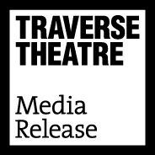
FOR IMMEDIATE RELEASE: 27 August 2019
Contact: Anna Docherty, Press and Media Officer
anna.docherty@traverse.co.uk / press@traverse.co.uk
Direct: 0131 659 7104

TRAVERSE FESTIVAL 2019 RECEIVES EXCEPTIONALLY STRONG AUDIENCE, CRITICAL AND AWARD RECEPTION

- Audience numbers reach nearly 36,000

- Over 40 five-star reviews across the programme

- Mouthpiece wins the coveted Carol Tambor Best of Edinburgh Award, facilitating a New York transfer

- A total of 13 award wins and four shortlistings

Traverse Festival 2019

The Traverse Theatre is proud to have delivered an exceptionally strong and well-received Festival programme, celebrating resilience and action in the face of today’s challenging times. The range of stories and artists, both emergent and established, speaks to our year-round commitment to new writing and has resulted in us being hailed as ‘the best for original plays’ (The Times) and ‘a cornerstone of the Edinburgh Fringe’ (The Independent), putting the Traverse at the heart of this international cultural celebration.

Audience numbers and reactions reflected the strength of the programme – with total numbers reaching 35,754 across the 256 production performances. Particularly strong critical praise saw Traverse Festival 2019 receive a total of 42 five-star reviews, and overwhelming audience demand for several productions resulted in additional performances for Enough, Mouthpiece, Burgerz and Frankenstein: How to Make a Monster.

Touring

Of the record-breaking seven productions bearing the Traverse Theatre stamp, several immediately move on to further engagements with audiences elsewhere: Crocodile Fever (Traverse Theatre Company in association with Lyric Theatre, Belfast) will tour to The Lyric, Belfast (3-8 September); How Not to Drown (ThickSkin and Traverse Theatre Company, in co-production with Tron Theatre and Lawrence Batley Theatre) will tour to Tron Theatre, Glasgow (11-14 September) and Lawrence Batley Theatre, Huddersfield (16-19 September); What Girls Are Made Of (Raw Material and Traverse Theatre Company, in association with Regular Music) will tour to Live Theatre, Newcastle (4-6 September), Soho Theatre, London (9-28 September) and Melbourne International Arts Festival (3-31 October); and Rich Kids: A History of Shopping Malls in Tehran (Javaad Alipoor and HOME, in association with Traverse Theatre Company) will tour to HOME, Manchester (23 October-2 November).
Other Traverse Festival 2019 shows with upcoming tour dates include Trying It On (UK tour, 3 September-31 October); Until the Flood (Arcola Theatre, London, 4-28 September); and Burgerz (UK tour, 9 October-23 November).

Awards

Carol Tambor Best of Edinburgh Award:
- Mouthpiece
Fringe First Awards:
- Enough
- How Not to Drown
- Rich Kids: A History of Shopping Malls in Tehran
- The Patient Gloria
- Until the Flood
The Stage Edinburgh Awards:
- Angus Taylor and Shauna Macdonald in Mouthpiece
- Dael Orlandersmith in Until the Flood
Herald Angel Awards:
- Dritan Kastrati in How Not to Drown
- The Patient Gloria
Total Theatre Awards:
- Travis Alabanza in Burgerz (Emerging Company/Artist)
- Frankenstein: How to Make a Monster (Innovation, Experimentation and Playing With Form)
BroadwayWorld Edinburgh Fringe Festival Awards:
- Crocodile Fever (Best Production)

In addition, there was a SIT-UP Award shortlist for How Not to Drown; a Holden Street Theatres Award shortlist for Mouthpiece; and a Carol Tambor Best of Edinburgh Award shortlist for Burgerz.

Linda Crooks, Traverse Executive Producer, says:
“The success of the Traverse’s 2019 Festival programme must be attributed to the exceptional work of the artists on our stages, the crucial stories they have chosen to tell, the selfless teams who have supported them and our fantastically enthusiastic and open-minded audiences who have once again championed the Traverse and our work throughout the month – we thank them all unreservedly.
We are delighted that so many of the productions will be shortly moving on to further life around the country and the world, taking these vibrant and important stories far beyond the Traverse’s walls – and we are particularly thrilled to have again won the Carol Tambor Best of Edinburgh Award which will bring Mouthpiece to a New York audience. We are already looking forward to Traverse Festival 2020 and the insightful, innovative and occasionally outrageous productions it will bring!”

-ENDS-

The Traverse Theatre is supported by:
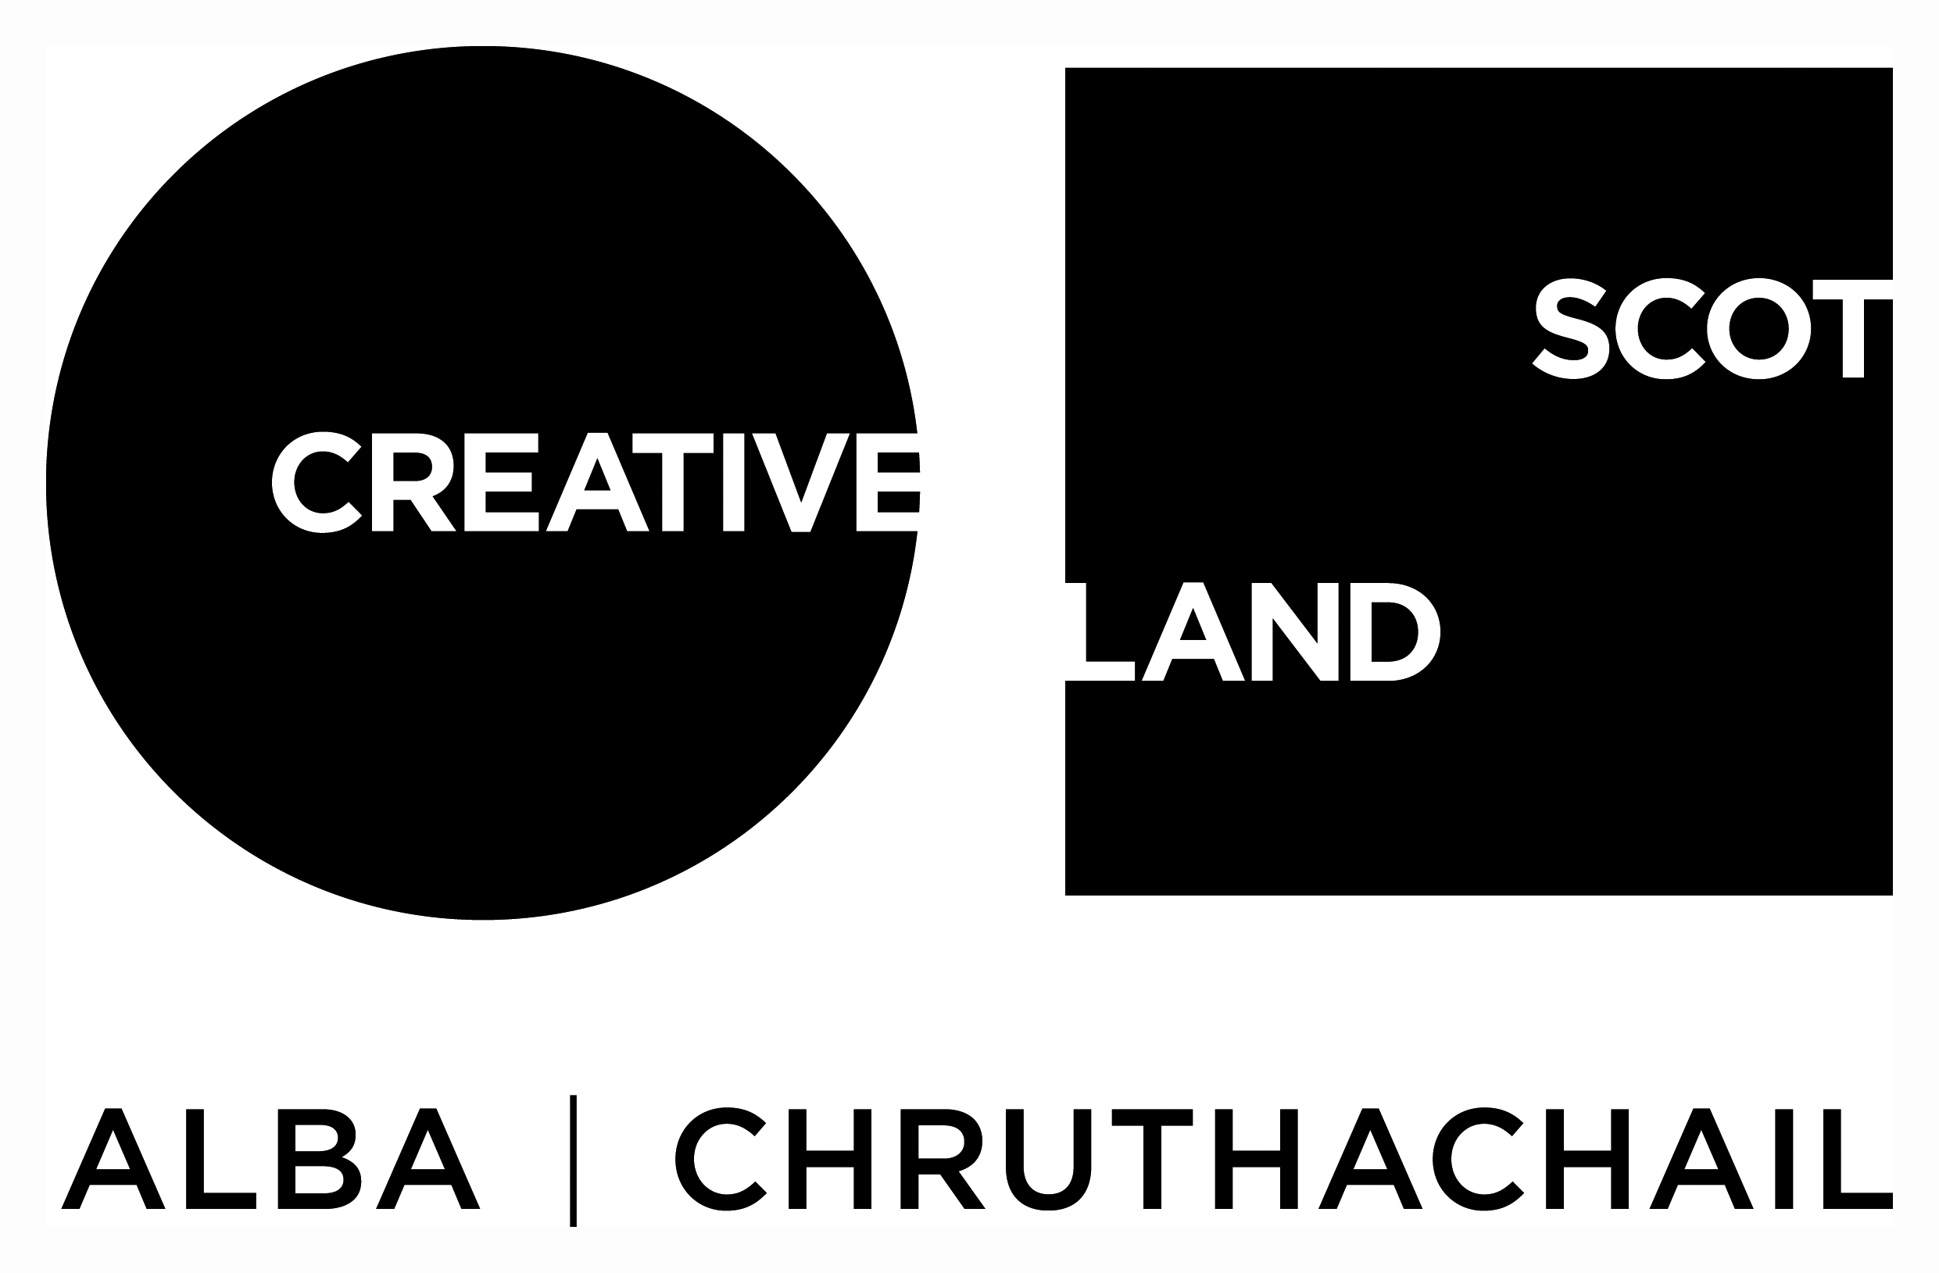
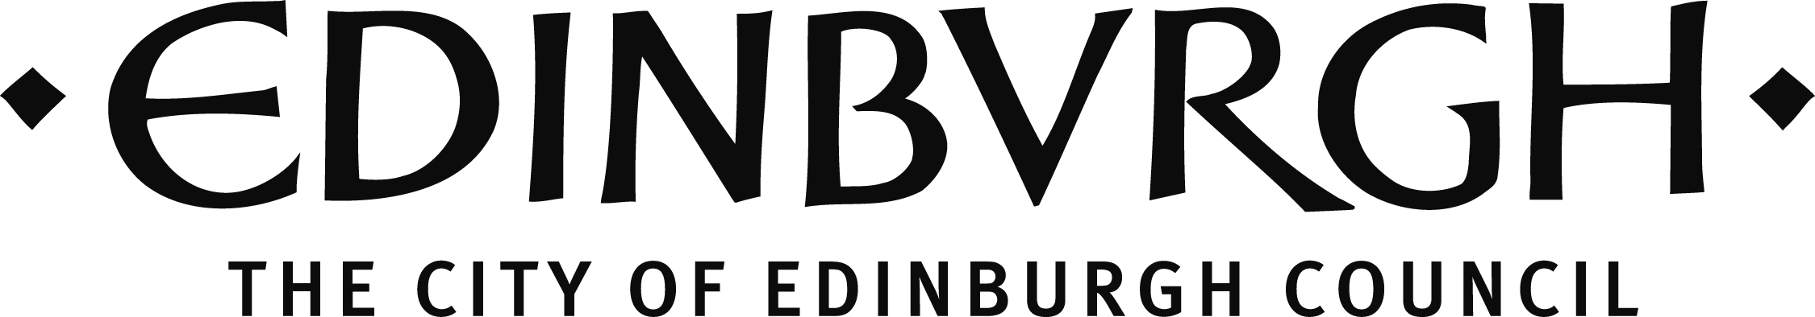

Traverse Theatre (Scotland) is a Limited Company (Registered Number SC 076037) and Scottish Charity (Registered Number SC 002368) with its Registered Office at 10 Cambridge Street, Edinburgh, Scotland, EH1 2ED.

