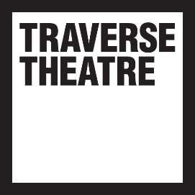

**TRAVERSE THEATRE MEDIA RELEASE**

**For immediate release:**

**Contact:** [press@traverse.co.uk](mailto:press@traverse.co.uk)

**TRAVERSE THEATRE ANNOUNCES FIRST ACTIVITIES OF 60th YEAR**

* **Traverse celebrates 60 years of change in 2023 with a range of exciting creative engagement activities and productions**
* **Class Act expands to schools around Scotland for the first time in Class Act On Tour**
* **Traverse Theatre Company production, *Sean and Daro* *Flake It ‘Til They Make It* by Laurie Motherwell, makes its world premiere in April**
* **Helen Forsyth, formerly Chief Executive of Berwickshire Housing Association, is appointed as Chair of the Traverse’s Board**
* **Zakia Moulaoui Guery, founder of Invisible Cities, and writer May Sumbwanyambe join as new Trustees**
* ***A Play, A Pie and A Pint* returns with a season of six piping hot new plays**

2023 marks 60 years since the Traverse Theatre was founded, opened its first premises in Edinburgh’s legendary Grassmarket, and revolutionised theatre not just in Edinburgh, but far beyond.

Over the past six decades, the Traverse has been in a state of constant evolution, and this year our activities celebrate 60 years of continual change, which have helped to keep us at the leading edge of performance and societal discourse.

This year we are putting additional focus on our creative engagement activities to develop both upcoming generations of talent, and cultivate future audiences for culture. For whilst life may be more difficult than ever before for many, we know that stories and the communities they build, will endure.

**Traverse Executive Producer, Linda Crooks, said:**

*“As the Traverse moves into its sixtieth year, we are operating in some of the most challenging circumstances theatre, culture, and society more widely have ever experienced. But as an organisation founded on boldness, and which has constantly celebrated change and reinvention, we are excited about what the future holds, and thankful to all of those whose critical support at this precarious moment will ensure we are able to discover the adventures yet to come. We are particularly delighted as part of our 60th anniversary activities to reveal our national expansion of Class Act, an active expression of our hope for the artists and audiences who will grow to create the work which grips the hearts of the next generations.”*

**Class Act On Tour**

We are excited to announce the expansion of our renowned Class Act programme to four more areas across the country. Working with schools in Aberdeenshire and Ayrshire, professional playwrights and creatives will turn pupils around Scotland into theatremakers, developing their own works for the stage. As well as mentorship from writers embedded into schools, participants will benefit from digital workshops from artists such as the award-winning artist Jordy Deelight, *Moorcroft* playwrightEilidh Loan and theatremaker Gary McNair.

Participants’ scripts will then be publicly performed by a cast of professional actors in one of our partner venues: Aberdeen Performing Arts, Aberdeen Arts Centre and Ayr Gaiety.

Schools in Aberdeenshire and Ayrshire are able to apply to participate in Class Act On Tour from today.

A showcase of scripts from Class Act On Tour, as well as those from Edinburgh participants Craigroyston Community High School, Craigmount High School, Trinity Academy, Tynecastle High School and Intercultural Youth Scotland, will be brought to life by a team of professional theatre-makers including directors, actors, filmmakers and musicians at the Traverse on Wed 15 and Thu 16 March.

**Class Act Producer, Robbie Gordon, said:**

*“We’re absolutely thrilled that in 2023 we’re expanding Class Act across Scotland, as we invite schools and students from Aberdeenshire and Ayrshire to get involved! We’ve got the most mind-blowingly talented artists on board to share their skills and experience, and we can’t wait to see what brilliant stories are shared.”*

Class Act On Tour is supported by Paul Hamlyn Foundation, the Backstage Trust, the William Syson Foundation, The Craignish Trust, David & June Gordon Memorial Trust, the John Thaw Foundation, Aberdeen City Council: Creative Funding, The Murdoch Forrest Charitable Trust and The Nancie Massey Charitable Trust.

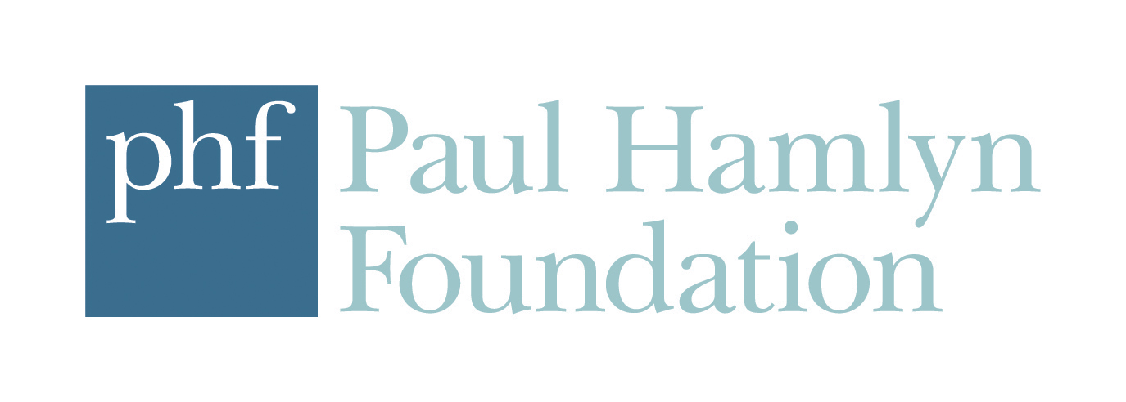

***Sean and Daro Flake It ‘Til They Make It***

In April we will premiere Laurie Motherwell’s new play, *Sean and Daro Flake It ‘Til They Make It*, which tells the story of Sean and Daro, a couple of likely lads who reckon they’ve got it licked with making a fortune in the ice cream van business. However, they quickly discover that conquering the ice cream business will be anything but a sundae stroll… As the bills, admin and brain freezes build up, the pals are put to the test and their relationship gets frosty. Will they stay solid, or melt under the pressure?

Directed by Birds of Paradise’s Artistic Director, Robert Softley Gale, *Sean and Daro Flake It ‘Til They Make It* draws from landmark Traverse productions *Midsummer* and *Passing Places*, to tell a contemporary story of hustle, friendship and Flakes in Glasgow.

Tickets on sale now.

**Writer Laurie Motherwell said:**

*“The Traverse, with new writing at its heart, has been the site for so many wonderful theatre experiences for me. The countless visits to see work, a meeting place during the Fringe, nursing a coffee and leaching the internet. For as long as I’ve loved theatre it’s been a place I’ve wanted my work to be, and I’ve been lucky to be involved with the Trav in many ways over the last however many years. My first public reading took place in Trav 2 during the Festival as a culmination of my Uni degree, I’ve been part of a Traverse Young Writers cohort, was back in Trav 2 for a Breakfast Play in 2018, and most recently I stepped in front of the camera to host a new workshop series. Each of these experiences has helped me to grow and develop my writing. Which is why the next part is so exciting.*

*I am absolutely over the moon Sean and Daro’s joyous journey will be part of the Trav’s 60th anniversary season. Through its illustrious history it’s been home to so many of my favourite plays and to be able to have some connection to those works is something I’ll never take for granted.*”

**New board appointments**

We are delighted to welcome Helen Forsyth as Chair of the Traverse Board, following Sir John Elvidge’s departure after eight years in the position. Helen has over 40 years’ experience across a range of independent and public agencies providing care, housing, and support to many groups of people including those in housing need, refugees, those experiencing dementia and mental health problems. She retired in 2020 from her job as a CEO of a rural housing association. Having studied Drama at University of Exeter and has remained a lifelong supporter of professional theatre and been involved in community theatre in both urban and rural Scotland. As well as Chairing the Traverse board, she is also Chair of Space at the Broomhouse Hub, Chair of the Scottish Federation of Housing Associations and Vice Chair of the South of Scotland Enterprise agency.

We are also very pleased that Zakia Moulaoui Guery, founder of Invisible Cities, and writer May Sumbwanyambe join as new Trustees.

Continuing Trustees are consultant Morag Ballantyne; Chief Operating Officer of Canongate Books, Kate Gibb; writer Kieran Hurley; Chief Executive of HOME and Director of Culture for Manchester City Council, Dave Moutrey; Sixteen Films Producer Rebecca O’Brien; Partner at Blackadders Donna Reynolds Co-Artistic Director of Manchester Royal Exchange, Bryony Shanahan; and Development Director Christopher Wynn.

**A Play, A Pie and A Pint**

Our productions in association with A Play, A Pie and A Pint return for a 7-week season from February until April:

*Until It’s Gone* by Alison Carr (Tue 28 Feb – Sat 4 Mar)

*Burning Bright* by Áine King (Tues 7 – Sat 11 Mar)

*Babs* by Morna Young (Tue 14 – Sat 18 Mar)

*Write-Off* by Aodhan Gallagher (Tue 21 – Sat 25 Mar)

*Variant* by Peter Arnott (Tue 28 Mar – Sat 1 Apr)

*The Spark* by Kathy McKean (Tue 4 – Sat 8 Apr)

Tickets on sale now.

**LISTINGS INFO**

Class Act On Tour

Aberdeenshire and Ayrshire applications open Wed 18 Jan.

To apply, contact [jennifer.galt@traverse.co.uk](mailto:jennifer.galt@traverse.co.uk)

Sean and Daro Flake It ‘Til They Make It

Sat 15 – Sun 23 April

Tickets: <https://www.traverse.co.uk/whats-on/event/sean-and-daro-flake-it-til-they-make-it>

A Play, A Pie and A Pint

Tue 28 Feb – Sat 8 April

Tickets: <https://www.traverse.co.uk/whats-on/a-play-a-pie-and-a-pint>

Full programme and booking: <https://www.traverse.co.uk/whats-on>

Traverse Theatre, 10 Cambridge St, Edinburgh, EH1 2ED I traverse.co.uk

**For more information, interviews or images, contact** [**press@traverse.co.uk**](mailto:press@traverse.co.uk)

*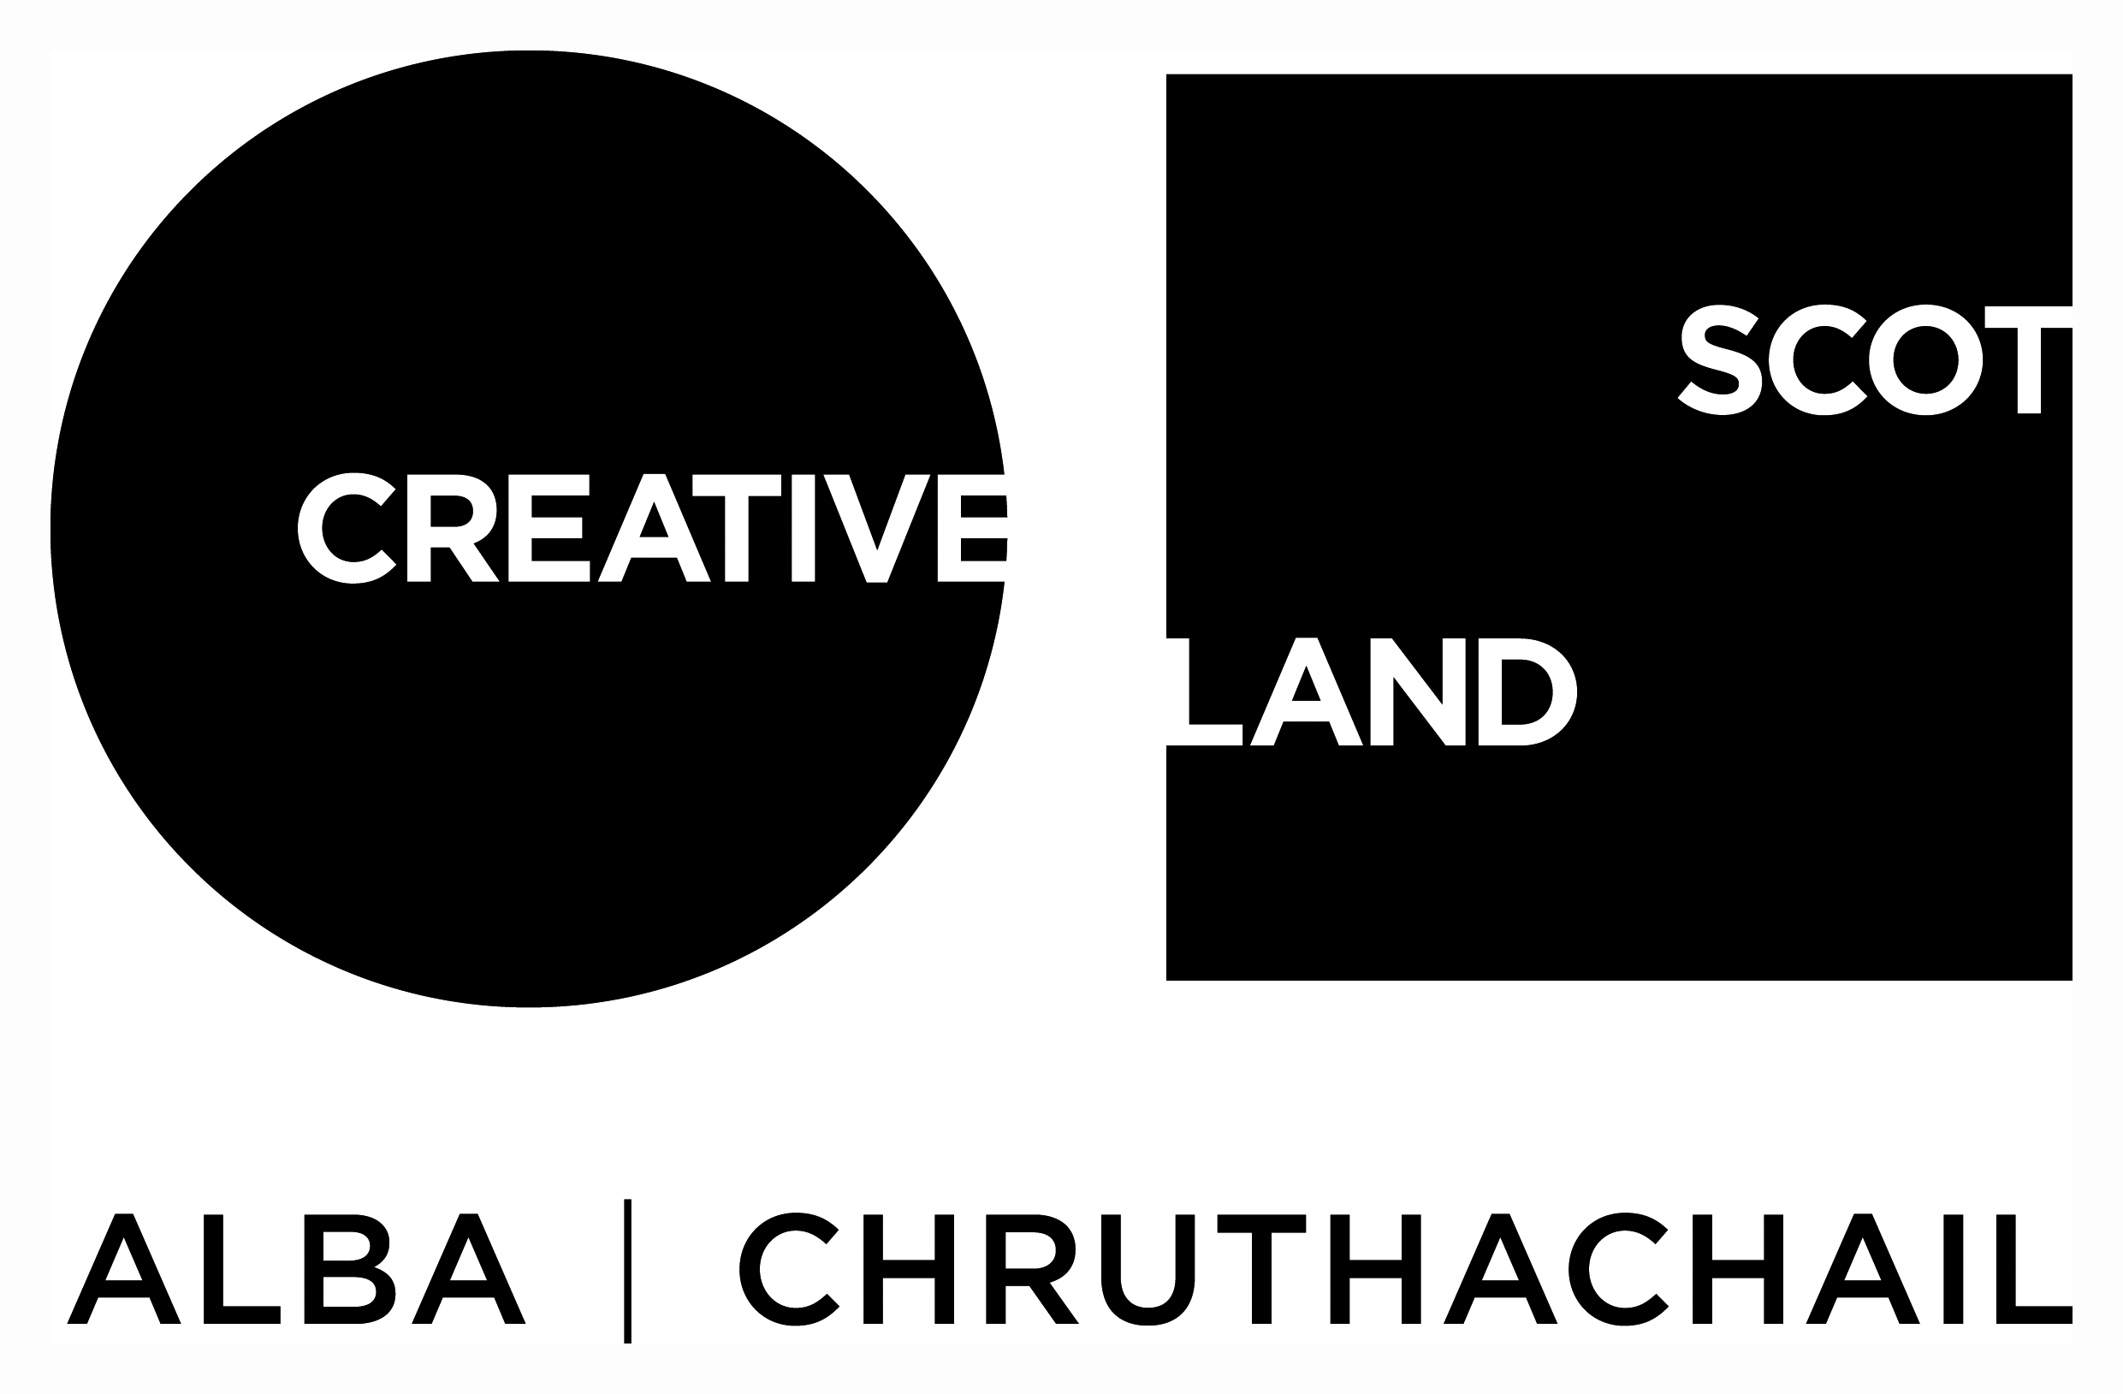***Traverse Theatre is supported by:**

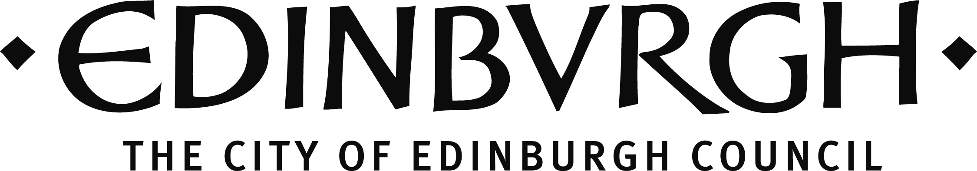

The Traverse Theatre is funded by Creative Scotland and The City of Edinburgh Council, and has received additional support from the Scottish Government's Performing Arts Venues Relief Fund and Creative Scotland’s Recovery Fund for Cultural Organisations.

 

Traverse Theatre (Scotland) is a Limited Company (Registered Number SC076037) and a Scottish Charity (Registered Number SC002368) with its Registered Office at 10 Cambridge Street, Edinburgh, Scotland, EH1 2ED.