FOR IMMEDIATE RELEASE: 1 November 2019
Contact: Anna Docherty, Press and Media Officer
anna.docherty@traverse.co.uk / press@traverse.co.uk
Direct: 0131 659 7104

TRAVERSE THEATRE ANNOUNCES CAST AND CREATIVE TEAMS FOR WORLD PREMIERE PRODUCTIONS THIS FESTIVE SEASON

- Tickets on sale now

The Traverse is delighted to reveal full details of the cast and creative teams bringing two world premiere productions to its stages this festive season – Strange Tales by Pauline Lockhart with Ben Harrison, a Grid Iron and Traverse Theatre Company co-production; and I Can Go Anywhere by Douglas Maxwell, a Traverse Theatre Company production.

Both productions continue the Traverse’s engagement with communities that are important to modern Edinburgh and its identity. They follow the great local and international success of Mouthpiece by Kieran Hurley and its take on the city’s class and cultural divides, which was hailed by The Scotsman’s Brian Ferguson as ‘one of the most powerful pieces of theatre I’ve seen in 25 years… and the best piece of work reflecting the evolution of the city’.

Strange Tales
Grid Iron and Traverse Theatre Company co-production

Co-writers and directors Pauline Lockhart and Ben Harrison of Grid Iron will be joined by the creative team of Assistant Director Yuyu Wang, Community Creative Advisors Joy Jin and Zhuoer Lin, Set and Costume Designer Karen Tennent, Live Effects Designer Fergus Dunnet, Composer Ruth Chan, Lighting Designer James Johnson, Sound Designer Richard Bell and Video Designers Bright Side (Cristina Spiteri and Susanna Murphy).

The Strange Tales production team will be joined by two students on placement from the Edinburgh Lighting and Sound School – a Technician Placement and a Stage Management Placement – as part of the Traverse’s continued commitment to developing the skills of the next generation of technicians, stage managers and crew members.

The cast will include Robin Khor Yong Kuan, Luna Dai and Pauline Lockhart.

Based on Pu Songling’s legendary Strange Tales from a Chinese Studio, audiences can expect to be beguiled and bewitched by brand new adaptations of a selection of these renowned tales, involving innovative new digital technology, puppetry and illusion. Though written centuries ago, they feel remarkably current, reflecting and commenting upon many aspects of modern society – greed, attraction, arrogance and hope, among many others. But you must enter the production’s immersive and spellbinding world with an open mind and a brave heart if you’re to escape these tales ever again….

Strange Tales is brought to you in partnership with the Confucius Institute for Scotland and is part of the Royal Shakespeare Company’s Chinese Classics Translation Project, funded by Arts Council England. Development process supported by Puppet Animation Scotland’s Creative Fund.

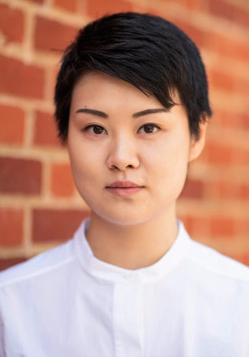
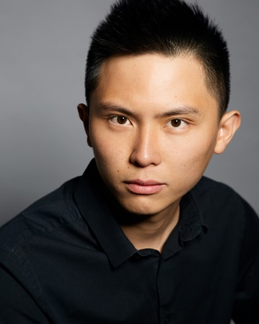

(L-R: Robin Khor Yong Kuan, Luna Dai, Pauline Lockhart)

I Can Go Anywhere
Traverse Theatre Company

Eve Nicol, who was one of this year’s Traverse Festival Breakfast Plays playwrights and who worked as Assistant Director with Festival hit What Girls Are Made Of, will make her Traverse directorial debut with I Can Go Anywhere, Douglas Maxwell’s first play for the Traverse since the challenging and thought-provoking The Whip Hand.

Completing the creative team will be Designer Jen McGinley, Composer/Sound Designer MJ McCarthy and Lighting Designer Benny Goodman.

Laura Michie from Fife College will also join the production team as Stage Management Placement.

Making their Traverse Theatre Company debuts will be Nebli Basani as Jimmy, an asylum seeker with a brilliant plan to stay in the UK, and Paul McCole as Stevie, the disillusioned academic he’s counting on to help him.
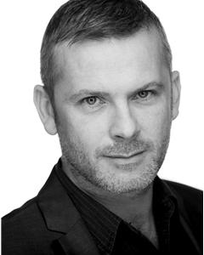
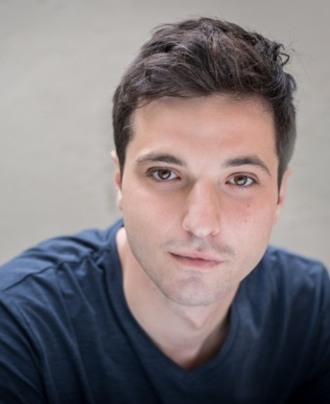

(L-R: Nebli Basani, Paul McCole)

LISTINGS:

Strange Tales
Tue 3-Sat 21 Dec, 7.30pm
Fri 13 Dec, 2.30pm
Sat 21 Dec, 2pm

I Can Go Anywhere
Tue 10-Sat 21 Dec, 8pm
Thu 12, Sat 14, Thu 19 & Sat 21 Dec, 2.30pm

Traverse Theatre, Edinburgh, EH1 2ED
Tickets on sale now: 0131 228 1404 and online via traverse.co.uk

For more information, press releases or images, contact anna.docherty@traverse.co.uk

Traverse Theatre is supported by:

Strange Tales is supported by:

Traverse Theatre (Scotland) is a Limited Company (Registered Number SC 076037) and Scottish Charity (Registered Number SC 002368) with its Registered Office at 10 Cambridge Street, Edinburgh, Scotland, EH1 2ED.

-ENDS-

Traverse 剧团宣布圣诞档全球首演剧目创意团队与演员阵容
- 现正火热售票

今年圣诞档，Traverse剧团将为大家呈献《聊斋》(Strange Tales) 及《无所不至》(I Can Go Anywhere) 两部全球首演剧目。在此，我们非常荣幸地公布创意团队信息与演员阵容。经Pauline Lockhart与Ben Harrison合作改编，《聊斋》一剧由Grid Iron与Traverse剧团联合制作；Douglas Maxwell的《无所不至》由Traverse剧团独家出品。

长期以来，Traverse对代表现今爱丁堡特色的群体十分重视。继《Mouthpiece》后，《聊斋》及《无所不至》亦继承了这一传统。Kieran Hurley的《Mouthpiece》因其深入独到的阶级与文化视角在当地乃至国际上都取得了巨大成功。Brian Ferguson (《The Scotsman》报社记者) 更是对《Mouthpiece》倍加赞誉，评论其为“25年以来最能反应爱丁堡城市变化的剧目之一”。而在此基础上，这两部剧将更加深入地揭示爱丁堡内在的阶级与文化差异。

《聊斋》
Grid Iron与Traverse剧团联合制作

本剧创意团队由剧作家及导演Pauline Lockhart (Grid Iron)、 Ben Harrison (Grid Iron)、 助理导演Wang Yuyu、社区创意顾问Joy Jin及Zhuoer Lin、服装及道具师Karen Tennent、现场特效师Fergus Dunnet、作曲家Ruth Chan、灯光师James Johnson、音效师Richard Bell及视频指导团队Bright Side (Cristina Spiteri及Susanna Murphy) 组成。

此外，两名就读于爱丁堡灯光音效学校 (Edinburgh Lighting and Sound School) 的学生将通过技术与舞台两类实习项目参与到制作团队中。此类实习项目由Traverse剧团创建，目的在于培养下一代技术人员、舞台管理人员及相关剧院工作人员。

本剧将由许勇宽(Robin Khor Yong Kuan), Luna Dai和Pauline Lockhart倾情出演。

本剧改编自蒲松龄《聊斋志异》系列故事。通过融入现代科技、木偶剧及魔幻元素，《聊斋》将为你带来独一无二的观剧体验。即便创作于数百年前，这些故事仍具有现实意义。穿越时空，它们折射了当代社会的种种现象：贪婪、诱惑、傲慢与希望……你需要带着一颗开明勇敢的心浸入剧中，否则这些故事很可能会一直萦绕在你的脑海……

本剧由苏格兰孔子学院支持构建，隶属皇家莎士比亚剧团 (Royal Shakespeare Company) 中国经典戏剧翻译项目 (Chinese Classics Translation Project)，由英格兰艺术委员会 (Arts Council England) 提供资金支持。排演阶段由苏格兰木偶动画创意基金 (Puppet Animation Scotland’s Creative Fund) 提供支持。

(左起：许勇宽(Robin Khor Yong Kuan), Luna Dai, Pauline Lockhart)

《无所不至》
Traverse剧团

Douglas Maxwell的新作《无所不至》将由Eve Nicol执导登上Traverse的舞台。这将是继极具挑战、发人深省的剧作《The Whip Hand》后，Douglas与Traverse的再次合作。 Eve曾以剧作家的身份加入Traverse艺术节晨间剧项目 (Traverse Festival Breakfast Plays) 并作为助理导演参与制作《What Girls Are Made Of》一剧。《无所不至》是Eve首次以导演身份出品的剧作。

此外，本剧创意团队还包括设计师Jen McGinley，作曲家及音效师MJ McCarthy及灯光师Benny Goodman。

与此同时，Nebli Basani和Paul McCole亦将首次登上Traverse舞台。Nebli Basani将在剧中扮演Jimmy，他希望在英国寻求避难所并开启新生活；而Paul McCole则将扮演Stevie，一位头脑清晰的学者。关于留在英国，Jimmy有一个完美的计划，而与此同时，他也一心希望Stevie能够帮助他实现他的梦想。

(左起： Nebli Basani, Paul McCole)

演出安排：

《聊斋》
2019年12月3日- 21日，19：30
2019年12月13日，14：30
2019年12月21日，14：00

《无所不至》
2019年12月10日- 21日，20：00
2019年12月12/14/19/21日，14：30

Traverse剧团，爱丁堡，邮编：EH1 2ED
购票方式：致电0131 228 1404或访问traverse.co.uk。

如需了解更多相关信息，请电邮：anna.docherty@traverse.co.uk。

Traverse剧团由以下单位提供支持：

《聊斋》由以下单位提供支持：

Traverse剧团（苏格兰）为有限责任公司（注册号SC 076037）及苏格兰慈善机构（注册号SC 002368），注册办公地址：苏格兰爱丁堡剑桥街10号（邮编：EH1 3ED）。

-完-

