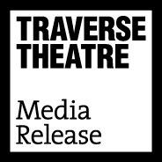
FOR IMMEDIATE RELEASE: 15 May 2019
Contact: Anna Docherty, Press and Media Officer
anna.docherty@traverse.co.uk / press@traverse.co.uk
Direct: 0131 659 7104

TRAVERSE THEATRE ANNOUNCES BOLD PROGRAMME FOR 2019 FESTIVAL, CELEBRATING RESILIENCE AND ACTION IN THE FACE OF CHALLENGE AND OPPRESSION

- A record seven Traverse Theatre Company productions, co-productions and in associations, including brand new works from Meghan Tyler and Stef Smith, and a first co-production with the innovative ThickSkin

- The return of sell-out, smash hit productions Mouthpiece and What Girls Are Made Of

- Writers include Travis Alabanza, Javaad Alipoor, BAC Beatbox Academy, David Edgar, Nicola McCartney and Gina Moxley
- 13 full productions: 5 world premieres, 1 European premiere, 2 UK premieres, 3 Scottish premieres, 2 returning Traverse Theatre Company productions – and 4 new Breakfast Plays

- Tickets on sale Thursday 16 May

Following the overwhelming success of last year’s Festival, and our recent 10 Critics’ Awards For Theatre in Scotland (CATS) nominations, the Traverse Theatre is excited to announce the full programme for Traverse Festival 2019, this year including seven works proudly bearing the Traverse Theatre Company stamp – more than any recent Traverse Festival programme. The programme presents two Traverse Theatre Company world premieres (Crocodile Fever by Meghan Tyler, and Enough by Stef Smith) and a selection of bite-sized Traverse Theatre Company new writing world premieres presented as The Breakfast Plays: The Future Is […]. Plus, the return of Traverse Theatre Company sell-out Mouthpiece by Kieran Hurley; a Festival venue evolution for our Raw Material co-production smash hit What Girls Are Made Of by Cora Bissett; a world premiere co-production with ThickSkin (How Not To Drown, by Nicola McCartney and Dritan Kastrati), and we’ll be working in association with Javaad Alipoor on his prescient new work Rich Kids: A History of Shopping Malls in Tehran.

Traverse Festival 2019 confidently speaks of the Traverse’s commitment to sharing Scottish new writing with as wide an audience as possible, whilst this year looking forward to, more than ever, extending the reach of our productions beyond their Festival life, as What Girls Are Made Of and Crocodile Fever travel further afield in September, following successful tours and transfers of our recent productions of Ulster American, Mouthpiece and Locker Room Talk.

Gareth Nicholls, Interim Artistic Director, says:
“To present six Traverse Theatre Company productions and co-productions – two of which have already proven themselves as critical and audience hits – as well as working in association with Javaad Alipoor, over a single Festival, is massively exciting. We’re extremely proud to be telling such varied and vital stories of Scottish origin, which in turns will make audiences laugh, cry, rage, think, debate – and above all, thoroughly enjoy themselves!”

Linda Crooks, Traverse Executive Producer, says:
“This year we’re delighted to welcome a number of companies to the Traverse Festival for the very first time. The productions each represent distinct and defiant realities and stories, which allow our audiences an enriching and enjoyable chance to understand the world through the experiences of those both similar to, and very different from, themselves at a time in history when this feels vital. To again be the August home for so many world and UK premieres from such innovative and important creative voices is an honour and we can’t wait for audiences to discover a whole host of stories they’ve never heard or seen before.”

FULL PROGRAMME DETAILS

Traverse Theatre Company

Crocodile Fever
World premiere. Traverse Theatre Company in association with Lyric Theatre, Belfast
Writer: Meghan Tyler
Director: Gareth Nicholls
A surreal, grotesque, and blackly comedic family drama set in Northern Ireland in 1989 during The Troubles, Meghan Tyler’s Crocodile Fever opens as rebellious Fianna crashes back into the life of her pious sister Alannah. Together in the unlovely family home for the first time in years, the sisters are back at each other’s throats in seconds. And when they are forced to confront their tyrannical father’s hideous legacy, all hell breaks loose. Fuelled by Taytos, gin, 80s tunes and a chainsaw, it’s the Devlin sisters versus the world. Gareth Nicholls directs following his outrageously entertaining and hugely popular Festival 2018 production of Ulster American. Part of Made in Scotland Showcase 2019.

Crocodile Fever cast will be: Bhav Joshi, Sean Kearns, Lisa Dwyer Hogg, Lucianne McEvoy.

Enough
World premiere. Traverse Theatre Company
Writer: Stef Smith
Director: Bryony Shanahan
Stef Smith (Swallow)’s poetic, unpredictable and explosive new play is a fragmentary and intense journey into female friendship. Two immaculate, iconic, accommodating flight attendants are here for your safety, your comfort and your pleasure. Or so you think. But 30,000 feet below them their seemingly perfect lives are rapidly unravelling. In the sky, over the sea and in cheap hotel rooms around the world, they can feel the ground shake beneath them. Something is rising up, something which can not be ignored. If they’re going to survive what’s coming, something needs to change… Enough is an epic elegy to modern women and what happens when you can no longer be the woman people want.

How Not To Drown
World premiere. A ThickSkin and Traverse Theatre Company production, co-produced with Tron Theatre and Lawrence Batley Theatre
Writers: Nicola McCartney and Dritan Kastrati
Director: Neil Bettles
In 2002, in the turmoil after the end of the Kosovan War, an 11-year-old Dritan Kastrati (co-writer of How Not To Drown) is sent on the notoriously perilous journey across the Adriatic, accompanied by a gang of people smugglers. Relying on young wit and charm on his journey to the UK, Kastrati’s fight for survival continues when he finds himself caught within the British care system. Featuring a diverse cast of five – including Kastrati himself – playing more than 30 characters, this is a vibrant, uplifting and action-packed true story of an unaccompanied child’s journey to find asylum within the UK, and a safe place in the world. Part of Made in Scotland Showcase 2019.

Mouthpiece
Traverse Theatre Company
Writer: Kieran Hurley
Director: Orla O’Loughlin
Following a sold out run at the Traverse in December 2018 and a critically-acclaimed London transfer to Soho Theatre, Kieran Hurley (Beats, Square Go)’s startling, shocking and unexpectedly humorous smash hit returns to captivate a Festival audience, performed by a new cast. Set in Edinburgh and telling the story of two unlikely lives intertwined – Libby, a onetime writer who whiles away her days in trendy cafes, and Declan, a talented young man struggling with a volatile home life defined by poverty – Mouthpiece takes a look at two different sides of a city that exist in ignorance of one another, and asks whether it’s possible to tell someone else’s story without exploiting them along the way.

What Girls Are Made Of
Raw Material and Traverse Theatre Company co-production, in association with Regular Music
Writer: Cora Bissett
Director: Orla O’Loughlin
Having enjoyed a sold out world premiere run as part of Traverse Festival 2018 – and a follow-on tour taking in Scotland, Ireland, Brazil and the USA –What Girls Are Made Of returns to bust out of the Traverse 1 walls, taking to the larger space of Assembly Hall to satisfy Festival audience demand. Written and performed by Cora Bissett, it charts her rollercoaster journey from indie-kid hopeful to wised-up woman. Performed with live backing band, this epic piece of gig theatre celebrates the euphoric highs (touring with Radiohead, partying with Blur) and epic lows (untrustworthy managers, £40,000 debt) of her young life. And, for the first time, the run will feature special dates with the original Darlingheart drummer, Cathryn Stirling. Co-produced with Raw Material, one of Scotland’s newest and brightest independent producing companies.

Breakfast Plays: The Future Is […]
World premiere. Traverse Theatre Company
Writers: Kolbrún Björt Sigfúsdóttir, Erin McGee, Eve Nicol, Diane Stewart
Director: TBC
Four new plays from four of the most exciting voices in Scottish theatre. Mentored by established playwrights Zinnie Harris, Stephen Greenhorn, Linda McLean and Douglas Maxwell, four emergent women writers (Erin McGee, Eve Nicol, Kolbrún Björt Sigfúsdóttir, and Diane Stewart) tackle topics exploring where we are and where we might be headed next – politically, socially, culturally. Poetic, punchy, generous and unforgiving, their plays showcase the imminent future of new writing in Scotland. An ever-popular Traverse Festival favourite, performed script-in-hand, and served with breakfast.

Rich Kids: A History of Shopping Malls in Tehran
World premiere. Javaad Alipoor and HOME, in association with Traverse Theatre Company
Writer: Javaad Alipoor
Director: Javaad Alipoor
Co-Created by: Javaad Alipoor and Kirsty Housley
Writer, theatre-maker and activist Javaad Alipoor (The Believers Are But Brothers) returns with a show inspired by the stories of rich/poor division that exist across the world – co-created with Kirsty Housley – confronting contemporary politics, the collapse of regimes and countries, and the ways social media allows the poorest to see how differently the rich are living. In the global south we see the children of elites and post-colonial dictatorships flashing cash, dollar signs, Bollinger and infinity pool holidays, while people languish under sanctions and dictatorships. Around the world more and more people, like their countries, are running out of steam, and their ruling classes are only out for themselves. With purpose and humour, Rich Kids: A History of Shopping Malls in Tehran prods at the question of how we got here, and what comes next?

Visiting Companies

Burgerz
Scottish Premiere. Hackney Showroom presents
Writer and performer: Travis Alabanza
Director: Sam Curtis Lindsay
Hackney Showroom present Travis Alabanza’s Burgerz, following runs in London and Berlin. The story takes its offing from when someone threw a burger at them and shouted a transphobic slur, after which performance artist Alabanza became obsessed with burgers. How they are made, how they feel, and smell. How they travel through the air. How the mayonnaise feels on your skin. This show is the climax of their obsession – exploring how trans bodies survive and how, by them reclaiming an act of violence, we can address our own complicity. Cooking a burger onstage becomes a vehicle to process years of gendered control and repression. Originally developed in association with Ovalhouse and Marlborough Theatre.

Frankenstein: How To Make A Monster
Scottish premiere. Battersea Arts Centre and BAC Beatbox Academy
Writer: BAC Beatbox Academy
Director: Conrad Murray and David Cumming
Part electrifying gig, part thrilling theatre, Frankenstein: How To Make A Monster (one of the Observer's ‘Top 10 shows 2018’) sees six mic’d up performers boldly deconstruct Mary Shelley's original to reimagine a world of modern monsters – from identity, body image, to a world saturated by social media. This powerful and poetic show pushes the power of the human voice to its expressive limits, from a cappella beats, raw rhythmic storytelling to soaring, complex harmonies. This run marks the Scottish debut of BAC Beatbox Academy, (Battersea Arts Centre’s home-grown young collective for artists aged 8-29 years), presenting their first professional production. During the run, curtain raiser performances will take place on the Traverse 1 stage before shows, created by pupils from Leith Academy. In a partnership project between Battersea Arts Centre, the Edinburgh International Festival and the Traverse Theatre, pupils from Leith Academy will connect with artists from BAC Beatbox Academy this summer; learning to beatbox – making their own music using nothing but their mouths – and performing to Traverse Festival audiences.

Spliced
UK premiere. Chalk It Down Productions
Writer: Timmy Creed
Director: Gina Moxley
A multi-disciplinary, site-specific show (performed off-site on a squash court at Edinburgh Sports Club) from exciting, upcoming Irish actor/writer Timmy Creed, dealing with his formative years as part of the Gaelic Athletic Association. Performed by Creed and comprised of a three-part monologue, it begins a conversation about masculinity, identity and mental health in sport, with thrilling music and visual projections. Spliced is a visceral account of Creed’s struggle to become an individual outside of the sporting institution that raised him over 21 years of playing. It poses the important question: can we talk about mental health, self-expression and masculinity in a sporting context?

The Patient Gloria
UK premiere. Gina Moxley and Abbey Theatre with Pan Pan Theatre Company
Writer: Gina Moxley
Director: John McIlduff
A mash up of re-enactment, real footage, lived experience and a punk gig, The Patient Gloria – by Gina Moxley – centres on the true story of a 30-year-old, chain-smoking, loquacious divorcee, Gloria, who in 1964 California allowed her counselling sessions to be filmed for an educational film called Three Approaches to Psychotherapy. The films were subsequently shown in movie theatres and on TV as The Gloria Films, betraying her privacy. The Patient Gloria is a timely meditation on female desire in a new political context where misogyny is the winning ticket, described as an ‘experimental extravaganza’ (Irish Independent), that is ‘very funny, very explicit and very sobering’ (Sunday Independent). Writer Gina Moxley (also the director of Spliced) performs in the piece, which premiered at the Abbey Theatre as part of the Dublin Theatre Festival, and will be joined on stage by choreographer and performer Liv O’Donoghue, and musician Jane Deasy.

Trying It On
Scottish premiere. Warwick Arts Centre and China Plate
Writer: David Edgar
Director: Christopher Haydon
A new play written and performed by David Edgar, reflecting on the legacy of the momentous year that was 1968 – the Paris student revolt, the assassination of Martin Luther King, Enoch Powell’s “rivers of blood” speech, and the ongoing war in Vietnam – drawing on first-person interviews with leading political figures of the time, as well as contemporary activists. The performance also marks Edgar’s first professional stage performance in this revealing, autobiographical one-man play. In Trying It On, the 70-year-old Edgar is confronted by his 20-year-old self, asking whether they share the same beliefs, and, if not, what has changed. Christopher Haydon directs following his previous hit Festival productions of Diary of a Madman, Grounded and The Christians.

Until The Flood
European premiere. Arcola Theatre
Writer: Dael Orlandersmith
Director: Neel Keller
Pulitzer Prize nominee Dael Orlandesmith’s new piece inspired by the event of 8 August 2014, when a police officer shot and killed Michael Brown, an African American teenager in Ferguson, Missouri. It prompted weeks of social unrest, propelled by the activist movement Black Lives Matter, and an investigation by the U.S. Department of Justice.After the shooting, Orlandersmith conducted interviews with dozens of people who were shaken by the event. From these conversations, she has created eight characters who embody a community struggling to come to terms with the complex event. Until The Flood explores the dark forces of American history, race and politics that exploded in the streets of Ferguson, Missouri and sent shock waves across the nation.

Elsewhere in the programme…

TalkFest 2019
Playwrights’ Studio Scotland and Made in Scotland present
A series of engaging discussions offering audiences a chance to delve deeper into what stimulates the artists behind this year’s Edinburgh Festival. In Ways and Means: Theatre in 2019 and Beyond, playwright Douglas Maxwell and spoken word poet Jenny Lindsay discuss what makes great theatre; and in Anatomy of a Play: How Not To Drown, playwright Nicola McCartney and actor Dritan Kastrati dissect the process of writing Kastrati’s astonishing biographical play, How Not To Drown. Part of Made in Scotland Showcase 2019.

Pre-View
The University of Edinburgh and Playwrights’ Studio, Scotland present
Readings from eight brand new plays by emerging playwrights from England, Ireland, Poland, Scotland, Singapore, the USA and Wales, all graduating from the Masters in Playwriting at the University of Edinburgh. Get in at the ground level with exciting playwriting voices of the future as they explore some of the world’s biggest issues in fresh new ways.

James Tait Black Prize for Drama 2019: The Award Ceremony
The University of Edinburgh in association with Playwrights’ Studio, Scotland and Traverse Theatre present
The James Tait Black Prize for Drama celebrates innovative and ground-breaking drama produced worldwide in the last year. Extracts from the shortlisted plays will be performed, and presenter Shereen Nanjiani will hold thought-provoking discussions with the playwrights about their work, before the winner of the esteemed prize is revealed. Part of the oldest literary awards in the UK, the £10,000 prize is awarded to the play that most clearly demonstrates an original voice and makes a significant contribution to the art form.

LISTINGS:
Traverse Theatre, Edinburgh, EH1 2ED
Tickets on sale Thursday 16 May: 0131 228 1404 and online via traverse.co.uk

Edinburgh Sports Club, Edinburgh, EH4 3DH
Tickets on sale Thursday 16 May: 0131 228 1404 and online via traverse.co.uk

Assembly Hall, Edinburgh, EH1 2LU
Tickets on sale now: 0131 623 3030 and online via assemblyfestival.com

Pricing note: We offer £5 tickets year-round (including Festival) to Unemployed, Job Seekers Allowance, Employment Support Allowance and Universal Credit (proof required), and operate Under 30s/student concessions. We are also piloting, and continuing to develop, a £1 Ticket scheme to reach communities and people within Edinburgh and beyond who might not have visited the Traverse before (open to UC/JSA/ESA and under 25s). During the Festival we will offer a number of tickets for £1 (purchasable in cash, at the box office) for selected performances of Crocodile Fever, How Not To Drown, and Frankenstein: How To Make A Monster.

For more information, press releases or images, contact anna.docherty@traverse.co.uk

The Traverse Theatre and is supported by:
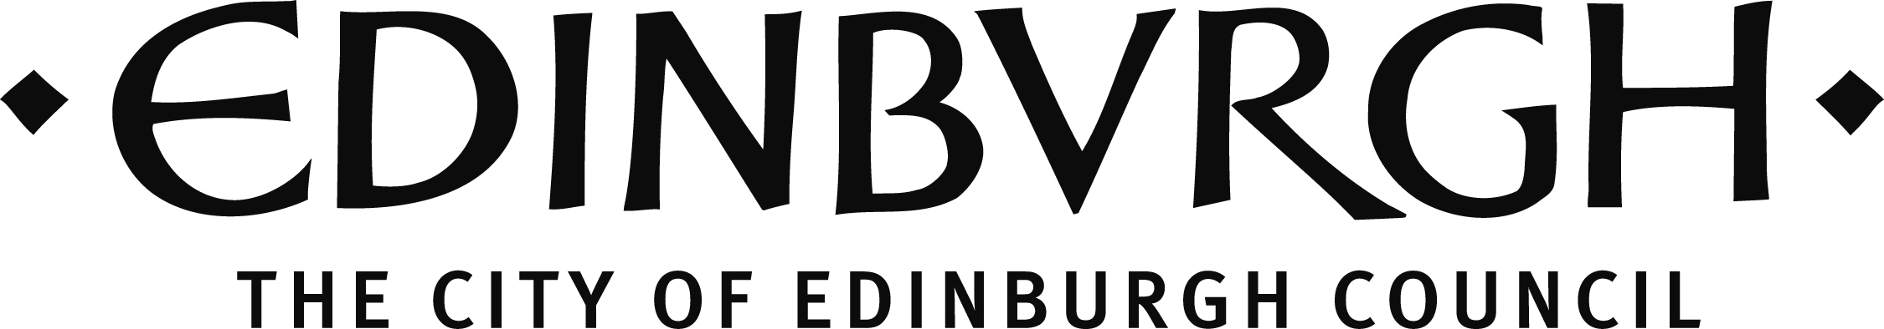
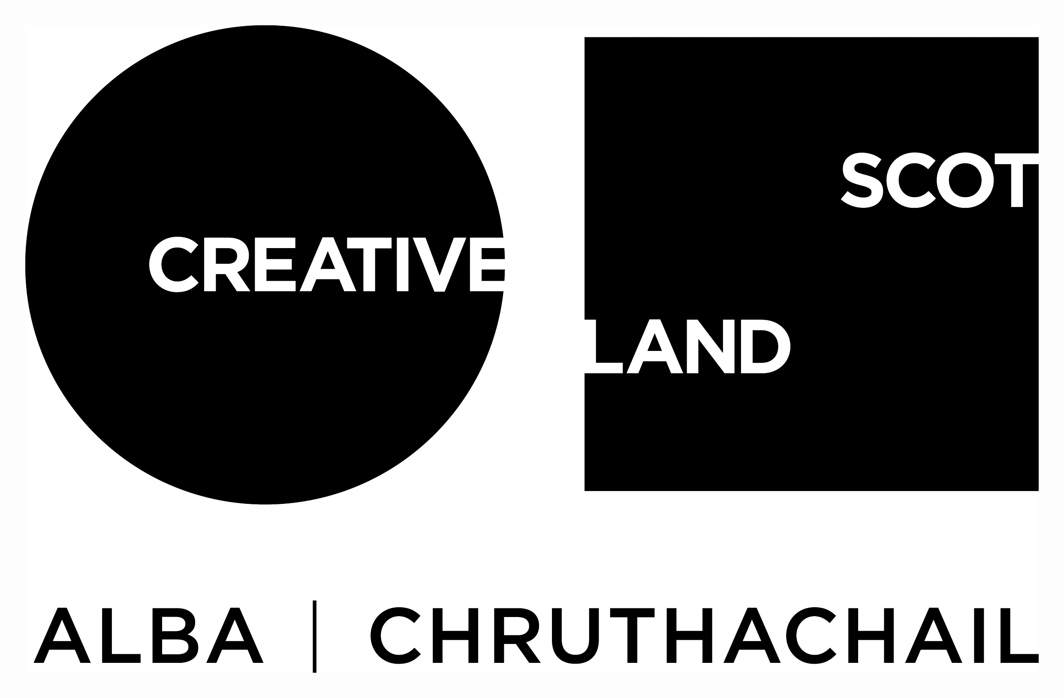

Traverse Theatre (Scotland) is a Limited Company (Registered Number SC 076037) and Scottish Charity (Registered Number SC 002368) with its Registered Office at 10 Cambridge Street, Edinburgh, Scotland, EH1 2ED.

-ENDS-

