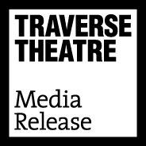
FOR IMMEDIATE RELEASE: 13 May 2020
Contact: Victoria Murray, Head of Brand and Audience
victoria.murray@traverse.co.uk / press@traverse.co.uk

TRAVERSE THEATRE INVITES ASPIRING WRITERS TO UNLEASH THEIR CREATIVITY AS IT LAUNCHES AMBITIOUS DIGITAL SERIES OF OPEN SUBMISSIONS WORKSHOPS
- - -

CAST AND CREATIVE TEAMS FOR TRAVERSE YOUNG WRITERS’ SCRATCH PERFORMANCES ALSO CONFIRMED

- - -

- Online workshops released over the next 16 weeks to take aspiring writers from initial idea through drafting their script

- Tutors include members of the Traverse’s Artistic team, playwrights and theatremakers including Debbie Hannan, Hannah Lavery, Douglas Maxwell, Meghan Tyler, Julia Taudevin and Frances Poet

- All workshops are free to access and will be available until September 2021

- Workshops culminate in the opening of the 2020 Open Submissions window for writers living in the UK and Ireland to send full-length scripts to the theatre

- Introductory session with the Traverse’s Literary Associate Eleanor White, available now

- - -

Now more than ever, the Traverse is committed to creating opportunities for anyone to connect with and unleash their innate creativity. Today we announce a dynamic new series of Open Submissions Workshops and the delivery of digital Scratch performances, enabling our Young Writers Group to continue their creative development and share new stories with audiences through this exciting online showcase.

…………………………

OPEN SUBMISSIONS WORKSHOPS

Over the next 16 weeks, starting Wednesday 13 May, the Traverse will be producing a series of Open Submissions Workshops that will be made available to view and listen to on demand and for free through their website and YouTube channel from anywhere in the world.

Each week a professional playwright or theatremaker, both established and early career, will deliver a workshop on a particular aspect of the writing process, and elements of particular consideration for writers. The series aims to practically and proactively support writers through the process of having an initial idea for a script through creating a draft, for potential submission to the theatre’s Open Submission window beginning on 1 September, when it will be read by a team of theatre professionals for possible development and presentation by the theatre at a future date.

For those who may want to work on their ideas for longer, all sessions once live will be available to view and listen to at any point until 1 September 2021.

Tutors already confirmed to deliver workshops are Debbie Hannan, Gareth Nicholls, Meghan Tyler, Julia Taudevin, Hannah Lavery, Douglas Maxwell and Frances Poet, with many more to be confirmed in coming weeks.

Scripts which have previously been developed by the Traverse through its Open Submissions programme include Gagarin Way by Gregory Burke, Milk by Ross Dunsmore and Crash by Andy Duffy, with writers such as Natalie McGrath (First Stages and Pride Plays) and Conor O’Louhglin (First Stages and A Play, A Pie and A Pint) receiving development of pieces, having submitted to the initiative.

The first session, with the Traverse’s Literary Associate Eleanor White, offers an introduction to the series and the Open Submissions initiative, is available now and can be watched here.

Linda Crooks, Executive Producer, says:

“The Traverse is committed to finding new ways to support as many people as possible in using this period to unleash their creativity and potentially discover an unexplored talent. Creativity is an attribute we all have, and the stories we need and want to hear – now more than ever - could come from anyone and anywhere. We hope that this ambitious series of Open Submissions Workshops will encourage anyone who may have dreamt of writing a play to take the leap towards the potential production of their work on one of our stages, when such an event is possible again. Presenting these workshops in a digital form means that they can be used and enjoyed globally, and we hope that writers who engage with this series may create transformative work for not just the Traverse, but other theatres – and their audiences - around the world.”

…………………………

TRAVERSE YOUNG WRITERS’ SCRATCH PERFORMANCES

Since late March the Traverse Young Writers Group has received weekly online tuition from acclaimed playwrights so they can continue to develop their creative writing skills. An important aspect of the Young Writers programme is presenting excerpts of the writers’ work in a Scratch Night performance at the Traverse, during which each writer has the opportunity to gather feedback from members of the audience, industry and their peers.

The Traverse is committed to sharing the excellent work the Young Writers Group have created so are delighted to present brand new, specially created, pieces from nine Young Writers online, directed remotely and with performers filming in their own homes under lockdown conditions.

The first piece will be made available on our YouTube channel and website at 8pm on Sat 16 May (the time and date of the planned Scratch Night performance at the Traverse), with a new piece going live each night until Sat 24 May.

The Young Writers who will be featured are Bluey Little, Katie McCulloch, Shelley Middler, Rhianna Varney, Leonie Jones, Kasia Grycuk, Kari Hall, Gabriel Floyd and Tom Zachar.

Pieces will be directed by Gareth Nicholls and Debbie Hannan.
Performers confirmed so far include Zoe Bullock, Claire Macallister, Nicole Cooper, Laura Lovemore and Isobel McArthur.
Viewers are invited to share any feedback which will help writers to further develop their work by emailing writing@traverse.co.uk.

Eleanor White, Literary Associate says:

“We have been so impressed by the resilience and creativity our Young Writers Group have shown since we moved their course online following lockdown. We are delighted to be able to share these specially created and brand new works online, allowing them to reach audiences both within and far beyond the local area – an opportunity they couldn’t deserve more. These are some of the most exciting new voices in Scottish theatre and their pieces cover a huge range of topics and emotions – but they all have in common their ability to transport audiences outside of their current circumstances and showcase some exceptional talent.”

…………………………

VIEWING INFORMATION

Open Submissions workshops
Watch here
New workshop available every Wed from 13 May 2020
Available on demand and for free until September 2021

Traverse Young Writers’ Scratch performances
Watch here
First piece goes live at 8pm on Sat 16 May
A new piece available each night at 8pm until Sun 4 May
Available on demand and for free until 16 May 2021

Please note that all times referred to in this release are BST.

Traverse Theatre, Edinburgh, EH1 2ED

For more information, press releases or images, contact victoria.murray@traverse.co.uk

Traverse Theatre is supported by:
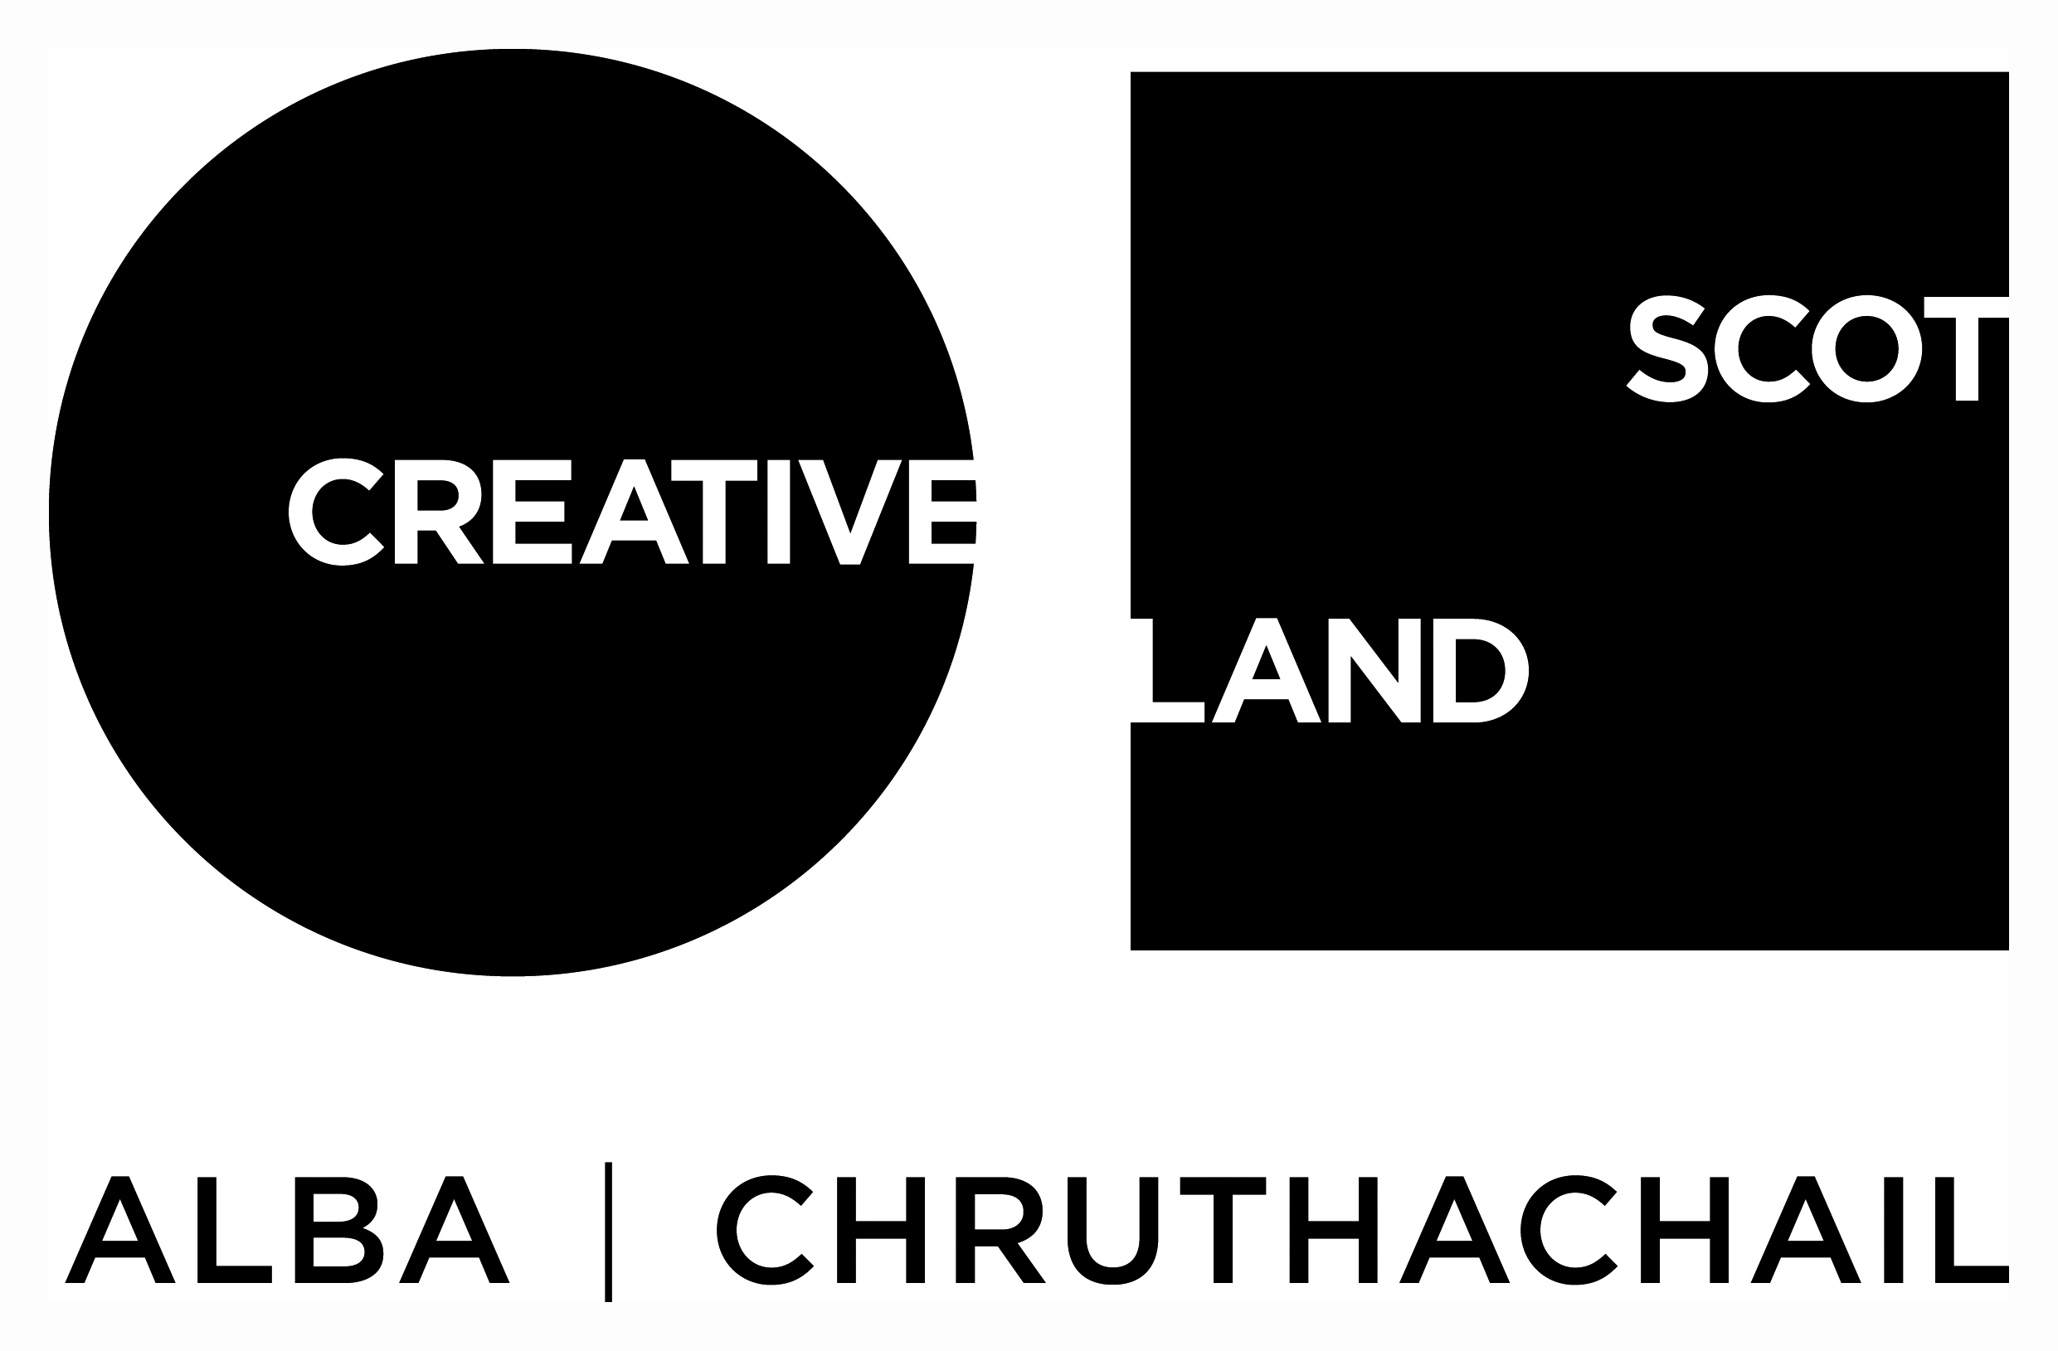
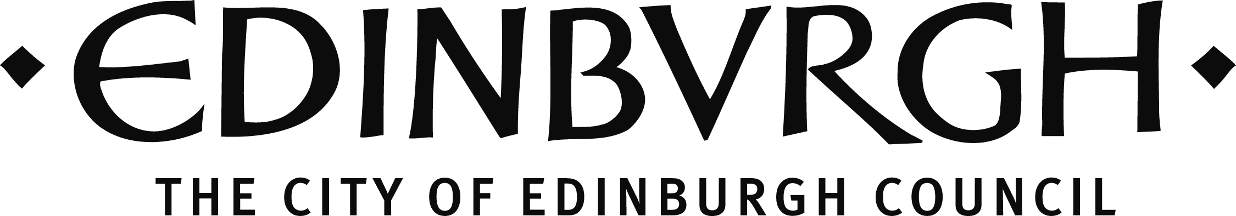

Traverse Young Writers and Open Submissions is further supported by:

Dr David Summers Charitable Trust
The Nimar Charitable Trust
The Russell Trust
The Teale Charitable Trust
The Turtleton Chairtable Trust
The RKT Harris Charitable Trust
The William Syson Charitable Foundation

Traverse Theatre (Scotland) is a Limited Company (Registered Number SC 076037) and Scottish Charity (Registered Number SC 002368) with its Registered Office at 10 Cambridge Street, Edinburgh, Scotland, EH1 2ED.

-ENDS-

