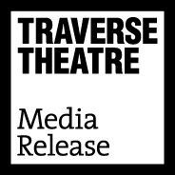
FOR IMMEDIATE RELEASE: 13 June 2019
Contact: Anna Docherty, Press and Media Officer
anna.docherty@traverse.co.uk / press@traverse.co.uk
Direct: 0131 659 7104

TRAVERSE THEATRE ANNOUNCES EXCITING NEW INFORMATION ON TRAVERSE FESTIVAL 2019

- Hat-trick of CATS award wins including ‘Best Female Performance’ (Ulster American) for Lucianne McEvoy, who will return in Traverse Festival 2019’s Crocodile Fever

- Casting announced for shows including Enough, How Not To Drown and Rich Kids: A History of Shopping Malls in Tehran

- Ground-breaking community projects revealed for BAC Beatbox Academy’s Frankenstein: How To Make A Monster

- Print brochure out now

CATS wins

At the annual Critics’ Awards for Theatre in Scotland (CATS) ceremony, the Traverse Theatre Company is overjoyed to have scooped a hat trick of awards for Ulster American, including a ‘Best Female Performance’ award for Lucianne McEvoy. We’re delighted that she will return to play a leading part in the Traverse Festival 2019 world premiere production of Crocodile Fever, by Meghan Tyler.

Festival 2018 smash hit Ulster American also won on the night for ‘Best New Play’ and ‘Best Production’. More information on future touring for Ulster American will be announced soon.

We also received shortlist nominations for returning Traverse Festival 2019 shows Mouthpiece (‘Best New Play’, ‘Best Male Performance’, ‘Best Director’) and What Girls Are Made Of (‘Best Production’, ‘Best Female Performance’, ‘Best Music and Sound’). Traverse Festival 2019 will be your next chance to see these critically-praised productions, with Mouthpiece featuring an all-new cast, while What Girls Are Made Of enjoys an exciting Festival venue evolution to Assembly Hall

Casting

In Traverse Theatre Company casting news, we can reveal that Amanda Wright and Louise Ludgate will play Toni and Jane (respectively) in Stef Smith’s fragmentary and intense journey into female friendship, Enough. And, as mentioned above, ‘Best Female Performance’ (CATS 2019) winner Lucianne McEvoy will play a leading role in Crocodile Fever – Meghan Tyler’s surreal, grotesque, and blackly comedic family drama set in Northern Ireland in 1989 during The Troubles – alongside Bhav Joshi, Sean Kearns and Lisa Dwyer Hogg.

Our co-production with ThickSkin, How Not To Drown, will feature actors Ajjaz Awad, Esme Bayley, Daniel Cahill, Reuben Joseph and Dritan Kastrati playing a rotating cast of characters, including Kastrati himself, on whose journey across the Adriatic with a gang of people smugglers to a new life in Europe the play is based.

Elsewhere, Rich Kids: A History of Shopping Malls in Tehran , produced in association with the Traverse Theatre Company, will be performed by Javaad Alipoor (who is also the writer, and co-creator, alongside Kirsty Housley) and Peyvand Sadeghian.

Community projects

We’re thrilled to reveal more exciting details on the community projects surrounding Frankenstein: How To Make A Monster. A partnership between Battersea Arts Centre Beatbox Academy, Edinburgh International Festival and the Traverse Theatre, bringing three world class organisations together for the first time to present a new community-based programme, as part of the Traverse’s Festival 2019 Programme.

Founded on the principals behind Battersea Arts Centre’s dynamic Beatbox Academy, the project will create a unique opportunity for young people from Leith Academy, currently engaged in Edinburgh International Festival’s three-year school residency project. Young people will work with Conrad Murray, who leads BAC’s Beatbox Academy, and Edinburgh-based musician Josie O’Neil, to jam with other young musicians, improve their vocal techniques and make their own music using nothing but their mouths.

The Beatbox Academy is currently in residence in Leith Academy, engaging with 350 pupils in beatbox and song-writing workshops, following which they will be invited to sign up for an intensive Beatbox Summer School in July. The young people will have the opportunity to build on their beatbox and song-writing skills to create their own music, ultimately showcasing their talent in curtain raiser performances at the Traverse across the month of August (every Festival performance of Frankenstein: How To Make A Monster, except 10pm), celebrating young talent and bringing their energy to enthusiastic audiences.

LISTINGS:
Traverse Theatre, Edinburgh, EH1 2ED
Tickets on sale now: 0131 228 1404 and online via traverse.co.uk

Assembly Hall, Edinburgh, EH1 2LU
Tickets on sale now: 0131 623 3030 and online via assemblyfestival.com

Pricing note: We offer £5 tickets year-round (including Festival) to Unemployed, Job Seekers Allowance, Employment Support Allowance and Universal Credit (proof required), and operate Under 30s/student concessions. We are also piloting, and continuing to develop, a £1 Ticket scheme to reach communities and people within Edinburgh and beyond who might not have visited the Traverse before (open to UC/JSA/ESA and under 25s). During the Festival we will offer a number of tickets for £1 (purchasable in cash, at the box office) for selected performances of Crocodile Fever, How Not To Drown, and Frankenstein: How To Make A Monster.

For more information, press releases or images, contact anna.docherty@traverse.co.uk

Traverse Theatre and is supported by:
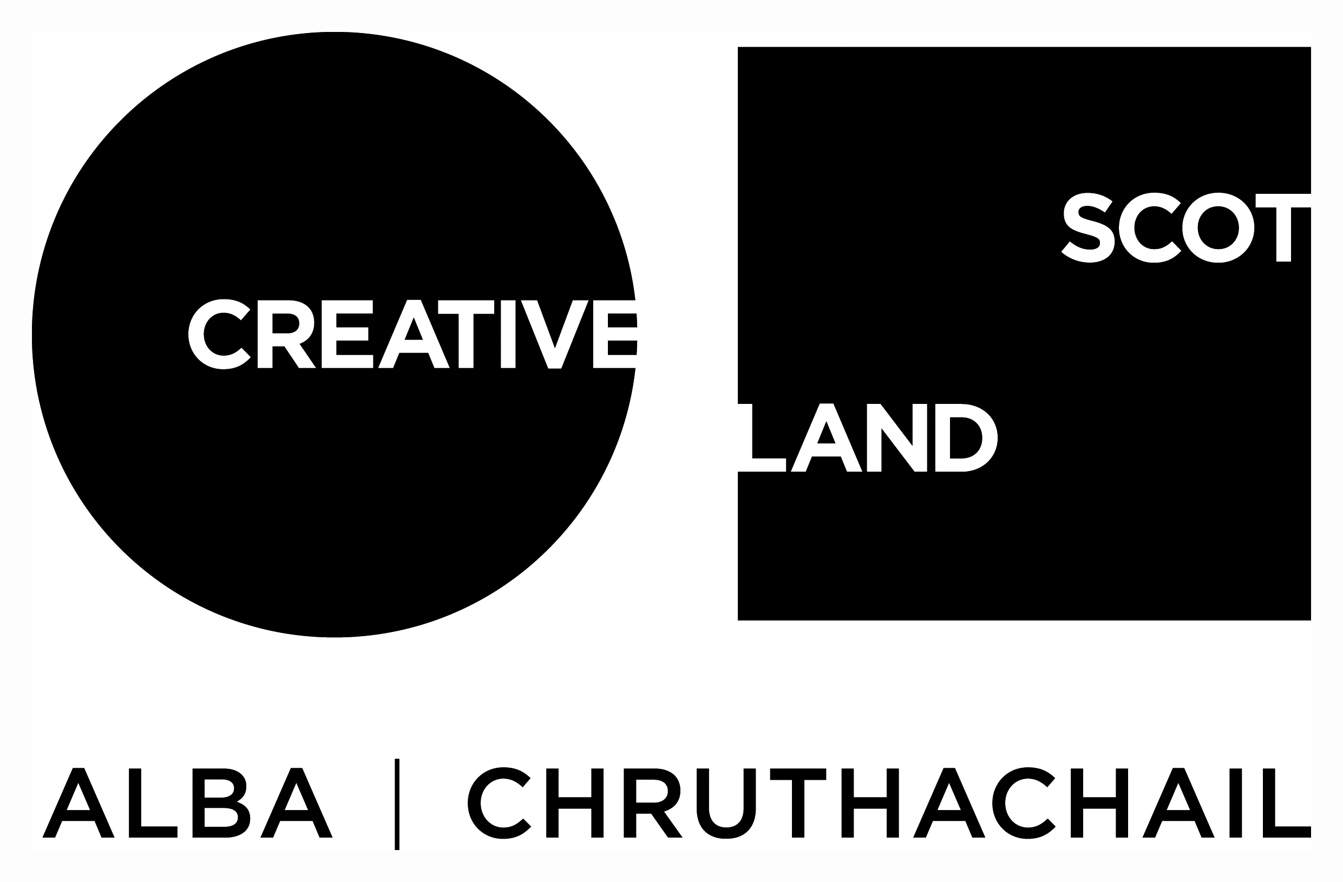
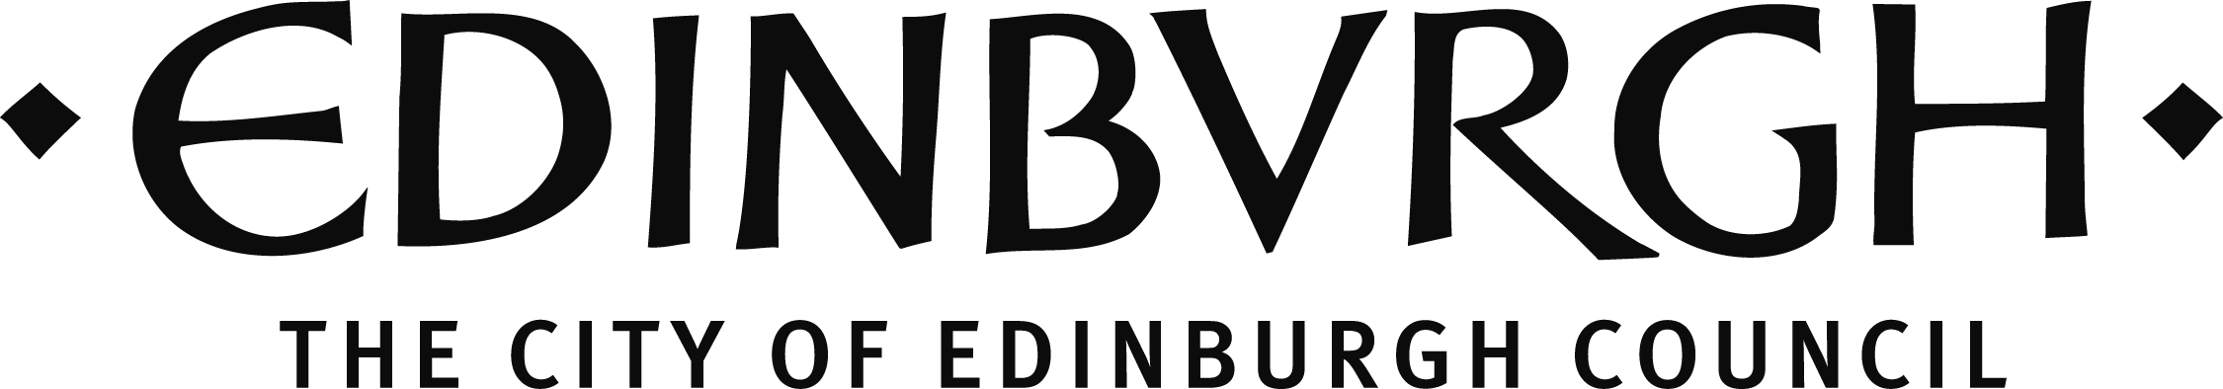

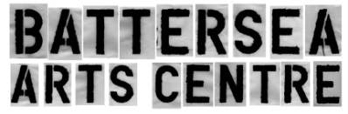
Beatbox Academy: Edinburgh Festival 2019 is supported by:

Traverse Theatre (Scotland) is a Limited Company (Registered Number SC 076037) and Scottish Charity (Registered Number SC 002368) with its Registered Office at 10 Cambridge Street, Edinburgh, Scotland, EH1 2ED.

-ENDS-

