FOR IMMEDIATE RELEASE: 19 July 2019
Contact: Anna Docherty, Press and Media Officer
anna.docherty@traverse.co.uk / press@traverse.co.uk
Direct: 0131 659 7104

THRILLING TRIO OF TRAVERSE THEATRE COMPANY NEW WORK ANNOUNCED FOR AUTUMN/WINTER 2019

- Brand new Traverse Theatre Company productions The Monstrous Heart (co-produced with Stephen Joseph Theatre), Strange Tales (co-produced with Grid Iron), and I Can Go Anywhere

- First Stages Festival celebrates new voices in Scottish theatre with a series of script-in-hand readings

- Visiting Company world premiere of National Theatre of Scotland’s The Panopticon, plus Stellar Quines, Eclipse Theatre Company and more

- Tickets on sale now

Traverse Theatre Company

With Traverse Festival 2019 presenting a total of seven Traverse Theatre Company productions – more than any recent year documented – we are thrilled to look ahead to our autumn/winter season, which is similarly abundant with fresh and provocative Traverse Theatre Company new work. We have a total of three world premiere productions – The Monstrous Heart, Strange Tales, and I Can Go Anywhere – as well as a new writing showcase (First Stages Festival) and the return of our long-running flagship education project Class Act.

First up in the season is our co-production with Stephen Joseph Theatre, The Monstrous Heart (22 October-2 November) by Oliver Emanuel (The 306 trilogy, Flight, Dragon), directed by Gareth Nicholls (Crocodile Fever, Ulster American, Letters to Morrissey). A thrilling, chilling and witty piece of new writing examining afresh the eternal question of whether we are the product of nature or nurture, it centres on Mag (Christine Entwistle), who lives in a rustic cabin in the Canadian wilds. When her estranged daughter Beth (Charlene Boyd) turns up newly released from prison, the past becomes terrifyingly present. And it has teeth. Assistant Director Jordan Blackwood (supported by a Federation of Scottish Theatre Assistant Director Bursary with funding from Creative Scotland) joins the team. It opens at Stephen Joseph Theatre (3-19 October).

In celebration of our yearly Open Submissions initiative – which invites anyone with an idea for a play to send us their script – this year, six scripts have been selected from over 400 to receive in-house dramaturgical support to develop them towards the stage. This culminates in our first ever First Stages Festival (8 & 9 November), presenting script-in-hand readings from the six selected playwrights: Eva Edo, David Finnigan, Natalie McGrath, Rachael O’Connor, Conor O’Loughlin, and Hugo Timbrell. The festival is a celebration of the Traverse’s commitment to nurturing and supporting new voices in Scottish theatre, and will also include two writing workshops (one with Meghan Tyler (Crocodile Fever), and one with 2019 Traverse IASH Creative Fellow Lewis Hetherington), plus panel discussions and networking opportunities. Open Submissions 2019 is open from 2 September-31 October.

The Traverse Theatre’s festive season presents a distinct offering of fresh storytelling, told in innovative ways. Strange Tales (30 November-21 December), our co-production with acclaimed immersive theatre company Grid Iron, is an adaptation (written and directed by Pauline Lockhart and Ben Harrison) from the renowned work of Chinese literature, Strange Tales (from a Chinese Studio) by Pu Songling, and will take place in Traverse 1 – but not as you know it... Filled with intrigue, mysticism, magic, sensuality, and a dash of terror, this thrilling immersive production uses puppetry, movement and cutting-edge digital technology to thrust you right into the pages of the tales themselves. The Traverse and Grid Iron are also seeking a UK-based emerging British East Asian theatre director, to undertake an assistant director placement. More details on our website soon.

In Traverse 2 will be I Can Go Anywhere (7-21 December) by Douglas Maxwell (Charlie Sonata, The Whip Hand, Decky Does a Bronco) – an anthem to solidarity and acceptance in an increasingly hostile world and filled with Maxwell’s trademark dark humour. When Jimmy decides to seek asylum in the UK, inspired by the Mod culture which he has come to embody, he comes up with a brilliant plan. One that involves Stevie – a disillusioned academic, previously an ‘expert’ on British youth culture – who is struggling to cope after a break-up. Directed by Eve Nicol (The Drift).

Our A Play, A Pie and A Pint, Òran Mór (presented by Traverse Theatre) season continues with From Paisley to Paolo (10-14 September) by Martin McCardie; Number One Fan (17-21 September) by Kim Millar; Mack the Knife (24-28 September) by Morag Fullerton; The Signalman (1-5 October) by Peter Arnott; Fly Me to the Moon (8-12 October) by Marie Jones; and The Sweetest Growl (15-19 October) by Claire Nicol. Ticket price includes a pie and a drink.

Elsewhere, Class Act returns for its 28th year, inspiring senior pupils from schools across Edinburgh to become playwrights, creating scripts to be premiered on our stage (13 & 14 November). This year we present the work of pupils from Boroughmuir High School, Craigroyston Community High School, Trinity Academy, and Wester Hailes Education Centre.

Visiting Company productions

September

The season opens swiftly after the Festival ends with a reading from Sally Hobson’s latest script –The Play of Light upon the Earth (5 September), intimately exploring, with lyricism and dark humour, how innocence can be reclaimed even in these most turbulent of times. Directed by Muriel Romanes.

Our first full visiting company production of the season is musical maverick Daniel Padden’s WhirlyGig (13 & 14 September) – co-produced with Red Bridge Arts and Catherine Wheels, it is an extraordinary musical adventure for everyone aged six upwards, featuring four musicians, 30 instruments, and a myriad of musical puzzles to solve. It is followed closely by Eclipse Theatre Company’s sell-out 2018 success Black Men Walking (18-21 September), the first story from an Eclipse Theatre Company movement spearheading the largest ever national delivery of new Black British stories. It tells the story of three men who walk, and one day find themselves forced to walk backwards through two thousand years before they can move forwards.

October

Next up is the Scottish Premiere of Bruce Norris’s acclaimed Clybourne Park (3-5 October) – produced by Rapture Theatre in association with South Lanarkshire Leisure and Cultural Trust – a razor-sharp satire about the politics of race, which has already been lauded with the Pulitzer Prize, a Tony Award, and an Olivier Award.

Here for a run of nine performances in Traverse 1, is National Theatre of Scotland’s The Panopticon (10-19 October) – the world premiere adaptation of Jenni Fagan’s beloved debut novel of the same name. A visceral, bloody and brutal testament to life and friendship, it offers a new kind of heroine for the 21st century in smart, funny and fierce 15-year-old Anais Hendricks. While over in Traverse 2, National Theatre of Scotland pop up again to present a single performance of Hannah Lavery’s The Drift (10 October) – an autobiographical, poetic spoken word show, exploring Lavery’s legacy of growing up mixed-race in Scotland.

October will also feature Christopher York’s award-winning Build a Rocket (16 & 17 October), produced by Stephen Joseph Theatre and Tara Finney Productions. This powerful and uplifting one-woman show, performed by Serena Manteghi, tells the story of a bright 16-year-old from a small seaside town, whose life is turned upside down when she becomes pregnant. Can the thing which threatens to ruin her life actually be the thing which saves her?

Rounding off our visiting company productions in October are back-to-back performances from Anatomy Arts (Anatomy: Finest Cuts, 24 October) and Sonnet Youth and Company Many (thick skin, elastic heart, 25 & 26 October), both in Traverse 2. Anatomy: Finest Cuts present a live cabaret variety night, promising everything from noise art to fart jokes, and opera to pop, while thick skin, elastic heart (produced in association with Platform, Theatre Royal Dumfries and D&G Arts Live) is a hybrid poetic theatre production, showcasing a diverse range of UK voices, woven together with athletic, physical delivery. It will also feature an Edinburgh poet support slot.

Rounding off October and taking us into November is a double-bill of Stellar Quines new works, Fibres (29 & 30 October) and Hope and Joy (1 & 2 November). The former (a co-production with Citizens Theatre) is Frances Poet’s big-hearted play about what it means to entwine our lives with another, in sickness and in health, capturing a very Glaswegian resilience and wit to tell the story of the legacy of asbestosis in the Clyde shipyards. While the latter (a co-production with Pearlfisher) is Ellie Stewart’s unique tale of love and loss, telling the story of Hope and her swan-boy son Magnus, and Joy, a hospital cleaner who comes to their rescue.

November

Into November is the Scottish premiere of Still No Idea (5-8 November), presented in association with the Traverse Theatre. Written by Lisa Hammond, Lee Simpson and Rachael Spence, and originally co-produced by Improbable and The Royal Court Theatre, it tells of Lisa and Rachael's quest to make a show. A mischievous look at two friends searching for drama, action, and a story to tell, it is part-verbatim theatre, part-confession, part-comedy sketch show, with a bit of singing and dancing thrown in.

Following on from that is the Scottish premiere of Alex & Eliza (13 & 14 November). Written and directed by Umar Butt, it is a deeply personal story – taking its inspiration from Butt’s own grandmother – of a young couple, fleeing their country, their religion, and their lives for love, and for freedom.

Towards the end of November (and before Traverse Theatre Company-own work takes over for the festive season, see above) we have a duo of family-friendly productions. First up is Atlantis Banal: Beneath the Surface (21-23 November), a brand new show from renowned children’s theatre maker/designer Shona Reppe (co-produced with Vélo Théâtre), set in a ‘pop-up’ art gallery, featuring a flying fish, fashion on a tin can, and a mermaid who isn’t afraid to make an exhibition of herself. It sits alongside a special return Traverse run of Catherine Wheels’ award-winning production of Andy Manley’s White (27 & 28 November, also designed by Shona Reppe) – a playful, highly visual show for ages two to four-years-old, in which colour begins to creep into a perfectly ordered, white world.

Plus, Youth Theatre Arts Scotland present Emergence 2019 (15 & 16 November) – a celebration of bold new works-in-progress from the country’s leading directors of youth theatre, with each new piece representing the culmination of a four-month-long artistic development programme, and created in collaboration with some of Scotland’s most talented young performers. While Soundhouse return with their usual stellar calendar of acclaimed weekly Monday (and the occasional Sunday) gigs in the Traverse Bar Café (9 September-16 December).

LISTINGS:
Traverse Theatre, Edinburgh, EH1 2ED
Tickets on sale now: 0131 228 1404 and online at www.traverse.co.uk

-ENDS-
First Stages Festival is supported by The Noël Coward Foundation.

The scripts for First Stages Festival have been sourced from for our Open Submissions programme, which is supported by the Foyle Foundation:

The free provision of Class Act is supported by:
Creative Scotland, The City of Edinburgh Council, The Robertson Trust, Anderson Anderson & Brown Charitable Initiative, Dr David Summers Charitable Trust, John Thaw Foundation, The Mackintosh Foundation, The McGlashan Charitable Trust, The Murdoch Forrest Charitable Trust, The JTH Charitable Trust, The Nimar Charitable Trust, The Russell Trust, The Steel Charitable Trust and The W M Mann Foundation

The Traverse Theatre is supported by:
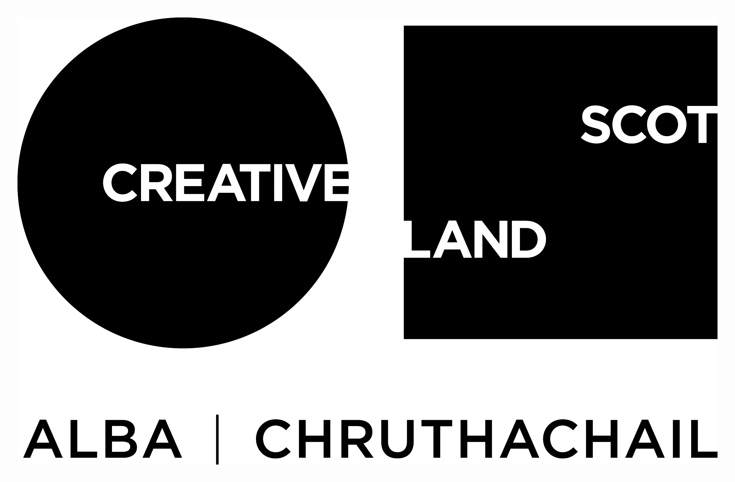
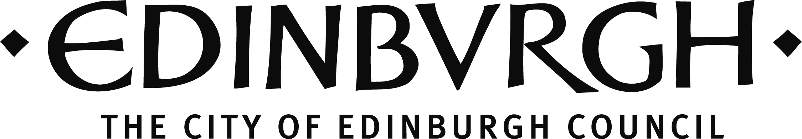

Traverse Theatre (Scotland) is a Limited Company (Registered Number SC 076037) and Scottish Charity (Registered Number SC 002368) with its Registered Office at 10 Cambridge Street, Edinburgh, Scotland, EH1 2ED.

