FOR IMMEDIATE RELEASE: 17 July 2019
Contact: Anna Docherty, Press and Media Officer
anna.docherty@traverse.co.uk / press@traverse.co.uk
Direct: 0131 659 7115

TRAVERSE THEATRE SIGNALS NEW APPROACH BY RECRUITING
FOR TWO NEW ARTISTIC LEADERSHIP POSITIONS

- Recruitment underway for Artistic Director, Traverse Theatre Company and Director of Creative Development

- Artistic Director responsible for creating and delivering an ambitious artistic programme of new works to excite and inspire audiences

- Director of Creative Development responsible for developing and delivering creative learning, community engagement, and talent development programmes

- New structure will bolster the Traverse’s vibrant artistic programme and development of pathways into the theatre for new artists and audiences

The Traverse Theatre will make two new senior hires this year as the Edinburgh institution evolves a fresh approach to its work as a leading voice for the arts in Scotland and beyond.

After a period of consultation with staff, partners and other external stakeholders, Scotland’s new writing theatre is reshaping its senior team by recruiting for two leadership positions: Artistic Director, Traverse Theatre Company and Director of Creative Development.

The changes are intended to ensure the Traverse Theatre gives due focus to its twin priorities of creating an ambitious artistic programme for Scotland’s new writing theatre that celebrates new work in all its forms; and developing creative development and community engagement programmes that bring new and essential voices to the theatre’s stages.

Linda Crooks, Executive Producer, says:
“The Traverse Theatre is evolving. As we approach our sixth decade, we want to amplify new voices and to reach new eyes and ears with the work we produce and present. To achieve that, we need to respond to the changing world around us and open up new pathways for people to come to the theatre, both as writers and as audience members.

“The Director of Creative Development role has been created to ensure we devote increased time and effort in strengthening these pathways by nurturing our relationships with a diverse range of communities and individuals, both here in Scotland and further afield. We believe that creativity is an attribute we all have and that everyone should be given the opportunity to explore their artistic talents.

“In creating a new role which has ultimate responsibility for that work, we will in turn enable and empower our new Artistic Director, Traverse Theatre Company, to focus exclusively on overseeing a new writing programme that delivers on our ambitious artistic vision for the Traverse over the next five years and beyond.

“The people we appoint to these two roles will be joining a passionate, talented and determined team that has been instrumental in shaping the new structure and is eagerly awaiting this next phase in our growth.”

Sir John Elvidge, Chair of the Traverse Theatre Board, says:
“The Traverse has always been a leader and innovator in theatre, and the creation of these new positions will allow us to develop new approaches to working with artists and audiences to ensure that we continue to break new ground in the future.

“Championing new writing is a high risk, high stakes business. It is our purpose to make audiences think, to provoke essential debate, and to push boundaries – and we will always endeavour to give oxygen to stories that do this.

“The Traverse is so much more than the bricks and mortar of the building we occupy. We are a truly collaborative enterprise which relies on our ability to harness the diverse talents of as many different individuals, groups and communities as possible.

“We are eager to further increase the representation of voices which reflect modern Scotland both domestically and internationally and look forward to meeting applicants who share this drive and are keen to join our passionate team.”

Notes of interest for both roles close on Friday 9 August. Click here to access the recruitment packs for Artistic Director, Traverse Theatre Company and Director of Creative Development.

For more information or images, contact press@traverse.co.uk

-ENDS-

The Traverse Theatre is supported by:
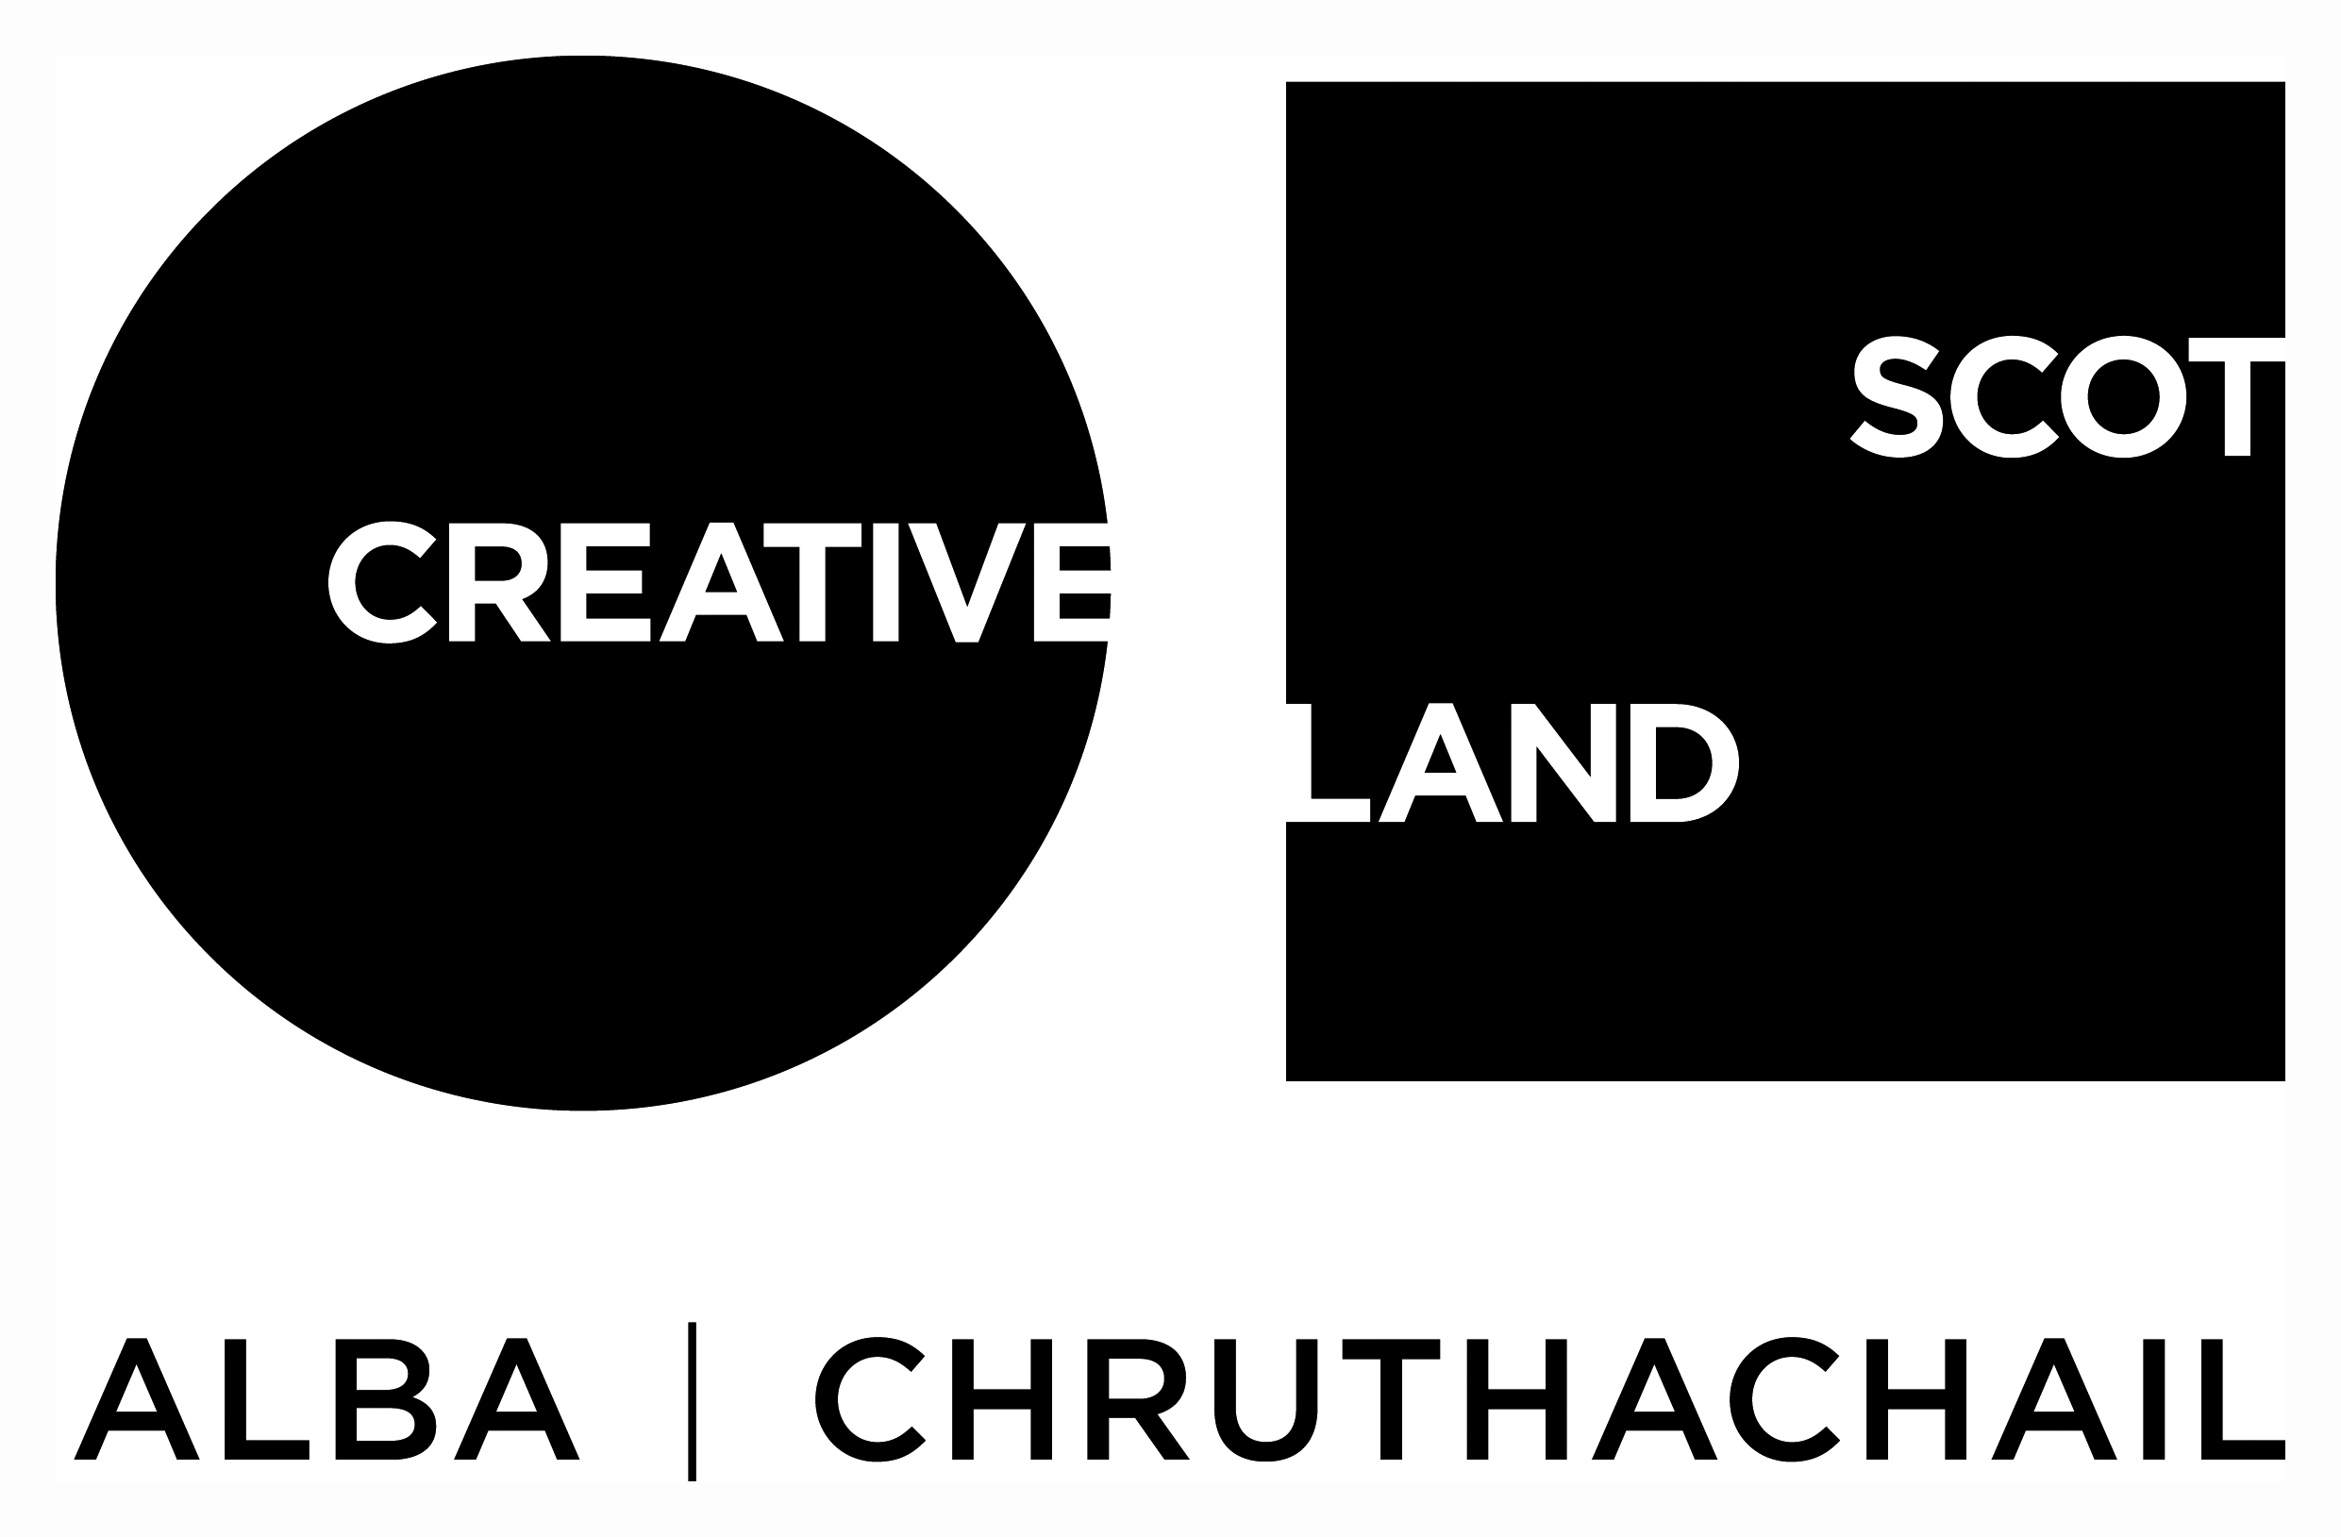

Traverse Theatre (Scotland) is a Limited Company (Registered Number SC 076037) and Scottish Charity (Registered Number SC 002368) with its Registered Office at 10 Cambridge Street, Edinburgh, Scotland, EH1 2ED.

