FOR IMMEDIATE RELEASE: 29 November 2019
Contact: Anna Docherty, Press and Media Officer
anna.docherty@traverse.co.uk / press@traverse.co.uk
Direct: 0131 659 7104

TRAVERSE THEATRE ANNOUNCES SPRING 2020 SEASON (JANUARY-APRIL) AND LAUNCHES £1 TICKETS SCHEME FOR YOUNG PEOPLE AND THOSE IN RECEIPT OF ALLOWANCES

- New £1 Tickets scheme makes theatre more accessible to under 25s and those in receipt of a range of allowances

- Traverse Theatre Company present the world premiere production of Rona Munro’s Donny’s Brain

- Award-winning sensation Mouthpiece returns for a limited run prior to worldwide touring

- Extended eight-play season of lunchtime favourite A Play, A Pie and A Pint

- Tickets on sale now

Traverse Theatre Company

With a commitment to making theatre accessible to all, in 2020 we are launching a new £1 Tickets scheme. A new ticketing initiative, which was piloted throughout 2019, to welcome people from groups and communities who might not be aware of our work, or who may not otherwise have access to theatre – available to Under 25s and those receiving Job Seeker's Allowance, Employment Support Allowance, Universal Credit or Carer’s Allowance. Tickets are available for all Traverse Theatre Company productions and co-productions (and most visiting company shows, too), across the entire run of a show. With that in mind, we look ahead to next year and reveal the full January-April 2020 season.

First up is Traverse Theatre Company’s gripping hit about class, culture and appropriation – Mouthpiece (6-15 Feb), by Kieran Hurley – which returns following a sold-out run at Traverse Festival 2019, where it won the prestigious Carol Tambor Best of Edinburgh Award facilitating a New York transfer. It then goes on to tour to Tron Theatre, Glasgow (26-29 Feb); Adelaide Festival, Australia (6-14 Mar); and Auckland Arts Festival, New Zealand (19-28 Mar).

The ever-popular A Play, A Pie and A Pint, Òran Mór (presented by Traverse Theatre) season returns with an extended run of eight shows, taking in Infernal Serpent (31 Mar-4 Apr) by David Gerow; Celestial Body (7-11 Apr) by Morna Pearson; Rose (14-18 Apr) by Lorna Martin; The Storm (21-25 Apr) by Owen Whitelaw; Exquisite Corpse (28 Apr-2 May) by Conor O’Loughlin – which was presented script-in-hand at the Traverse’s inaugural First Stages Festival of new talent in November 2019; Mary and Ada Set the World to Rights (5-9 May) by Jane Livingstone; Silver Superheroes (11-16 May) by Morna Young; and Milkshake (18-23 May) by Rob Drummond. Ticket price includes a pie and a drink.

Rounding off the season as a whole is the Traverse Theatre Company world premiere of Donny’s Brain (14 Apr-2 May. Delving into the eternal mystery of the human brain, this dynamic and visually striking production follows Donny and Emma on a funny and moving journey as all they know about love and loss is thrown into question.

Visiting Company productions

January

The first visiting company production of the season is Mary Jane Wells and Scottish Theatre Producers’ Heroine (30 Jan-1 Feb). Written and performed by Wells, it tells the true story of US soldier and survivor of military sexual trauma, Danna Davis, with grit, lyricism and necessary black humour. Both performances will be followed by a post-show discussion with a curated panel of military, legal and survivor advocate experts.

February

February opens on a comedic note with a one-night-only performance of Stephen Bailey’s Can’t Be Bothered (1 Feb), in which the comedian and renowned gossip takes in a bit of storytelling, some inappropriate anecdotes and more sincerity than he’s ever dared before.

Next up, Tandem Writing Collective (7 Feb) playwrights Jennifer Adam, Amy Hawes and Mhairi Quinn present a taster of five topical new scripts and live music, performed script-in-hand by local actors, and featuring talented new directors.

Acclaimed theatre company LUNG (in association with Leeds Playhouse) present bold documentary theatre piece Trojan Horse (11 & 12 Feb), written by Helen Monks and Matt Woodhead (who also directs) – tackling a local story that hit the national press, of Muslim teachers and governors who were accused of plotting extremism in Birmingham schools, adapted from the real-life testimonies.

Shift Theatre Company return with another batch of Pride Plays (14 & 15 Feb), Scotland’s first ever LGBTQI+ playwright festival – giving the stage to the voices of a community who still feel underrepresented in Scottish theatre. Part of LGBT History Month Scotland. Both performances will be followed by a post-show discussion.

Traverse regulars Scottish Dance Theatre return with Antigone, Interrupted (20-22 Feb) by Joan Clevillé – an intimate solo work marking Clevillé’s first creation as Artistic Director of Scottish Dance Theatre. Together with performer Solène Weinachter, it re-imagines the classic story for a contemporary world through the body and voice of a single performer.

Another returning face (last here with Twa), Annie George presents Home is Not the Place (21 & 22 Feb) – contrasting the remarkable story of the short life and lost work of her grandfather, Kerala poet PM John shortly before India’s independence, with her own, as an immigrant in the UK. Featuring music by Niroshini Thambar and visuals by Lorna Simpson and Jacqueline Matisse.

The Dynamite Club (in association with The Secret Actors Company) present Nan Shepherd: Howling at the Machine (26 & 27 Feb), written and directed by Erlend Clouston – an animated lecture on Nan Shepherd, the author of The Living Mountain. It features Fats Waller, Jefferson Airplane, Sigmund Freud, Mount Everest, and more, plus the voices of Björk, Tilda Swinton, Karine Polwart and Gerda Stevenson.

Northern Stage, in co-production with The Young’uns and Harbourfront Centre Toronto, present a musical celebration of northern working class activism, as Teesside folk trio The Young’uns perform a new, theatrical version of The Ballad of Johnny Longstaff (27-29 Feb), featuring songs from the original album alongside new material and animation.

Rounding off February, and making us thankful it’s a leap year, is the Scottish premiere of W*ank Buddies (29 Feb), by Jake Jarratt and Cameron Sharp (in association with Live Theatre), which debuted to sell-out audiences at Elevator Festival 2019. Written and performed by Jarratt and Sharp, it touches on themes of identity, class, sexuality and masculinity to ask, what are boys really made of?

March

March opens with the world premiere of Scottish Ensemble and Untitled Projects’ (in association with Perth Theatre, Horsecross) We Are In Time (3 & 4 Mar), written by Pamela Carter. It tells the extraordinary story of a transplanted heart, through song, words and a visionary new live score for strings and electronics by Icelandic composer Valgeir Sigurðsson.

Next up, In The Works present poet Ellen Renton’s new spoken word theatre show – Within Sight (5 & 6 Mar) – a one-woman performance on disability, running and the Paralympics, confronting ableism within our society. In Traverse 1 the same week, acclaimed family theatre company Red Bridge Arts present a contemporary retelling of Frances Hodgson Burnett’s literary favourite The Secret Garden (6 Mar), adapted and directed by Rosalind Sydney for everyone aged six-plus.

To be enjoyed individually, or as a trilogy, Tangram Theatre Company stage a takeover of the Songs of Friendship works by James Rowland – Team Viking (11 Mar); A Hundred Different Words for Love (12 Mar); Revelations (13 Mar), and as a trilogy (14 Mar). Written and performed by Rowland, they combine story, comedy, music and song in a revelatory storytelling cycle about love, life, friendship and death.

Ex-girlfriends Mary Higgins and Ell Potter asked women and trans people aged 11 to 97 what makes them sweat, flush and gush. They made a sweaty verbatim dance party out of the answers. Following a sell-out run at London’s Soho Theatre, HOTTER Project and Ellie Keel Productions’ HOTTER (12 & 13 Mar) launches arse-first in our direction.

A world premiere of breathtaking proportions, Theatre Gu Leòr with WHYTE (in association with Tron Theatre) present MAIM (17 & 18 Mar) Translated as ‘Panic’ in Gàidhlig, it is a call to arms, giving voice to the frustrations of the next generation who care deeply about the connection between their land and language.

March also features the Scottish premiere of Third Angel’s co-production with Northern Stage (in association with Sheffield Theatres) – The Department of Distractions (19 & 20 Mar). Written by Third Angel Co-Artistic Director Alexander Kelly with Stacey Sampson and the Company, it promises a conspiracy-theory documentary-exposé detective story for the 21st century.

The producers of the critically-acclaimed good dog, tiata fahodzi, and Wrested Veil in association with Leeds Playhouse, Soho Theatre and Tara Finney Productions present seeds (20 & 21 Mar) – an exploration of the human story of a fatal stabbing, told through the eyes of those left behind. Shortlisted for the Alfred Fagon Award.

Rounding off March is the return of NT Connections (24-28 Mar) – a yearly celebration of young people, theatre-making and the importance of access to the arts, for which the National Theatre commission ten new plays for young people to perform.

April

Into April, Franz Kafka’s influential, tragicomic novella The Metamorphosis (1-4 Apr) is brought to life in an international co-production between Vanishing Point, Emilia Romagna Teatro Fondazione and Tron Theatre. Adapted and directed by Matthew Lenton, it’s the story of an ordinary man who wakes up to find he has been transformed into a giant insect.

Edinburgh College’s Performing Arts Studio Scotland, the leading provider of performing arts education in Scotland, return to the Traverse with their end of year showcase – Pass Out 2020 (22 Apr) – this time creating new pieces on the theme of ‘dirt’. And regular staple Soundhouse returns with its usual stellar calendar of acclaimed weekly Monday (and the occasional Sunday, and even one Friday!) gigs in the Traverse Bar Café (13 Jan-26 Apr).

LISTINGS:
Traverse Theatre, Edinburgh, EH1 2ED
Tickets on sale now: 0131 228 1404 and online at www.traverse.co.uk

-ENDS-

The Traverse Theatre is supported by:
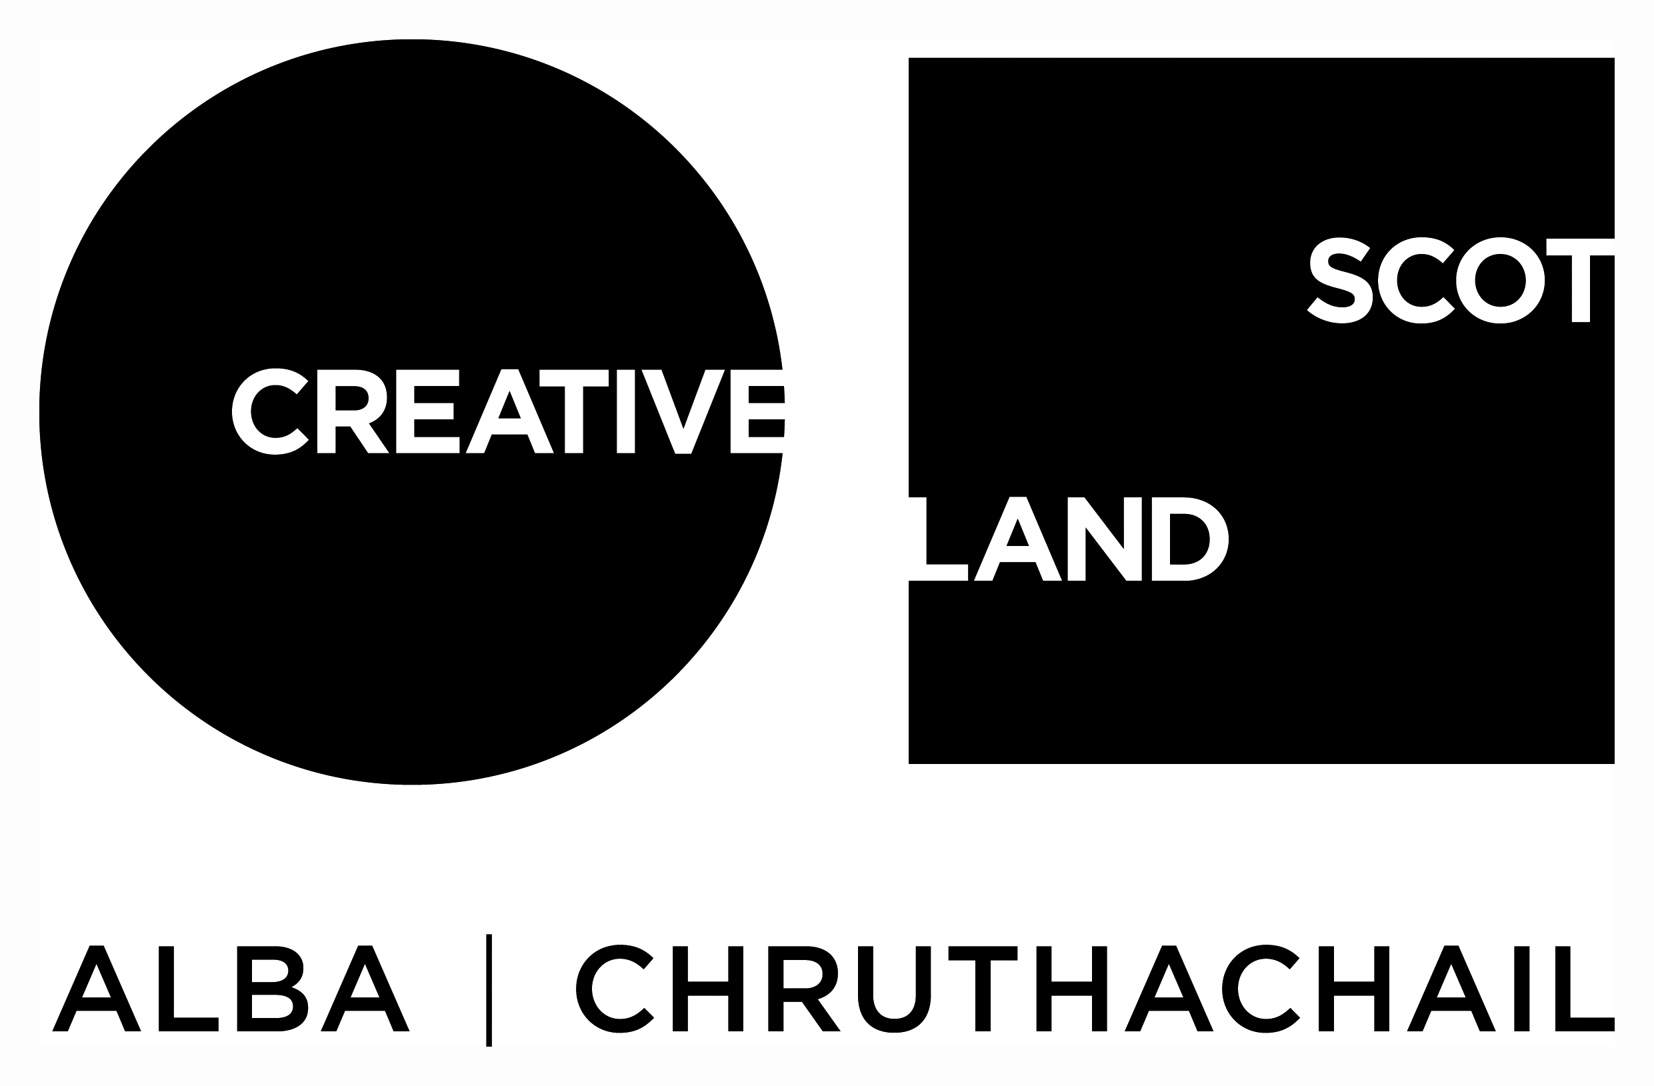
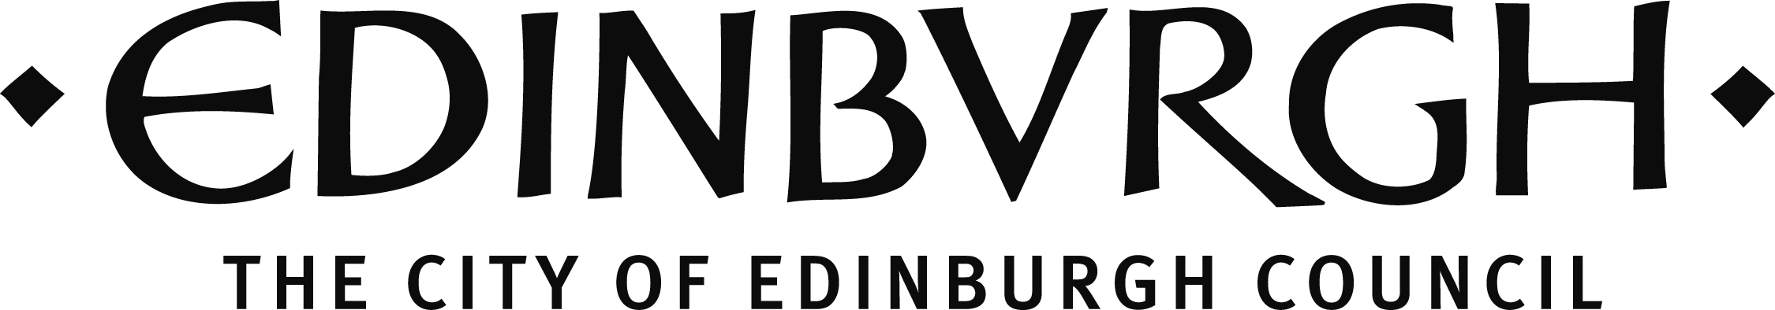

Traverse Theatre (Scotland) is a Limited Company (Registered Number SC 076037) and Scottish Charity (Registered Number SC 002368) with its Registered Office at 10 Cambridge Street, Edinburgh, Scotland, EH1 2ED.

