FOR IMMEDIATE RELEASE: 29 March 2019
Contact: Anna Docherty, Press and Media Officer
anna.docherty@traverse.co.uk / press@traverse.co.uk
Direct: 0131 659 7104

TRAVERSE THEATRE COMPANY CELEBRATES RECORD-BREAKING SPELL OF TOURING

- During March-June, Traverse Theatre Company tours five homegrown productions to 15 different locations, in four continents

- Ulster American in Australia, New Zealand, Ireland and Northern Ireland; What Girls Are Made Of in Scotland, Brazil, USA; Black Beauty in USA; Mouthpiece in England; Locker Room Talk in Scotland

- 112 performances in 15 different locations over 51 days

- Plus, we continue our partnership with Rage Productions, Mumbai with an international exchange project

The Traverse Theatre is excited that March-June 2019 will mark a record breaking spell of touring for the company – with five homegrown full productions touring to 15 different locations, in four continents, totaling 112 individual performances over 51 days. During that period, over one busy day – 17 April – we will have four productions playing in four different locations simultaneously.

Following a reprised sell-out run at the Traverse in February this year, and a follow-on tour to Adelaide Festival and Auckland Arts Festival during March, the award-winning Traverse Festival 2018 hit Ulster American continues its reign with dates in Dublin (The Abbey, 9-20 April) and Belfast (Lyric Theatre, 24-28 April). Written by David Ireland, it brutally and hilariously explores abuses of power, confusions of cultural identity and the silencing of the female voice, performed by the much-praised original cast of Darrell D’Silva, Robert Jack and Lucianne McEvoy. Directed by Traverse Interim Artistic Director Gareth Nicholls.

Meanwhile, Mouthpiece – Kieran Hurley’s gripping, provocative and critically-acclaimed smash hit exploring issues of class and culture – transfers to London (Soho Theatre, 2 Apr-4 May), following a sell-out run at the Traverse in December 2018. Produced in association with HighTide, it is reprised by the stellar original cast of Lorn Macdonald and Neve McIntosh, under the direction of former Traverse Artistic Director Orla O’Loughlin.

Another Traverse Festival 2018 sell-out, the award-winning gig theatre epic What Girls Are Made Of, our co-production with Raw Material, tours to Glasgow (Citizens Theatre at Tramway, 9-13 April); Edinburgh (Traverse Theatre, 16-20 April); Belfast (The MAC, 1-5 May); Kirkcaldy (Adam Smith Theatre, 7 and 8 May); Dundee (Dundee Rep, 14 and 15 May); Stirling (Macrobert, 17 and 18 May); Brazil (Cultura Inglesa Festival, 24-26 May); and Charleston, USA (Spoleto Festival, 4-8 June). Made in association with Regular Music, it charts writer/performer Cora Bissett’s rollercoaster autobiographical journey from indie-kid hopeful to wised-up woman. Performed with live backing band actor/musicians Susan Bear and Simon Donaldson, plus the new addition of Harry Ward. Directed by Orla O’Loughlin.
Off the back of overwhelming response from previous performances including Traverse Festival 2017; Latitude Festival; and a one-off invited presentation at the Scottish Parliament, Locker Room Talk embarks on a Scottish tour to Dundee (Dundee Rep, 17 April); Stirling (Macrobert, 18 April); Aberdeen (Lemon Tree, 19 April); Edinburgh (Traverse Theatre, 23 and 24 April); and Glasgow (Tron Theatre, 25-27 April). Created by Traverse Associate Artist Gary McNair, it is a provocative piece of event theatre continuing a vital conversation about misogyny and masculinity, with four female actors performing, verbatim, the words of men. The cast will feature previous performers Jamie Marie Leary and Maureen Carr, plus two actors new to the piece – Nicola Roy and Gabriel Quigley. Each performance is followed by a post-show discussion. Directed by Orla O’Loughlin.
Lastly, the CATS award-winning Black Beauty, produced with Red Bridge Arts, heads to Los Angeles (Wallis Annenberg Center for Performing Arts, 26 April-5 May), following last year’s acclaimed run in New York City, and follow-on tour of the UK and Ireland. Created by Andy Manley, Andy Cannon and Shona Reppe, this award-winning re-telling of the classic tale blends storytelling, music and puppetry to fun and poignant effect.

In addition to the bounty of touring productions, this April will also see the Traverse continue its international partnership with Rage Productions in Mumbai – where our flagship education project, Class Act, toured in 2018. We will be collaborating on a programme of activity exploring international exchange in creative process, kicking off with a creative residency in Mumbai during April, followed by an artist exchange project in summer 2019.

The Traverse’s Executive Producer, Linda Crooks, says:
‘We’re extremely proud to have so many productions touring simultaneously around the world during such a short period. It is a great success story for the Traverse Theatre Company and everyone involved – the artists, creative teams and production staff who’ve contributed to making these productions the huge hits they have proved to be. The speed with which these shows have transferred internationally speaks of the Traverse Theatre Company’s ambition to create essential new plays which speak directly to important issues in global society, as well as resonate with, and thoroughly entertain, audiences wherever they are performed.’

Notes to Editors

Press requests:
For more information, press releases or images, contact anna.docherty@traverse.co.uk. The Traverse’s Executive Producer, Linda Crooks, is available for interview upon request.

LISTINGS:
Mouthpiece
Soho Theatre, London: 2 April-4 May

Ulster American
The Abbey, Dublin: 10-20 April
Lyric Theatre, Belfast: 24-28 April

What Girls Are Made Of
Citizens Theatre at Tramway, Glasgow: 9-13 April
Traverse Theatre, Edinburgh: 16-20 April
The MAC, Belfast: 1-5 May
Adam Smith Theatre, Kirkcaldy: 7 & 8 May
Dundee Rep, Dundee: 14 & 15 May
Macrobert, Stirling: 17 & 18 May
Cultura Inglesa Festival, Brazil: 24-26 May
Spoleto Festival, Charleston, USA: 4-8 June

Locker Room Talk
Dundee Rep, Dundee: 17 April
Macrobert, Stirling: 18 April
Lemon Tree, Aberdeen: 19 April
Traverse Theatre, Edinburgh: 23 & 24 April
Tron Theatre, Glasgow: 25-27 April

Black Beauty
Wallis Annenberg Center for Performing Arts, Los Angeles: 26 April-5 May

The Traverse Theatre is supported by:
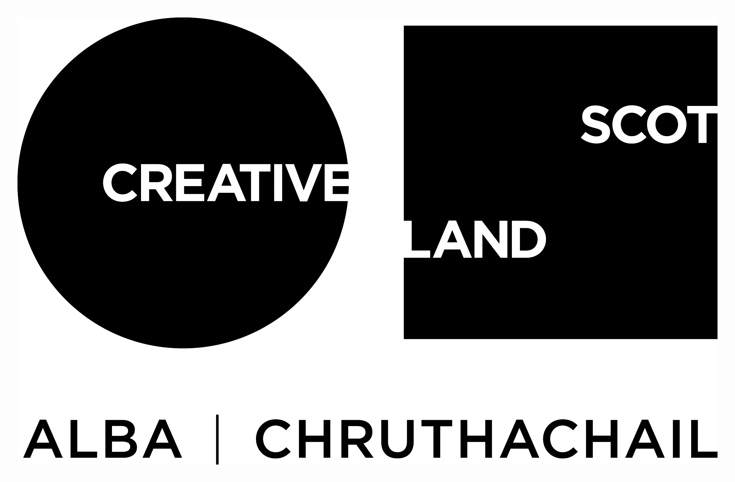

Traverse Theatre (Scotland) is a Limited Company (Registered Number SC 076037) and Scottish Charity (Registered Number SC 002368) with its Registered Office at 10 Cambridge Street, Edinburgh, Scotland, EH1 2ED.

-ENDS-

