FOR IMMEDIATE RELEASE: Mon 17 August
Contact: Victoria Murray, Head of Brand and Audience
victoria.murray@traverse.co.uk / press@traverse.co.uk

TRAVERSE THEATRE HITS “RESET”
WITH FESTIVAL PROGRAMME

- TRAVERSE TRANSFORMS TO EMBRACE CHANGE
AND NEW DIGITAL OPPORTUNITIES

- LAUNCHES TRAVERSE 3 - A NEW ONLINE VENUE PREMIERING
URGENT WORK FROM SCOTLAND AND AROUND THE WORLD
- IN THE SPIRIT OF ITS FOUNDING, TRAVERSE FESTIVAL 2020
EXTENDS PROGRAMME OF EVENTS YEAR ROUND
- BRINGS THE BEST OF NEW WRITING DIRECTLY FROM EDINBURGH AND BEYOND TO A GLOBAL AUDIENCE FOR THE FIRST TIME
- FIRST FESTIVAL PRODUCTIONS AVAILABLE FROM 24 AUGUST
WITH MORE TO FOLLOW IN LATER WEEKS AND MONTHS

The Traverse Theatre was founded with the hope of carrying the spirit of Edinburgh’s Festivals throughout the year– and in 2020 we have been inspired by our past to create a new future as we announce the launch of Traverse 3, our new online venue, and the extension of its Traverse Festival programme throughout the rest of the year.
The Traverse’s website will be transformed into Traverse 3 - joining our physical performance spaces Traverse 1 and 2 - and present a continually refreshed programme of cutting-edge productions, immersive stories and political discussions, which can be experienced and contributed to by audiences everywhere.
Where August would usually mark the world coming to the Traverse, this year the Traverse takes its programme directly to audiences around world for the first time in its history.
Brand new pieces have been commissioned for Traverse 3, which will be presented alongside stage productions reimagined to be enjoyed as films, podcasts, audio plays or performed recordings. Open access scripts, conversations and provocations, relayed live from the Traverse’s physical spaces in Edinburgh and across the country, will enable audiences to create their own work, unleashing their creativity and becoming creative contributors wherever they may be.
The online space of Traverse 3 will remain live and active as a permanent part of the Traverse’s cultural offering. It will be a centre of creative excellence, presenting bold, provocative and innovative work that puts audiences at its heart, throughout 2020 and beyond.
The first productions available as part of the Traverse Festival are:
- Declan directed by Lorn Macdonald with original text from Mouthpiece by Kieran Hurley
- Shielders by Matilda Ibini, Directed by Debbie Hannan
- Breakfast Plays: New Tracks
Contemporary Political Ethics (or, How to Cheat) by Jamie Cowan, Directed by Gareth Nicholls
Rabbit Catcher by Rebecca Martin, Directed by Gareth Nicholls
Matterhorn by Amy Rhianne Milton, Directed by Debbie Hannan
The Watercooler by Uma Nada-Rajah, Directed by Debbie Hannan
Doomsdays by Conor O'Loughlin, Directed by Debbie Hannan
- Removed by Fionnuala Kennedy, Directed by Emma Jordan
- Shedinburgh produced by Francesca Moody, starring various acts

And our participatory programme includes:
- Happenings produced by the Traverse
- Positive Stories for Negative Times by Wonder Fools in association with the Traverse Theatre
- Open Submissions Workshops produced by the Traverse
- Traverse Young Writers produced by the Traverse, led by Hannah Lavery
Details of all events are included below. They are available to browse now and most productions can be experienced from 10am on Monday 24 August.
All video events will be fully captioned and transcripts will be made available for all audio-only works. All events can be paused, rewound and rewatched as audiences choose, meaning each production offers a more relaxed viewing or listening option for those who would prefer.
Executive Producer, Linda Crooks, says:
“Unlocking the virtual doors of Traverse 3, and stepping into all the possibilities it presents, marks an important shift in how we respond to both our ‘now’ and our future. It is a huge opportunity for us to remove many access barriers and make our work the most democratic and inclusive it has ever been, both in terms of who we work with and who experiences what we create. We have always welcomed the world to our venue, in August especially, and in recent years have been able to share our work in selected international locations – but now we can bring the Traverse, and all of the incredible creativity with which we work, to the world.
We are delighted and grateful to be working with so many partner companies and members of the freelance community in creating the programme, including many who are making their Traverse Theatre debuts. I would like to use this opportunity to thank them and everyone who has been involved for embracing huge change to realise something that seemed impossible only a few months ago.
We also wish to also thank our incredibly loyal audiences who have been so supportive throughout the last few months, as well as our regular funders – we hope that they, and many more, enjoy the fantastic programme of digital Festival activity we have planned.”

WHAT’S UP FIRST IN THE TRAVERSE FESTIVAL PROGRAMME
The following performances and events will be available to experience from Monday 24 August.
A viewing link for members of the media only will be issued to you on Monday 24 August.
DECLAN directed by Lorn Macdonald with original text from Mouthpiece by Kieran Hurley
Traverse Theatre Company, co-commissioned with the Edinburgh International Festival
WORLD PREMIERE
Available 24-30 Aug
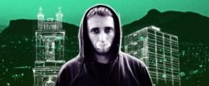
Declan is a brand new take on the Traverse Theatre’s 2019 Festival hit production Mouthpiece, about class, culture and appropriation.
Exploring the play’s central character through performance, Declan blends footage filmed in real Edinburgh locations and through performance, sound, cinematography and animation, places the audience firmly in Declan’s shoes, to see Edinburgh as he experiences it.
Frank, unflinching and filled with unexpected humour, Declan is an exhilarating and immersive film. It wrenches the spotlight away from those doing the talking, to those being talked about, and demands attention - on their own terms.
Declan performed by Lorn Macdonald and Angus Taylor; Sound design and composition by Kim Moore; Animation by Nisan Yetkin; Sound engineering by David McMillan; Camera operation by Matthew Bunting; Drone operation Airpunk.
Find out more
SHIELDERS by Matilda Ibini
Directed by Debbie Hannan
Traverse Theatre Company
WORLD PREMIERE
Available 26 Aug – 1 Sep
Shahbaz, Zira and Trice have been in lockdown in Glasgow for months, spending their days on the phone to each other whilst searching the skies for sightings from another planet. Now, though the world is opening up, Shahbaz must stay in his shielding bubble as Zira and Trice head back into the outside world and their ‘real’ lives, losing interest in hunting for answers amongst the stars.
But for Shahbaz his ‘normality’ starts to take a toll, and some new friends pay him a visitation...
A new digital play by Matilda Ibini (Little Miss Burden) and directed by Debbie Hannan (The Panopticon), Shielders is influenced by Afrofuturism and classic sci-fi movies, taking a unique look at the very alien world we now find ourselves in and its impact on those who still find themselves on the inside, looking out.
Performed by Michael Ahomka-Lindsay, Danielle Fiamanya, Laura Lovemore; Video design by Lewis den Hertog; Sound design by Mwen.
Find out more
BREAKFAST PLAYS: NEW TRACKS
Traverse Theatre Company
WORLD PREMIERE
Available 24 Aug - Fri 11 Sep
Traditionally taking place at 9am during the Traverse Festival, the Breakfast Plays are a key element of the Traverse’s creative development programme for writers, bringing brand new short plays by early career writers to the world and showcasing the best, new Scottish writing talent to the international audiences who flock to Edinburgh in August.
This year's Breakfast Plays each tackle what happens after an earth-shattering event occurs, and have been specially written and recorded as podcast plays so audiences around the world can collectively enjoy the world premiere of these short plays in their own unique setting, be it at home, on the beach or atop a lofty peak.
CONTEMPORARY POLITICAL ETHICS (OR, HOW TO CHEAT) by Jamie Cowan
Directed by Gareth Nicholls
A failed politician and carer are showing Kev, a young lad on academic probation, the in’s and out’s of running a polling station. The splendour of democracy in action! Except no one’s coming to vote, so there isn’t much in the way of action, that is, until they discover a forgotten ballot on the floor.

Performed by Robbie Jack, Bhav Joshi and Anna Russell-Martin; Sound design by Kim Moore; Sound engineering by Richard Bell; Dramaturgy by Eleanor White.

Find out more

RABBIT CATCHER by Rebecca Martin
Directed by Gareth Nicholls

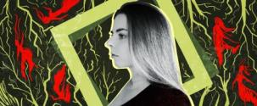

Dead in the woods, Ren of Ord clears her windpipe of soil, earth and rot. Sworn to enact vengeance, she rises to protect her land and her sisterhood from the fate that befell her that day upon the hill. Rabbit Catcher is a lyrical, mythical lore set within the dark, dense woods of Ord Hill, Inverness.

Performed by Karen Fishwick, Reuben Joseph and Anna Russell-Martin; Sound design by Oğuz Kaplangı; Sound engineering by Richard Bell; Dramaturgy by Eleanor White.

Find out more

MATTERHORN by Amy Rhianne Milton
Directed by Debbie Hannan

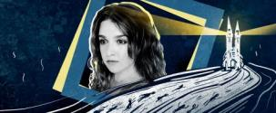

A cathedral at the edge of time, at the end of the world. A few hundred cling to life within its thick, safe walls. Humanity’s final outpost. The cathedral bells ring out in the hopes of finding more lost souls to bring to sanctuary, but is there anyone actually left to save?

Performed by Karen Fishwick, Helen Katamba and Laura Lovemore; Sound design by Kim Moore; Sound engineering by Richard Bell; Dramaturgy by Eleanor White.
Find out more

THE WATERCOOLER by Uma Nada-Rajah
Directed by Debbie Hannan

Two co-workers meet in the staff room of a non-descript corporate office. As one colleague struggles with current events across the Atlantic hitting home, the other is tasked with assessing her mental fitness. Uma Nada-Rajah’s The Watercooler addresses racism with a searing streak of surrealism.

Performed by Laura Lovemore and Anna Russell-Martin; Sound design by Mwen; Sound engineering by Richard Bell; Dramaturgy by Eleanor White.

Find out more

DOOMSDAYS by Conor O’Loughlin
Directed by Debbie Hannan

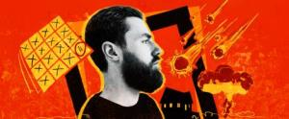

21st December 2012, the day the world was meant to end. The day a cult leader’s apocalyptic predictions failed. Faye and Felix devoted themselves to a doomsday that didn’t come and now, having seen the world get continually worse over the past nine years, they’re confronting their former leader with their findings.

Performed by Robbie Jack, Helen Katamba and Laura Lovemore; Sound design by Oğuz Kaplangı; Sound engineering by Richard Bell; Dramaturgy by Eleanor White.

Find out more
REMOVED by Fionnuala Kennedy
Directed by Emma Jordan
Prime Cut Productions
Available until 24-30 Aug
A sell-out hit at Belfast Children’s Festival, Baboro Festival and Dublin Theatre Festival, Removed is the funny, poignant and affecting story of Adam that offers a glimpse into the unknown experiences of growing up as a ‘Looked After’ child.

“Adam is OK to share his story - really it's alright - it's OK that his life was turned upside down - and the social workers were nice, kinda - and the foster homes, well...”

Removed is based on an amalgam of the many interviews gathered by Fionnuala Kennedy, with Voice of Young People in Care.

Performed by Conor O’Donnell; Set design by Ciaran Bagnall; Lighting design by Paul Keogan; Audio visual design by Conan McIvor; Composing by Conor Mitchell.

Find out more

SHEDINBURGH by Various artists
Francesca Moody Productions in association with Popcorn Group
Final performance, 7.30pm on Sat 5 Sep
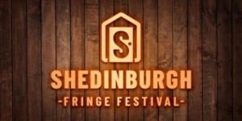
Celebrating and sustaining the best of the Edinburgh Festival Fringe in sheds!
Shedinburgh Fringe Festival is a brand new online festival presenting the very best of the Fringe stalwarts of theatre, music and comedy, and the best new acts, all performed live from sheds across the country and streamed into people’s homes this August.
Shedinburgh will take place between 14 August – 5 September with daily livestreamed events including ‘one night only’ performances from established Fringe favourites, slots for new artists through Open Call Submissions and industry panel discussions.
Find out more

PARTICIPATORY PROGRAMME
Throughout the lockdown period, the Traverse has been continuing to connect people with theatre and the arts, dedicating vital space to develop the talents of early career writers as they forge new pathways in their practice. We want to extend our invitation to audiences and writers around the world to learn, converse and be inspired by the individual and collective power of creativity.

HAPPENINGS
Traverse Theatre Company
The Traverse Theatre Bar is renowned as a space where important and impassioned conversations happen all year round, bringing artists and audiences together to discuss difficult issues and create fresh visions for the future.
Traverse Festival Happenings capture the spirit of these conversations, bringing them online - and onto the streets. Delivered in partnership with the Institute for Advanced Studies in the Humanities at the University of Edinburgh, Happenings are a series of curated artistic interventions, events, and discussions responding to the urgent question of the role of culture in society, who has voice through it and who owns the stories told.
Expect provocations from artists, academics, cultural experts, political representatives and young Edinburgh residents, Traverse Happenings will open up the conversation across the city, the nation and the globe.
The full schedule of Happenings events will be published soon.
Find out more

POSITIVE STORIES FOR NEGATIVE TIMES by Robbie Gordon & Jack Nurse, Stef Smith, Sabrina Mahfouz, Bea Webster and Chris Thorpe
Presented by Wonder Fools in association with the Traverse Theatre
Available from 26 Aug
Positive Stories for Negative Times is a response to the lack of physical spaces for young people to participate in creative activities due to the pandemic, and the detrimental impact that this is having on their mental health and wellbeing.

A national project featuring some of the UK’s most exciting voices in playwriting; Sabrina Mahfouz, Stef Smith, Chris Thorpe and Bea Webster join Wonder Fools’ own Robbie Gordon and Jack Nurse, pick up the mantle to create brand-new work that will then be gifted to communities around the UK, and then, internationally. A huge range of community groups, schools and youth theatres will be invited to sign up to turn the new writing into online performances. Working with those from isolated areas, to marginalised groups and vulnerable young people these new plays will be theirs to interpret in whichever creative way keeps them safe from the risks that come with the COVID-19 pandemic.

Wonder Fools will provide a framework of how to rehearse, direct and record the works, with specific guidance on how to deliver the project in total lockdown, through blended learning or completely live in the space. All performed plays will be uploaded and hosted on a bespoke platform - positivestories.scot - accessible anywhere in the world.

Find out more

OPEN SUBMISSIONS WORKSHOPS
Traverse Theatre Company
Available until Sep 2021
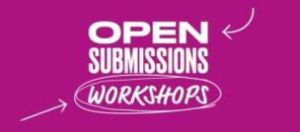
This free 16-week course delivered in video and podcast form led by playwrights and theatremakers supports aspiring writers to unleash their creativity, taking them from idea to draft.
Tutors include Debbie Hannan, Gareth Nicholls, Matilda Ibini, Natasha Sutton Williams, Julia Taudevin, Hannah Lavery and Meghan Tyler, and cover topics including writing dialogue, building dramatic tension, writing for self performance, representing working class voices, and writing with and representing disability.
Writers are encouraged to use these workshops to create a play to submit to the Traverse’s Open Submissions window, which opens on 1 September until 31 October.
Find out more

TRAVERSE YOUNG WRITERS SCRATCH PERFORMANCES
Traverse Theatre Company
Available until May 2021
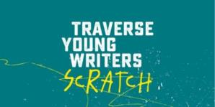
When the lockdown was announced our Traverse Young Writers Group were about to begin their weekly tuition from acclaimed playwrights, culminating in the presentation of their work on stage at the Traverse. Our plans were quickly reimagined with workshops and the performances moving online.
These brand new pieces from 9 of our Young Writers, directed remotely and with performers filming in their own homes under lockdown conditions, are available to watch online.
The writers featured are Bluey Little, Katie McCulloch, Shelley Middler, Rhianna Varney, Leonie Jones, Kasia Grycuk, Kari Hall, Gabriel Floyd and Tom Zachar.
Find out more

TRAVERSE YOUNG WRITERS AUTUMN/WINTER SEASON
Traverse Theatre Company
Applications open until 4 Sep
Applications for the Autumn/Winter 2020 season of the Traverse Young Writers Group, led by playwright, poet and performer Hannah Lavery, are now open to writers aged 18-25 from anywhere in Scotland, 14 August to 4 September.
Members of the Traverse Young Writers’ group have written many of our Breakfast Plays over the last three years – next year, it could be you!
Find out more

COMING SOON
New events and performances will become available in Traverse 3 from now until 2021, including the first online iteration of Class Act, the Traverse’s flagship education project which has been completely overhauled for 2020.
Information on new events will be made available in coming weeks and months.

HOW TO WATCH TRAVERSE FESTIVAL EVENTS
All currently available events can be found at traverse.co.uk/whats-on/traverse-festival
Almost all events are free to access with audiences encouraged to make a voluntary donation to the support the Traverse Theatre and its work.
All the events listed above can be browsed now and most will be available to experience from 10am on Monday 24 August, with varying end dates for watching.

USEFUL TO KNOW
By the end of 2020, we estimate that Traverse Festival events will offer paid opportunities to a minimum of 100 freelance artists, makers, facilitators, contributors and creatives.
Our Open Submissions window, during which any UK writer can anonymously submit a script to the Traverse, will be open from 1 September to 31 October. Open Submissions Workshops are available to view now.

Traverse Theatre, 10 Cambridge St, Edinburgh, EH1 2ED I traverse.co.uk

For more information, press releases or images, contact press@traverse.co.uk

Traverse Theatre is supported by:
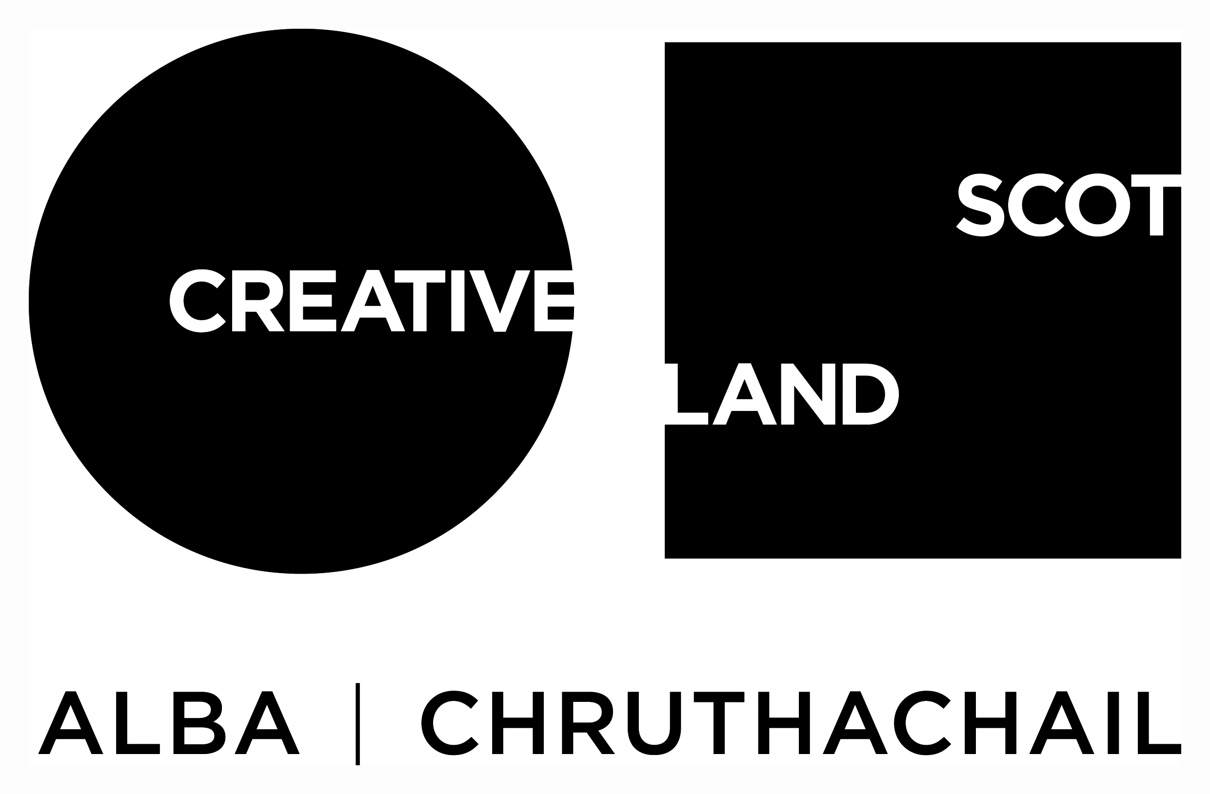
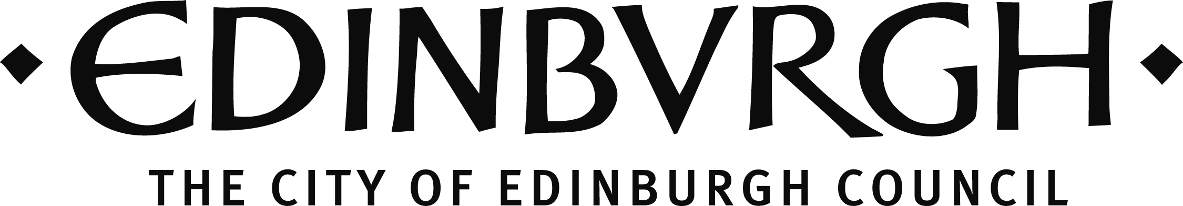

The Traverse is funded by Creative Scotland and The City of Edinburgh Council, with additional support from The Scottish Government Performing Arts Venues Relief Fund.
Breakfast Plays: New Tracks is supported by the Noël Coward Foundation and the Turtleton Charitable Trust.
Traverse Young Writers is supported by the Dr David Summers Charitable Trust, The Nimar Charitable Trust, The Russell Trust, The Teale Charitable Trust and The William Syson Charitable Foundation.
Happenings is in partnership with Institute for Advanced Studies in the Humanities at the University of Edinburgh

Traverse Theatre (Scotland) is a Limited Company (Registered Number SC 076037) and Scottish Charity (Registered Number SC 002368) with its Registered Office at 10 Cambridge Street, Edinburgh, Scotland, EH1 2ED.

-ENDS-

