FOR IMMEDIATE RELEASE: 5 March 2020
Contact: Anna Docherty, Press and Media Officer
anna.docherty@traverse.co.uk / press@traverse.co.uk
Direct: 0131 659 7104

TRAVERSE THEATRE TURNS UP THE HEAT TO PRESENT THE SCOTTISH RETURN OF THE FIRECRACKER SMASH-HIT HOT BROWN HONEY

- Quiet Riot and Traverse Theatre Company present the only Scottish dates on the Hot Brown Honey 2020 tour

- Summer 2020 also includes six world premieres and three Scottish premieres

- £1 Tickets available on every performance of every production, for those receiving low income benefits or under the age of 25

- Tickets on sale now

Hot Brown Honey and Traverse Theatre Company

A fierce and exciting feature of our Summer 2020 season is the smash-hit Hot Brown Honey (3-6 Jun), presented by Quiet Riot and Traverse Theatre Company, returning to the capital for the first time since sell-outs at the Edinburgh Festival Fringe 2016, 2017 and 2018. This exclusive five performance run (four nights, plus matinee) will mark the only Scottish dates on its 2020 tour. Turning up the heat with their firecracker of a show, this posse of phenomenal women smash stereotypes as they celebrate our similarities and differences in an explosion of colour, culture and controversy. Set in a dazzling beehive and with striking lighting, music and costumes, it spins tradition on its head, going above and beyond to challenge boundaries and embrace resilience, taking in dance, poetry, comedy, circus, striptease, and song as it goes.
Do you fancy fighting the power and becoming part of the hive? Keep an eye on our website for how to get involved in a buzzworthy new project.
Elsewhere in the season, Traverse Theatre Company present the world premiere of Donny’s Brain (14 Apr-2 May), by acclaimed Scottish playwright Rona Munro (Iron, The Last Witch, The James Plays). A bittersweet tale about forgetting love and losing yourself, it delves deep into the convoluted and eternal mysteries of the human brain, following Donny and Emma’s painfully funny and emotional journey of recovery and rediscovery after Donny loses his last three years of memories, throwing into question all they thought they knew about love and loss. Directed by award-winning director Caitlin Skinner (Hope and Joy, Woke).

The ever-popular A Play, A Pie and A Pint, Òran Mór (presented by Traverse Theatre) continues with Rose (14-18 Apr) by Lorna Martin; The Storm (21-25 Apr) by Owen Whitelaw; Exquisite Corpse (28 Apr-2 May) by Conor O’Loughlin – which was presented script-in-hand at the Traverse’s inaugural First Stages Festival of new talent in November 2019; Mary and Ada Set the World to Rights (5-9 May) by Jane Livingstone; The Silver Superheroes (11-16 May) by Morna Young; and Milkshake (18-23 May) by Rob Drummond. Ticket price includes a pie and a drink.

And if fresh new writing talent is your thing (which it really should be), join us for a night celebrating just that at the Traverse Young Writers’ Scratch Night (16 May). Each writer will have a short slot to try out an idea, developed over ten weeks with the support of playwrights James Ley, Isobel McArthur, Frances Poet, Hannah Lavery and Douglas Maxwell, and presented script-in-hand by professional actors and directors.

Following the launch of our new ticketing initiative last season, we are thrilled that £1 Tickets will be available across every performance of every production in our Summer 2020 season, available to those receiving low income benefits – including Job Seeker's Allowance, Employment Support Allowance, Universal Credit or Carer’s Allowance – and those under the age of 25.

Further summer productions

May

We kick off the season with a comedic offering courtesy of Andrew Roach Ltd and Ingenious Fools, who present a one-night-only showing of award-winning comedian Juliette Burton’s Defined (7 May), in which – following a time of huge change – she looks at how we label and define ourselves and our lives. Later in the month, the same company also present Richard Stott’s Right Hand Man (21 May) – a laugh-out-loud, but also heart-wrenching stand-up show examining body image, mental health and a personal take on being disabled in an image-obsessed world.

Next up, Fledgling Theatre present the Scottish premiere of Neck or Nothing (13-15 May) by Christopher Neels (who also directs) and Callum Cameron. A surrealist comedy inspired by the 1980s cult documentary Project Grizzly, it follows one man’s spiral into obsession and isolation in the pursuit of a dream to create the most important technological advancement in history – a giant suit to fight bears!

World premiering as part of the 2020 Scottish Mental Health Awareness Festival (SMHAF), the semi-autobiographical Black Year (16 May) is creator and composer Craig Peebles’ living memorial to a beloved father. A brand new Scottish musical, it explores themes of grief, anxiety and depression through song, spoken word and live score for classical ensemble, following the journey of four otherwise unconnected strangers, unified by loss, to ask: do we ever really get over grief or do we simply get on with it?

Rounding off May is The Spinners (21 & 22 May), presented by Glasgow producing duo Raw Material, returning to Scotland after a sell-out European premiere at Edinburgh Festival Fringe 2018. An exhilarating ride into myth and imagination from renowned Scottish director Al Seed and award-winning Australian choreographer and dancer Lina Limosani, it plunges audiences into the story of the Fates of Greek mythology.

June

Following their sell-out show last season, Tandem Writing Collective playwrights Jennifer Adam, Amy Hawes and Mhairi Quinn return to the Traverse with their new show And Then What...? (3 Jun). Building on the success of their recent short play ‘taster’ nights, they will present a mixture of new shorts alongside the first of three pieces now developed into a full length play. Performed script-in-hand by multi-talented actors and directors.

Arriving in town for its Scottish premiere, Scene Change Productions and Greenwich Theatre (in association with Norel Productions) present the bittersweet comedy One Jewish Boy (5 & 6 Jun), by Stephen Laughton – a tender two-hander telling the story of Jesse, who has never been able to shake off the vicious attack that brought Alexandra into his life. The love they share is real, pure and absolute, but what happens when you factor in politics and rising prejudices?

Another Scottish premiere, Fifth Word and Nottingham Playhouse present James Fritz’s LAVA (10-12 Jun) – a funny, tender, necessary story about human connection in the face of the inexplicable; in this case a young man rendered mute after unthinkable disaster. Recently announced casting includes Kacey Ainsworth (of Eastenders fame), Dan Parr, Fred Fergus and Safiyya Ingar.

Returning Traverse favourites Strange Town present a world premiere double bill over two nights – Beneath the Surface and Caravan Crush (12 &13 Jun). The former, written by James Beagon, is about five friends looking to alleviate summer holiday boredom by exploring a nearby cave, but now something is following them... The latter, by Catherine Exposito, is a dark comedy about growing up with a criminal record, as four youngsters – in the twilight between childhood and adulthood – roam free in a Scottish caravan park. Both writers are alumni of the Traverse Young Writers scheme, and we are delighted to welcome them back to present these productions.

July

Offering up a pick’n’mix of five new short plays from a variety of playwrights, In Motion Theatre present Write Lines (2 July) – a selection of plays inspired by a newspaper or media headline – the culmination of workshop development with playwright and producer, Lisa Nicoll.

Rounding off the season as a whole is the world premiere of Scottish Youth Theatre National Ensemble’s Once You See The Smoke (10 & 11 Jul), a new touring production taking on the greatest challenge of our time – climate change – and how young people can, and are, fighting back, for their future and yours.

Plus, returning for 2020 is a special extended Edinburgh International Children’s Festival (20-31 May), showcasing some of the world’s best theatre and dance for young audiences and offering children a theatrical experience like no other (full programme revealed on 24 Mar). While Soundhouse has exciting news – the Traverse will now be the official nightly hub for its Edinburgh Tradfest 2020 (2-11 May), before returning to the usual Soundhouse calendar of acclaimed weekly gigs in the Traverse Bar Café (various dates, 18 May-15 Jun).

LISTINGS:
Traverse Theatre, Edinburgh, EH1 2ED
Tickets on sale now: 0131 228 1404 and online at www.traverse.co.uk
More information on £1 Tickets here.

-ENDS-

The Traverse Theatre is supported by:
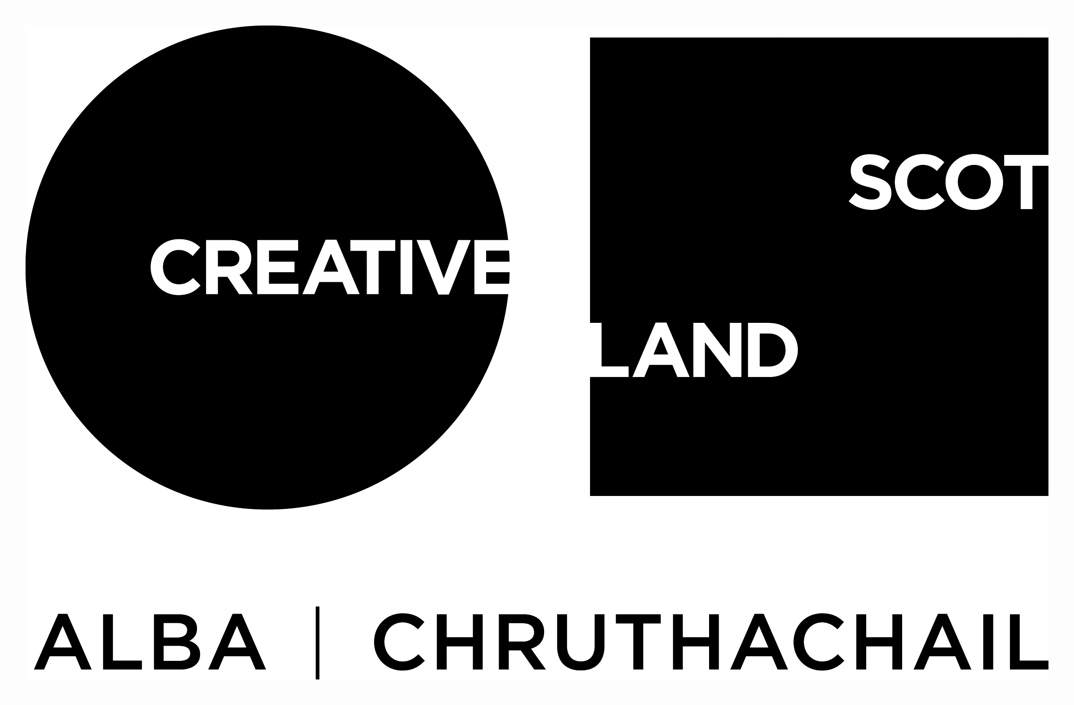
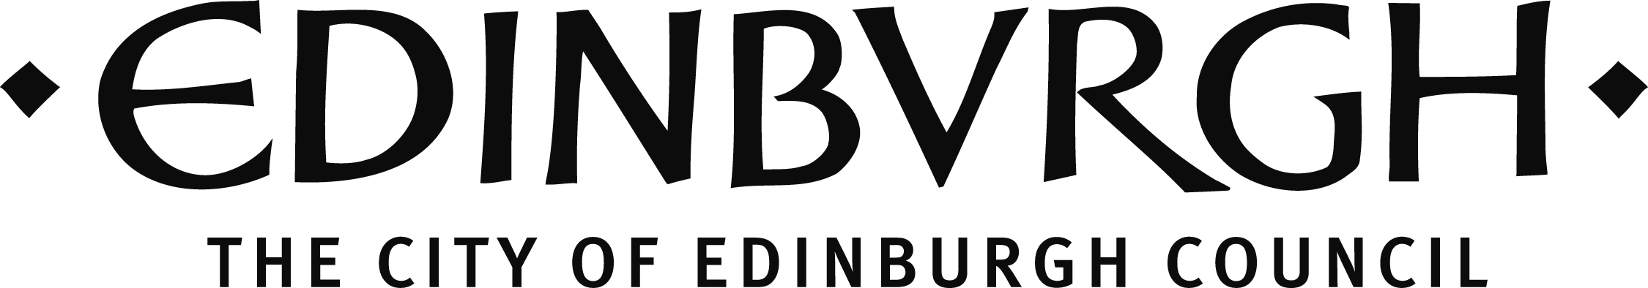

We would like to thank The Dr David Summers Charitable Trust, The Russell Trust, The Teale Charitable Trust and The William Syson Charitable Foundation for their generous support of Traverse Young Writers.

Traverse Theatre (Scotland) is a Limited Company (Registered Number SC 076037) and Scottish Charity (Registered Number SC 002368) with its Registered Office at 10 Cambridge Street, Edinburgh, Scotland, EH1 2ED.

