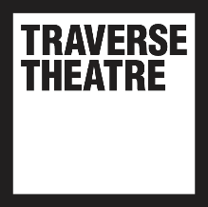
FOR IMMEDIATE RELEASE: Friday 24 November 2023, 13:00pm
Contact: press@traverse.co.uk

The Traverse announce first shows of Spring 2024 season

- Manipulate Festival return with six bold visual and physical theatre shows

- ThickSkin return to the Traverse with their new show Peak Stuff

- Birds of Paradise’s critically acclaimed Don’t. Make. Tea. is staged in Traverse 1

- Renowned Scottish Actor Paul Higgins joins with This Is Memorial Device, a Royal Lyceum Theatre

- The much-loved Class Act Showcase is back featuring brand new works from young people across Scotland

As 2023 comes to a close, we are already looking forward to 2024 with an exceptional season of work joining us from across the world. Today we present to you the first batch of shows joining us in the new year, with even more to come.

2024 begins with Protest from Fuel Theatre, an empowering play for children aged 8+ that explores the power of friendship, activism and believing in your own voice.

February sees the welcome return of Manipulate Festival, bringing the boldest visual theatre from around the world. Joining us from France are Compagnie Bakélite with Envahisseurs, and from The Netherlands Sofie Krog Teater with The House. Works from Scottish companies include the surreal and hilarious Pickled Republic by Ruxy Cantir; Plinth from renowned visual theatre maker Al Seed, which will be a poetic exploration of statues as artefacts of war; and Ragnarok by Tortoise in A Nutshell, a haunting tale of the world’s end and its rebirth. We’re also looking forward to the Scottish premiere of Tess, an adaptation of Thomas Hardy’s Tess of the D’Urbevilles by acclaimed circus company Ockhams Razor, fresh from their run in the West End.

Also coming up in February, Mechanimal will present their highly acclaimed Fringe 2019 show Vigil, a wild exploration of life in an age of extinction. Then the end of the month will see the return of everyone's favourite lunchtime theatre –a 6-week run of fresh new productions from A Play, A Pie and a Pint (with one taking to the Trav 1 stage). Keep your eyes peeled over the coming weeks for the grand reveal of these tasty treats.

We’re delighted that audience favourites ThickSkin will be bringing their new show Peak Stuff in March, as previously announced. Joining the Traverse 1 line-up that month will be the spellbinding gig-theatre show A Giant on the Bridge, and the wickedly funny Don’t. Make. Tea. from Birds of Paradise, who return with this 5-star production for two nights only – be sure not to miss it!

In April, renowned Scottish actor Paul Higgins will star on the Trav 1 stage in This Is Memorial Device, brought to us by our friends around the corner at the Lyceum, following a smash-hit run in August 2022. Traverse 2 will also host one-of-a-kind Fringe hit, Chicken by Sunday’s Child starring Traverse 50 alumni Eva O’Connor–a sell-out during the 2023 festival, so be sure to snap up your tickets.

Also joining us in the spring 2024 season will be Tandem Writers Collective with Rock, Paper Scissors; three script-in-hand readings of plays developed from their last visit to the Traverse in Spring this year. And finally – for now at least - our much-loved Class Act Showcase is back, featuring brand new works created by participants across Edinburgh – guaranteed to be lively, quirky, touching and completely unique.

-

LISTINGS

PROTEST
by Hannah Lavery
Traverse 1: Fri 26 - Sat 27 Jan
On sale now: https://www.traverse.co.uk/whats-on/event/protest-spring-24

THE HOUSE
Sofie Krog Teater
Traverse 2: Fri 2 - Sat 3 Feb
On sale now: https://www.traverse.co.uk/whats-on/event/the-house-manipulate-spring-24

PLINTH
by Al Seed
Traverse 1: Fri 2 - Sat 3 Feb
On sale now: https://www.traverse.co.uk/whats-on/event/plinth-manipulate-spring-24

ENVAHISSEURS (INVADERS)
Compagnie Bakélite
Traverse 2: Sun 4 Feb
On sale now: https://www.traverse.co.uk/whats-on/event/envahisseurs-invaders-manipulate-spring-24

TESS
by Ockham's Razor
Traverse 1: Wed 7 - Thu 8 Feb
On sale now: https://www.traverse.co.uk/whats-on/event/tess-manipulate-spring-24

PICKLED REPUBLIC
by Ruxy Cantir
Traverse 2: Fri 9 Feb
On sale now: https://www.traverse.co.uk/whats-on/event/pickled-republic-pickle-party-manipulate-spring-24

RAGNAROK
Tortoise in a Nutshell
Traverse 1: Sat 10 - Sun 11 Feb
On sale now: https://www.traverse.co.uk/whats-on/event/ragnarok-manipulate-spring-24

VIGIL
by Tom Bailey
Traverse 2: Thu 15 - Sat 17 Feb
On sale now: https://www.traverse.co.uk/whats-on/event/vigil-spring-24

PEAK STUFF
by Billie Collins
Traverse 1: Fri 1 - Sat 2 Mar
On sale now: https://www.traverse.co.uk/whats-on/event/peak-stuff

CLASS ACT SHOWCASE 2024
Students from Firrhill High School, Craigroyston High School, Tynecastle High School, Leith Academy as well as young people from Intercultural Youth Scotland
Traverse 1: Wed 6 - Thu 7 Mar
On sale now: https://www.traverse.co.uk/whats-on/event/class-act-showcase-2024-spring-24

A GIANT ON THE BRIDGE
Devised by Jo Mango and Liam Hurley
Traverse 1: Fri 8 - Sat 9 Mar
On sale now: https://www.traverse.co.uk/whats-on/event/a-giant-on-the-bridge-autumn-23

DON’T. MAKE. TEA.
by Rob Drummond
Traverse 1: Thu 21 – Fri 22 Mar
On sale now: https://www.traverse.co.uk/whats-on/event/dont-make-tea-spring-24

THIS IS MEMORIAL DEVICE
Based on the book by David Keenan, Adapted and Directed by Graham Eatough
Traverse 1: Wed 3 - Sat 6 Apr
On sale now: https://www.traverse.co.uk/whats-on/event/this-is-memorial-device-spring-24

CHICKEN
by Eva O’Connor and Hildegard Ryan
Traverse 2: Thu 18 - Sat 20 Apr
On sale now: https://www.traverse.co.uk/whats-on/event/chicken-spring-24

ROCK, PAPER, SCISSORS
by Jennifer Adam, Mhairi Quinn & Amy Hawes
Traverse 2: Various Dates
On sale now: https://www.traverse.co.uk/whats-on/event/rock-paper-scissors-spring-24

A PLAY, A PIE & A PINT
Traverse 1: Tue 26 Feb – Sat 2 Mar
Traverse 2: Tue 4 Mar – Sat 6 Apr

MORE DETAILS COMING SOON!

-

Full programme and booking: https://www.traverse.co.uk/whats-on

Traverse Theatre, 10 Cambridge St, Edinburgh, EH1 2ED I traverse.co.uk

For more information, interviews, press tickets or images, contact press@traverse.co.uk
Please find a selection of press images etc here.

Traverse Theatre is supported by:
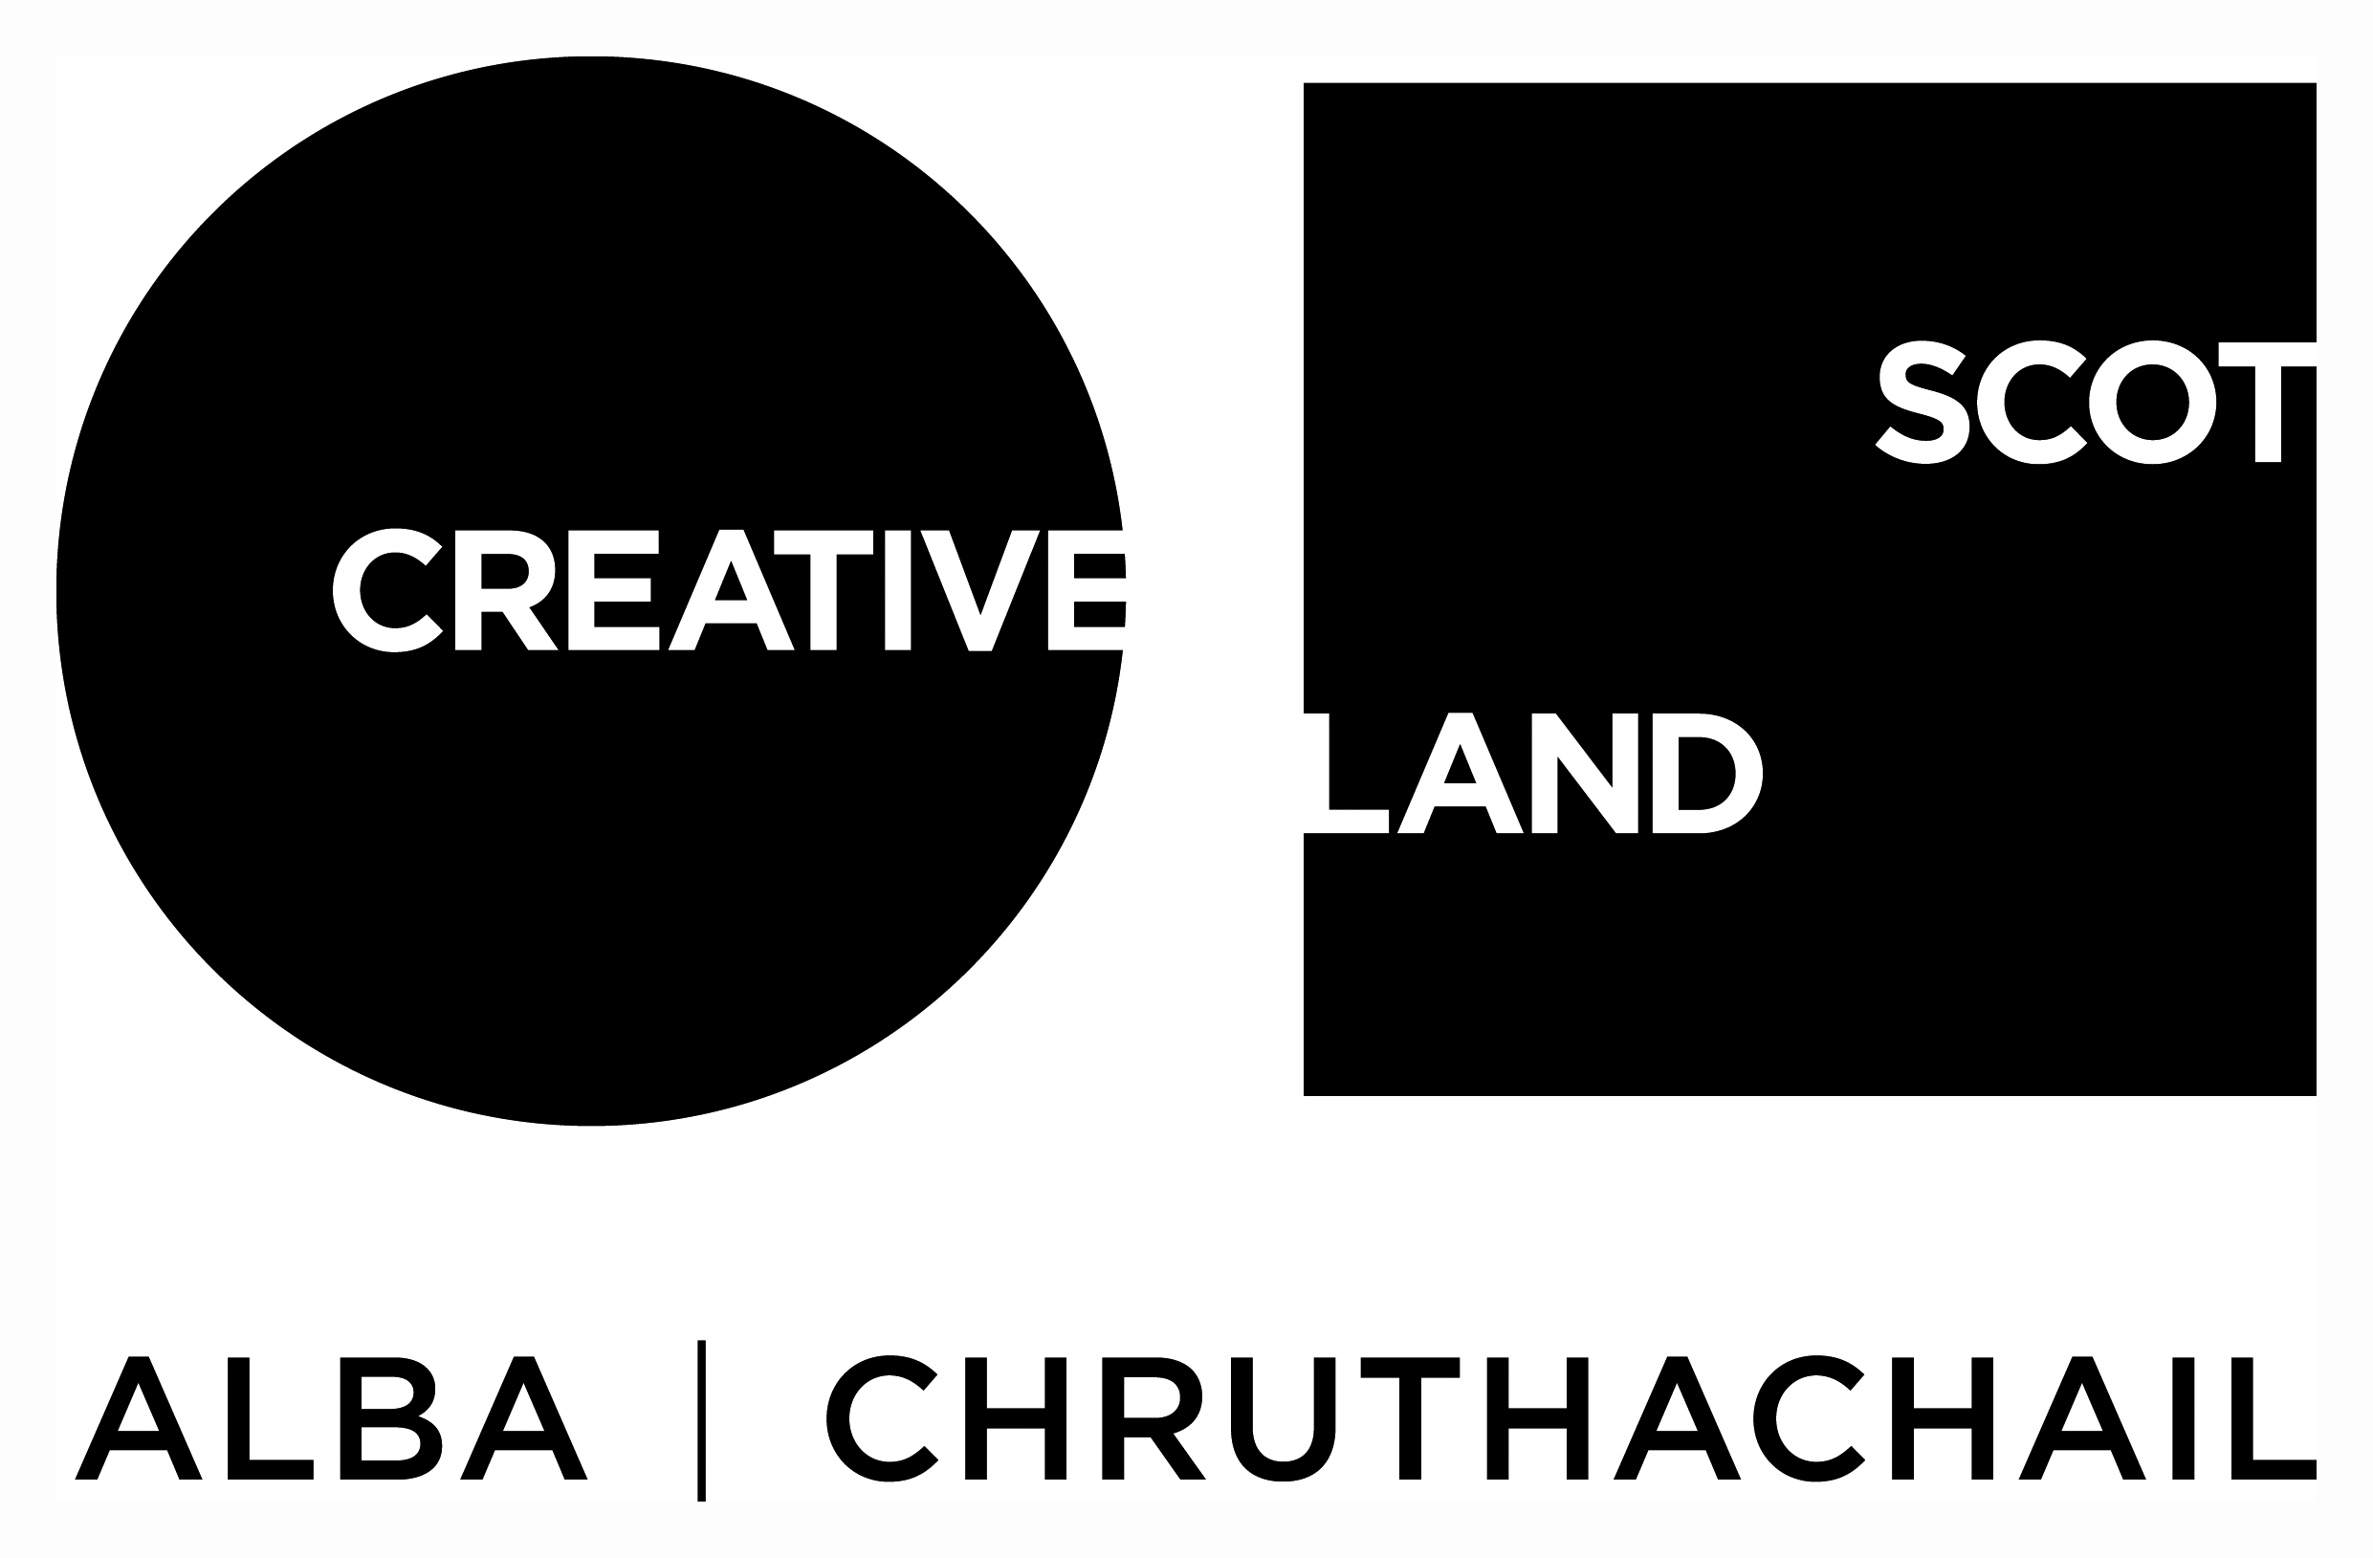
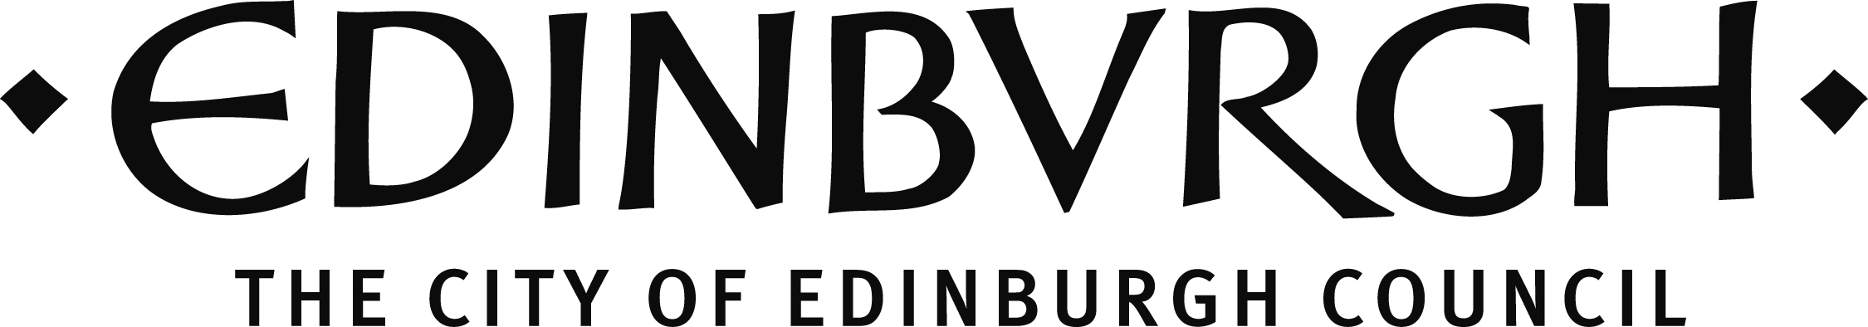

The Traverse is funded by Creative Scotland and The City of Edinburgh Council.

Traverse Theatre (Scotland) is a Limited Company (Registered Number SC076037) and a Scottish Charity (Registered Number SC002368) with its Registered Office at 10 Cambridge Street, Edinburgh, Scotland, EH1 2ED.

