FOR IMMEDIATE RELEASE: 13 February 2019
Contact: Anna Docherty, Press and Media Officer
anna.docherty@traverse.co.uk / press@traverse.co.uk
Direct: 0131 659 7104

THE TRAVERSE THEATRE ANNOUNCES MAY-JUNE PROGRAMME 2019

- Traverse Theatre Company rehearsed reading of Donny’s Brain, a new play by acclaimed Scottish playwright Rona Munro, directed by Caitlin Skinner

- Two exciting new appointments – Lewis Hetherington as IASH/Traverse Creative Fellow 2019, and Meghan Tyler as Channel 4 Playwright in Residence

- Visiting Company Scottish premieres by Actors Touring Company, Live Theatre and Blue Raincoat Theatre Company

- Tickets on sale now

Traverse Theatre Company

The Traverse Theatre’s past, present and future centre on the showcase of the brightest and most adventurous playwrights from Scotland and beyond. With each new season, we invite you to get under the skin of new writing in all of its forms, exploring the journey from page to stage, and experiencing exciting stories as they unfold for the first time.

We are thrilled, therefore, that our May-June season will include two rehearsed, script-in-hand readings of a new Traverse Theatre Company production by acclaimed Scottish playwright Rona Munro (Iron, The Last Witch, The James Plays) – Donny’s Brain (3 & 4 May). Directed by Edinburgh-based Caitlin Skinner (Woke, At A Stretch, Sanitise), it follows Donny as he comes round from a car crash, with no memory of the last three years. Funny and moving, it raises fascinating questions about the essence of love, human nature and our sense of self. Are we just a bunch of chemicals sloshing around? And who are we without our memories? Both reading will be followed by a post-show discussion.

We are also excited to announce that Lewis Hetherington has been awarded IASH/Traverse Creative Fellow 2019, and will be working on the commission of a new play that is both timely and epic – about three characters trying to evade their everyday realities by dislocating themselves into spaces beyond the present, where they can avoid the future in favour of oblivion, absence, and fantasy.

This year we also welcome Meghan Tyler as our Channel 4 Playwright in Residence, working on attachment throughout 2019 as she develops a bold and brilliant new commission for our main stage, Traverse 1.

Finally, our A Play, A Pie and A Pint, Òran Mór (presented by Traverse Theatre) season continues with Casablanca: The Gin Joint Cut (30 Apr-4 May) by Morag Fullarton; The Origins of Ivor Punch (7-11 May) by Colin MacIntyre; and Toy Plastic Chicken (14-18 May) by Uma Nada-Rajah. Ticket price includes a pie and a drink.

Visiting Company productions

The Scottish premiere of Actors Touring Company’s Keep on Walking Federico (9-11 May), written and performed by Mark Lockyer and based on his own experiences, is our first visiting company production of the season, One day, Mark gets a letter which takes him to a sleepy Spanish town. He can’t speak the language and he knows nobody, but he’s not here for fun, he’s here to grapple with the past. As his thoughts turn to his relationships with his parents, long-held secrets emerge. Encountering an array of weird and wonderful people, Mark’s challenge is to move forward whilst acknowledging what is behind him.

Here for just one-night-only is Wildcard Theatre’s Electrolyte (14 May) – a multi award-winning piece of gig theatre combining spoken word and original music to powerfully explore mental health. It follows protagonist Jessie through gigs, parties, city streets and warehouses, journeying from Leeds to London, on a quest to find her mother.

Next up, as part of the Luminate Festival, is one-off performance, Harbour (16 May) – created by Lyceum Original Sixty, the Royal Lyceum Theatre’s 60+ ‘ageing creatively’ group. Inspired by David Greig’s adaptation of Local Hero, it sees them explore the idea of community, love and communication in search of their own ‘local hero’.

Written and performed by actor, rapper, singer, Live Theatre Associate Artist and all-round rising star Kema Sikazwe (I, Daniel Blake), Shine (16-18 May) marks his powerful stage debut, making its Scottish Premiere at the Traverse. A bittersweet coming of age story with an electrifying live soundtrack, it begins with his move from Zambia to Newcastle at three-years-old, telling a heartfelt story of new surroundings, making a new life, and then watching that life fall apart.

In addition to the re-staging of Velvet Petal in our January-April season, Scottish Dance Theatre returns with an exhilarating new Double Bill in May (23 & 24 May): RITUALIA by Colette Sadler, the critically acclaimed reimagining of Igor Stravinsky’s Les Noces; and a new commission, The Circle, by the world renowned choreographic force that is Emanuel Gat.

In a powerful blend of theatrical storytelling, animation and live performance drawing, award-winning writer Annie George and visual artist Flore Gardner bring us Twa (24 & 25 May) – which unwinds contrasting stories about women who have been silenced. A contemporary tale interwoven with the Greek myth of Philomela – based on Ovid’s Metamorphoses – it is told with dark poetic text, startling imagery, and with music and sound design by Niroshini Thambar.

Nudging into June, Harry Josephine Giles & Co. present Drone (4 & 5 Jun) – a live jam of sound, visuals and poetry, telling the story of a military drone’s life and fears. Written by the Forward Prize shortlisted poet Harry Josephine Giles, it promises to be a spectacle performance mixed new every night by a cabaret band of multimedia artists.

Elsewhere, Blue Raincoat Theatre Company present the Scottish Premiere of Alice in Wonderland (6-8 Jun) – adapted for the stage by Jocelyn Clarke – a visually sumptuous and physical re-telling of Lewis Carroll’s beloved work, suitable for all the family.

Developed over an 18-month research period, Wonder Fools return (following The Coolidge Effect) with 549: Scots of the Spanish Civil War (6-8 Jun) – the true story of four miners who, 80 years ago, travelled from the streets of Prestonpans to the valleys of Spain to join the International Brigade. Drawing on personal testimony, speaking to family members and hunting down long lost relatives, it’s a raw and vivid piece, with the 7 June performance including a special selection of short devised performances from young people, plus post-show Q&A with historian Daniel Gray.

Lastly, Strange Town present a duo of pieces performed by a cast of young actors 8-18-years-old, Little Boxes/Stolen Futures (14 & 15 Jun). Little Boxes is an exploration of mental health and societal pressure on young people today, while Stolen Futures ponders how to survive in a post-apocalyptic future when your best friend is missing.

Plus, returning for a special 30th anniversary edition is Edinburgh International Children’s Festival (25 May-2 Jun), showcasing some of the world’s best theatre and dance for young audiences and offering children a theatrical experience like no other (full programme revealed and booking opens on 20 March). While Soundhouse has two programmes of high quality music this season – with five special Tradfest concerts at the Traverse (27 Apr-6 May), before returning to its usual calendar of acclaimed weekly gigs in the Traverse Bar Café (13 May-6 Jul).

LISTINGS:
Traverse Theatre, Edinburgh, EH1 2ED
Tickets on sale now: 0131 228 1404 and online at www.traverse.co.uk

The Traverse Theatre is supported by:
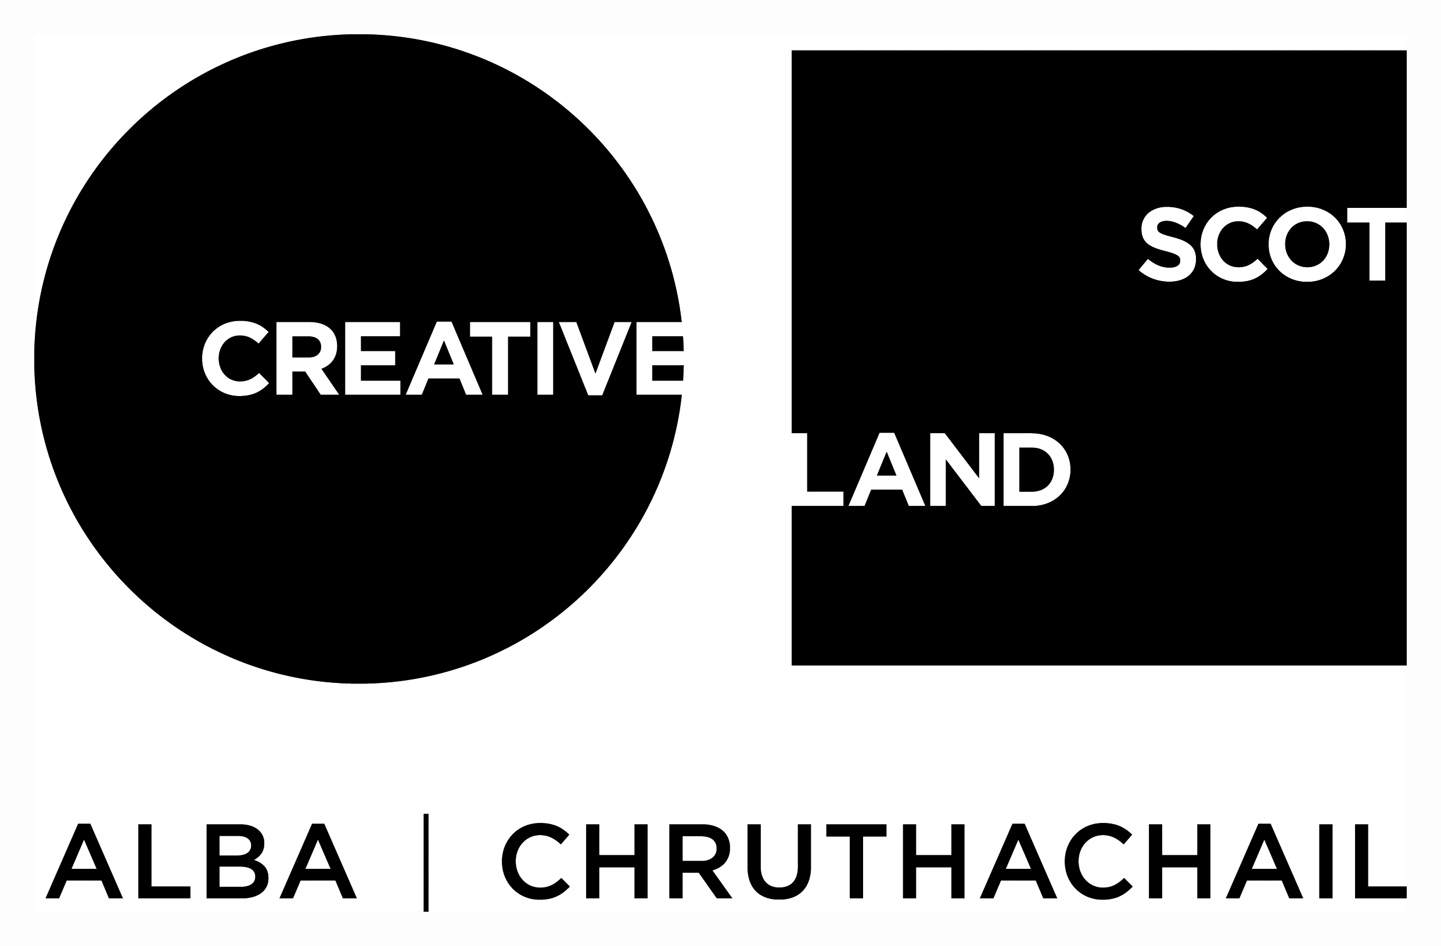

Traverse Theatre (Scotland) is a Limited Company (Registered Number SC 076037) and Scottish Charity (Registered Number SC 002368) with its Registered Office at 10 Cambridge Street, Edinburgh, Scotland, EH1 2ED.

-ENDS-

