FOR IMMEDIATE RELEASE: 6 February 2019
Contact: Anna Docherty, Press and Media Officer
anna.docherty@traverse.co.uk / press@traverse.co.uk
Direct: 0131 659 7115

MOUTHPIECE TRANSFERS TO SOHO THEATRE, LONDON IN SPRING 2019
- The Traverse Theatre Company production of Kieran Hurley’s Mouthpiece – a frank look at class and culture in Edinburgh – heads to London

- Neve McIntosh and Lorn Macdonald reprise their roles

- Tickets on sale now

We are excited to reveal that Mouthpiece – Kieran Hurley’s gripping, provocative and critically-acclaimed smash hit exploring issues of class and culture – will transfer to Soho Theatre, London in April (2 Apr-4 May).

Following hot on the heels of a sold-out world premiere run as the centerpiece of the Traverse Theatre’s Autumn/Winter 2018 season, the transfer sees playwright Kieran Hurley return to Soho Theatre for the first time following his successful debut show Beats.

Produced in association with HighTide, and directed by the Traverse’s former Artistic Director Orla O’Loughlin, Mouthpiece is an unexpected, darkly comic and at times shocking story of two unlikely lives intertwined.

Reprising their roles will be Neve McIntosh (Libby) and Lorn Macdonald (Declan). Libby whiles away her days in New Town cafés and still calls herself a writer – but she’s not put pen to page for years. Declan is a talented young artist struggling with a volatile home life on the outskirts of the city. As the two form an uneasy relationship, complicated by class and culture, Libby spots an opportunity to put her writing career back on track, and tell a story that really matters – Declan’s story. It’s a deeply personal look at the different Edinburghs which often exist in ignorance of one another, and examines whether it’s possible to tell someone else’s story without exploiting them.

A hit amongst audiences and critics alike, the production received a glowing set of five-star reviews and sparked lively debate, with The Stage calling it ‘a strong contender for Scotland’s best play of 2018’, while The Skinny praised the performances as being ‘utterly captivating’ and The National hailed it as ‘sharp and voracious, with plenty to say’.

Speaking to The Herald about the play’s pertinence, Hurley said: “I hope it says something about who gets to tell stories, about the stories that are excluded and some of the complexities around class… It’s about who does or doesn’t get to produce art and culture in society. Out of that comes a much bigger conversation about privilege and power.”
LISTINGS:
Soho Theatre, London, W1D 3NE
Tue 2 Apr-Sat 4 May 2019
Tickets on sale now: 020 7478 0100 and online at sohotheatre.com

For more information, press releases or images, contact press@traverse.co.uk

The Traverse Theatre is supported by:
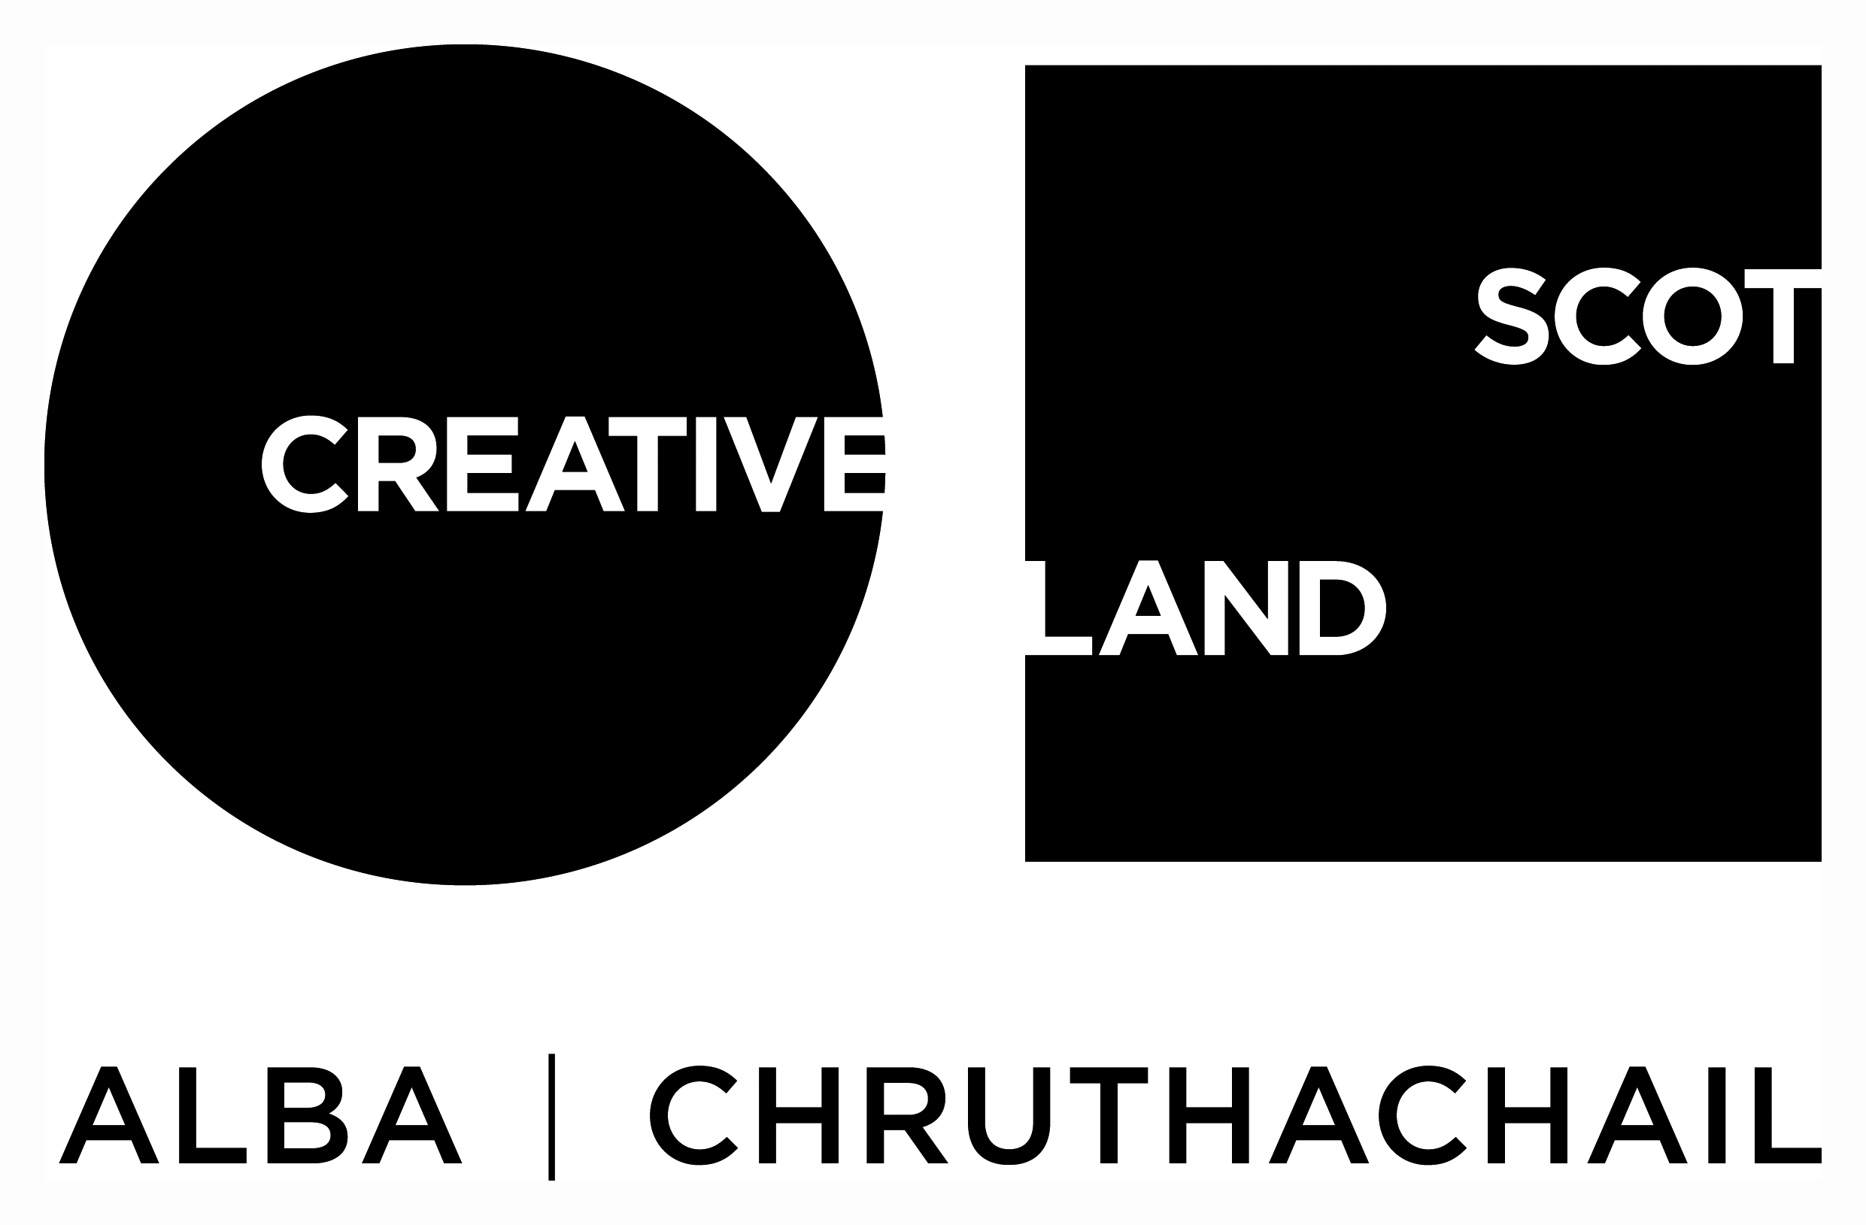

Traverse Theatre (Scotland) is a Limited Company (Registered Number SC 076037) and Scottish Charity (Registered Number SC 002368) with its Registered Office at 10 Cambridge Street, Edinburgh, Scotland, EH1 2ED.

-ENDS-

