About WhatsApp

As part of the performance, we ask audiences to join a WhatsApp group chat for the show. This is optional, but will enhance your experience.

Whatsapp Messenger is an instant messaging service, much like text messaging or iMessage. The application allows the sending of text messages and voice calls, as well as video calls, images and other media, documents, and user location. The group chat feature allows you to send the same message to multiple contacts at the same time and have conversations with a group of people. All data is end-to-end encrypted. This means that no third-party can access the data whilst it is transferred from one device to another.

After each show, the WhatsApp group is cleared and all of your phone data is wiped from the show phones. The show phones are never used outside of the show itself, and your number will not be held by the company or passed onto any third-party groups.

You can join the group by clicking on the link below, or by scanning the QR code:

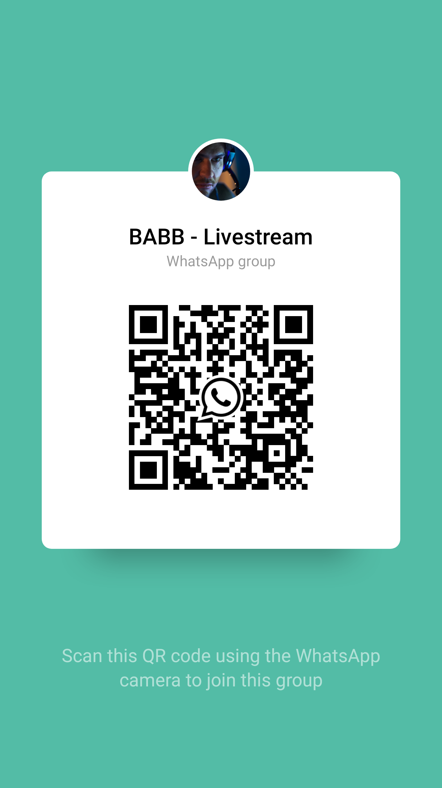
http://tiny.cc/7tszsz

To scan the QR code on iPhone, open up your camera app and position it so the entire QR code is visible. Finally, tap the pop-up notification that will appear at the top of your screen.
To scan the QR code on Android, press and hold the home button and tap Lens. This is the circle surrounded by lines to the left of the four coloured buttons at the bottom of your screen. Position your camera so the entire QR code is visible. Finally, tap the pop-up notification that will appear at the top of your screen.

You are welcome to join the group, however you will not be able to chat on the group until the show has commenced.

Important Privacy Points
- If you wish to remain anonymous in the WhatsApp group chat, please change your name within WhatsApp user settings. After the show, you can revert back to using your name.
- If you wish to hide your number from other participants of the group, information on how to do so can be found here: https://www.techjaspreet.com/how-to-hide-number-on-whatsapp/
- As a reminder, after each show, the WhatsApp group is cleared and all of your phone data is wiped from the show phones. The show phones are never used outside of the show itself, and your number will not be held by the company or passed onto any third-party groups.
- You can read the Traverse Theatre’s Privacy Policy here.

Helpful Links

- To download WhatsApp from the App Store for iOS devices, click here: https://apple.co/2rGOG33
- To download WhatsApp from Google Play Store for Android devices, click here: http://bit.ly/2EbexTr
- More information on end-to-end encryption: https://searchsecurity.techtarget.com/definition/end-to-end-encryption-E2EE

If you wish to hide your number from other participants of the group, information on how to do so can be found here: https://www.techjaspreet.com/how-to-hide-number-on-whatsapp/

